
Loyalty Tri-V Umph
Cooperation September 2015
Friendship

President- Bill Trachsel-734-658-7115 Sec.- M. Van Hollenbeke-734-765-2555
V. President-Steve Trachsel-586-850-0161 Treas.-M. Trachsel-586-484-0836

President’s Message

Well summer has come to a close. The kids and teachers head back to school this week. It's been a great summer, but it really will be nice to get back into a routine. The men's golf league completed its season. Mike Trachsel took home the A flight championship while Nick Angelosanto won B flight. Congratulations to those two, and thanks to Jay and Dave for running the league once again. We also
had our final golf weekend up north. Despite having to golf several times, it was a lot of fun. Thanks to Jeff and his committee for organizing everything.

We will hold our September meeting next week on Tuesday September 15th at 5:30 at Drakeshire Lanes. The meeting date has been pushed back to coincide with the start of bowling season. Hope to see everyone there.

Tri-V Wives Meeting

Please note that the Tri-V Wives club meeting date has changed for just October. Instead of the first Wednesday we will be meeting on the 2nd Wednesday only for October. Jacque Schaefer will be hosting and the meeting starts at 1pm. All Women of Tri-V are invited to attend. Also, please keep December 12th open on your calendar, the wives club Christmas luncheon will be held on that date. Watch the Ump for more details as the date gets close.

Art Trachsel
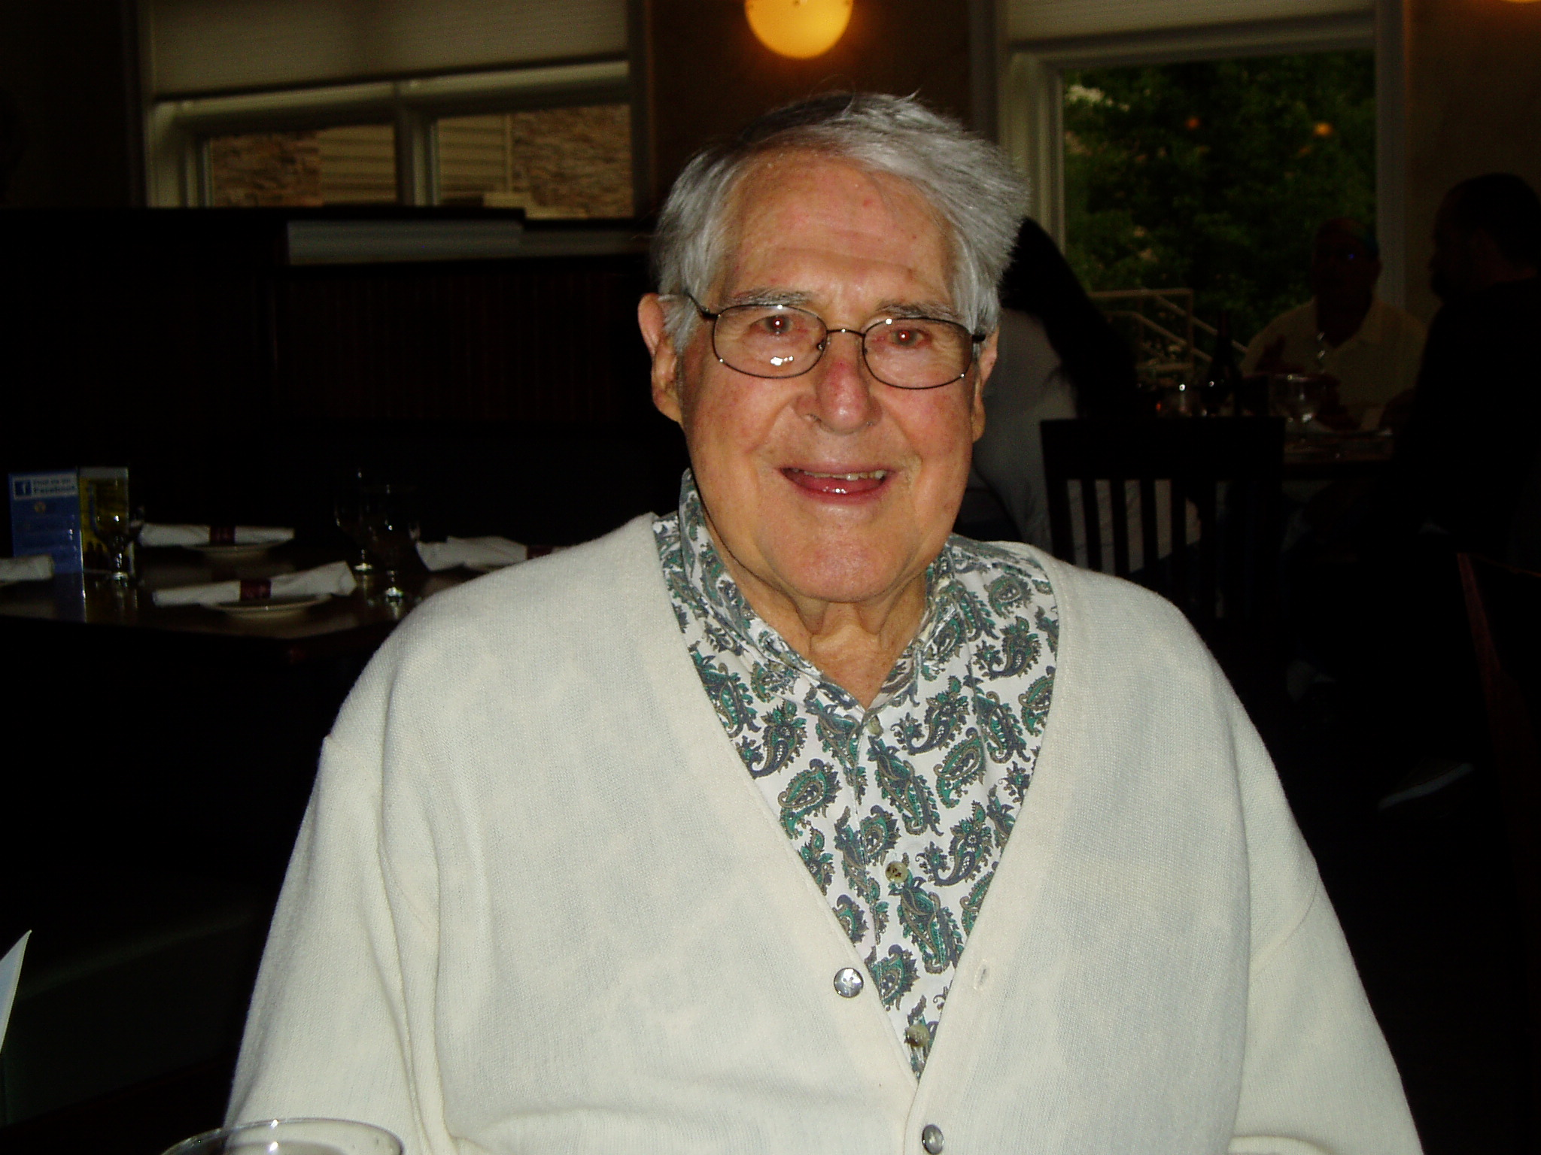
The oldest member of Tri-V, Art Trachsel, will be turning 95 on September 16th. He is really excited about it and I know he would appreciate hearing from you. His address is Art Trachsel, The Brook, 1201 W. Cedar Apt. B 12, Gladwin MI 48624.

Book Club

No Information received

Tri V Golf

The Tri V regular golf season wrapped up with the A and B flight half winners playing for the seasonal championship. In A flight Mike Trachsel and George Hoffman had an exciting and very close match with Mike winning on the last hole for a ½ stroke victory. Both players shot very well Mike had 37 and George shot 40 Mike was spotting George 2.5 strokes. In B flight Nick Angelosanto shot 37 his best round of the season and cruised to an easy victory over Dale Horst and Steve Trachsel. Congratulations to all the half winners for great seasons and especially to Mike and Nick for winning their flights. We want to thank all golfers for a great competitive season. Next season we plan to move to a 1 flight format using 100% handicap. We are also considering add the top 2 overall seasonal point getters to a playoff format. Committee: Jay Trachsel, Dave Burke

Final Golf

We had a great turn out for final golf this year up in Gaylord. We had 32 golfers for Friday and Saturday then Ken P. joined us for Sunday. The first 2 days we had great weather with sun and temps in the low 80’s, but on Sunday we started off good but ended the round in the rain. Again Ray’s Retreat is the perfect location for our group since Mike lets us have control of whole area while we are there. We had some first time players with us this year and I believe that they had enjoyable time with the group. We will be going up to Ray’s and the Gaylord area again next year unless someone can come up with a place that will be close to the same price that we pay now. I know Nick was looking at Benjamin’s Beaver Creek at the Natural since we could put 12 in a cabin. Not sure if they have grills for cooking or not. Please let me know if you have any idea’s that would make the weekend better. Again thanks for a great golf weekend and look forward to next year.

Committee:Jeff Trachsel, Geoff Steinhauer, John Mackson, Dale Horst

Marbles

Marbles will be played the first Saturday of the month beginning in October. Since this is new I am sure there will be some bumps in the road as we begin. Please be patient. Here are the rules and the beginning schedule. If you are on the schedule and don’t want to be or if you aren’t on the schedule and do want to be please let me knows.

Brian Trachsel
Ken Stress

Pinochle

With Marbles taking over the first Saturday of the month, Pinochle has moved to the third Saturday. The rules will be the same as the last couple of years. Here is the start of the schedule.
Brian Trachsel
Ken Stress

Childrens’ Xmas Party

The Children's Christmas Party is scheduled for Sunday, Dec. 6.

Trifles

From the Lardins
After two months Judy Lardin finally got her new Ford Flex. Same color (red) as John’s but she says a lot more gadgets. Don’t know how much John will drive as he is so accustomed to his. She took delivery of it on Wed. Sept. 2nd and on Thur. Sep 3rd Judy and John went to see Johnnie, their oldest son, new home he purchased north of Alpena. The home is three bedrooms, two baths in the middle of know where. At least that is what Judy and John think. Everything is at least 15 minutes away. As John said the chances of him retiring up there in the winter are as good a chance of John retiring in Ft. Myers in the summer.

From Jeff Trachsel


Jeff and Karen would like to announce the birth of their Granddaughter, Harper Danielle. Harper is the daughter of Steve and Andrea Novak along with big sister Kailyn. Harper was born on August 18, weighed in at 6 lbs 7 oz and 20 inches long. All are doing well.

Calendar of Events

September October
9-15 Men’s Meeting (5:30 pm) 10-3 Marbles Start
Drakeshire Lanes 10-14 Wives’Meeting ( 1pm)
10-17 Pinochle start

September Birthdays October Birthdays
9th Shirley Suchner 6th Robyn Mackson
12th Lee Anderson 8th Delores McMillan
16th Art Trachsel
26th Jane Trachsel &
Matt Hoffman

September Anniversaries October Anniversaries
9-16-67 Bob Sherry Kuhr 10-19-68 Jack & Jacqui Schaefer
9-18-71 Geo & Peg Hoffman 10-24-87 Brett & Lynne Barnes
9-30-89 Cal & Janet Cashman

MEMORIES FROM THE SEPTEMBER 2005 ISSUE OF TRI-V UMPH
Our prayers go out to Dottie Wagner who fell and broke her hip the end of Aug. She is currently in rehab. Also to Jacqui Schaefer who had knee surgery in Aug. and is recovering nicely as she starts her last year of home day care the end of Sep. Donna and John Clingerman celebrated the marriage of daughter, Becky, to Jason Hill on Sep. 4th at the Ciccone Vineyard, north of Traverse City. Those traveling included Peg and George Hoffman in their new fifth wheeler, making trips down south in July doing genealogy searches then in early Sep. to FL trying to decide where they might want to locate for the winter months. Doing too much traveling was Judy Lardin. Her travels the month of Aug. included five days in San Antonio TX visiting son Larry and family, six days in Buhl ID to celebrate her Uncle’s 80th birthday with her Mom and three days in Akron OH with John and his sister’s to visit their cousin. Karlyn and Tim Gies were making plans for a trip in the fall of 2006 to the US National Parks out west. The children of TRI-V Members spent time traveling. We start with Rob Kuhr, son of Sherry and Bob, traveling to Albania, Tracey and Nick Katcherian, daughter of Karlyn and Tim Gies, going to Seattle WA and Frank Connolly, son of Ellie and Terry traveling to Hong Kong. The TRI-V Steak Roast was held on Aug. 13th at Gilbert Willis Park, Wixom, with 54 in attendance.

MEMORIES FROM THE SEPTEMBER 2010 ISSUE OF TRI-V UMPH
The Sept. 2010 issue of the TRI-V Umph was a very small issue with no reports of any of the TRI-V Family in need of our prayers. This does not happen often but is a blessing when it does. The only trifle was reported by the Lardins on their trip to Corpus Christi TX to visit son Larry and family over the Labor Day Weekend. This was brought about when three year old Grandson, Jacob, came out of his bedroom with is suitcase packed and told his mom he was going to the airport to visit Grandma and Grandpa. A group of the TRI-V Family made plans for a weeklong trip to Branson MS leaving
on Sun., Sept. 19th. There was a report on the Steak Roast held on Aug. 14th at Gunnar Mettala Park, Wixom and the Girls Weekend on Aug. 20th at the Mannsiding Lodge Bed and Breakfast in Harrison MI.
This wraps up another trip down Memory Lane. School will have started by the time most have read this. Think back when you or our children started the school each year, especially those starting kindergarten for their first school experience. The excitement most had shown and the look on their face as well as the look on Mom’s face knowing that she was finally going to have a little of alone time. Most of all make it a point to be involved with the activities your children get into. Allow our schedule for BOTH Mom and Dad to attend the game or the concert. It means more to your kids than you might realize. I remember two years I was at one of the boy’s concert in Canton and they always honor those that have been in the service. There were not that many veterans in attendance and when they sang the Air Force fight song and I stood up I could see my grandson telling the guys sitting next to him with a big proud smile on his face “That’s my Grandpa.” Until we meet you in print next month, the Good Lord Willing, take care of one another.

With September being the month we celebrate Grandparents Day we send this of our Grandmas in TRI-V.
Once upon a time there was a child ready to be born. The child asked God, “They tell me you are sending me to earth tomorrow, but how am I going to live there being so small and helpless?”
God replied, “Among the angels, I’ll choose one for you. Your angel will be waiting for you and will take care of you.”
The child further inquired, “But tell me, here in heaven I don’t have to do anything but sing and smile to be happy.”
God said, “Your angel will sing for you and will also smile for you every day. And you will feel the angel’s love and be very happy.”
Again the child asked, “And how am I going to be able to understand when people talk to me if I don’t know the language?”
God said, “Your angel will tell you the most beautiful and sweet words that you will ever hear, and with much patience and care your angel will teach you how to speak.”
I’ve heard that on Earth there are bad people. Who will protect me?”
God said, “Your angel will defend you even it means risking its life.”
At the moment there was much peace in heaven, but voices from Earth could be heard and the child hurriedly asked, “God, if I am to leave now please tell me my angel’s name.”
God replied, “Her name is not important. You will simple call her “GRANDMA.”

