
Loyalty Tri-V Umph
Cooperation July 2015
Friendship

President- Bill Trachsel-734-658-7115 Sec.- M. Van Hollenbeke-734-765-2555
V. President-Steve Trachsel-586-850-0161 Treas.-M. Trachsel-586-484-0836

President’s Message

I remember a time when summer in Michigan was hot and humid. We used to run through sprinklers and listen for the ice cream truck. This summer has been a bit of a letdown weather-wise. I haven't seen a sprinkler or an ice cream truck yet. At least we were blessed with a few nice days over the holiday weekend. We were able to hit the beach and enjoy some clear evenings around a campfire. Hopefully there is more of that to come.

Last month we celebrated the 78th anniversary of the club with a banquet at Joy Manor. Bob Kuhr did a great job of emceeing the event and he and his committee did an excellent job organizing the entire evening. Killarney Creek played a few Irish folk songs that apparently only the folks at the back table by the bar knew. I guess a club trip to the Old Shillelagh is in order.

The golf league is well into its second half, and although I haven't made it out there yet, it sounds like they have escaped the awful weather so far. I will be out there one of these days. Until then, good luck (with the golf and the weather).

Tri-V Wives Meeting

The August meeting will be held at the Hankerd Inn during our stay there. Any questions call Judy Lardin at 734-261-1391.

Book Club

The next book club discussion will be on July 23 at the home of Jacqui Schaefer at 1:00 p.m. Book we will be discussing is "The Book Seller" by Cynthia Swanson.
PS--also invite any friends you think would like to join our discussion. I have invited two or three other persons.

Ladies Get Away

The ladies of Tri-V had such a relaxing, enjoyable time at Hankerd Inn in Pleasant Lake, MI we have decided to return for a get-a-way this year. We will be arriving on Monday, Aug. 3, 2015 and leaving on Wednesday, Aug. 5. The cost per person is $150.00 and includes lodging for two nights, two breakfasts, two dinners, one lunch and gas money per car. A $50 deposit will be required no later than May 1, 2015 which can be mailed to Victoria Angelosanto. Final payment of $100 must be made no later than July 27, 2014. Please make check out to Victoria Angelosanto. Everyone will have their own bed, but may share a bedroom. Pleasant Lake is very close to most of our homes, so if someone is not able to stay the whole time adjustments can be made. If you would like more information on the Bed and Breakfast, go to www.hankerdinnresort.com .

78th Anniversary Party

Our 78th anniversary party was held on Friday, June 19, at Joy Manor in Westland. There were 22 members and 17 guests in attendance. The evening started with a cash bar opening at 6:30 p.m. Prior to dinner, the old and new officers gave their customary speeches marking the official installation of the new officers.

The dinner was a buffet featuring entrees of California Chicken, Roast Beef, and Stuffed Pork Chops. As usual the food was well prepared.

After dinner the trio of Killarney Creek played and sang for us. You could also hear many of the younger members singing along with a number of the tunes.

The Committee (Bob Kuhr/Matt H./Ken Stress/Brian Trachsel)

Final Golf

We now have 31 golfers for the weekend. If anyone knows 1 more person that would like to go please let me know, that would give us even groups. With Ray’s having only 30 beds we have to get 1 room down at Waters Inn. This will be same price with all meals still included. So if there is 2 people that would like to stay at the Waters Inn let me know. We are also at that time when the remaining 130.00 is due in a few short weeks. Please get it to me so the committee can have it split up and ready for the weekend. We will be playing The Natural on Friday at 11:30a.m. so please be there by 11:00 so foursomes can get carts. We will be playing use the best drive then play your own ball for the rest of hole. Scoring will be the Callaway system. There will be only 2 flights for the entire weekend. Greenies and skins are included in the total price paid.

If you want to room with someone please let me know otherwise I will set up rooms.

Thanks
Committee
Jeff,Geoff,John and Dale.

Tri-V Picnic

The TRI-V Picnic will be held July 26th at Rotary Park in Livonia from 12:00 - 4:00 PM. If you did not sign up at Anniversary Party or put a ? Next to your name please call or E-mail me at marelee12@embarqmail.com. I need number of adults and children attending. Hope to see everyone there.

The Committee:
Jack Schaefer
Geoff Steinhauer
Lee Anderson
248-860-1693.

Childrens’ Xmas Party

The Children's Christmas Party is scheduled for Sunday, Dec. 6.

Trifles

From the Lardins
John Lardin remains on the mend. When he returned from FL in April he was diagnosed by the foot doctor as having Achilles tendencies. The doctor felt surgery was too risky and he given a boot that covered from his knee to his entire foot to wear for five weeks. Fortunately this solved the problem and during that time John did golf twice a week with the boot on. Then on June 16th a defibrillator/pacemaker/pump was inserted in his heart. A year ago his heart injection factor was at 40 beats a minute and a year later was down to 30 beats a minute. Another test in April confirmed the rate at 30 and his heart doctor determined he needed the implant. John wanted to wait until the end of Aug. and his doctor said “We should have done it yesterday.” Without the implant the injection factor would continue to decline and we all know what the results would have been. He will be rechecked on July 30th and if all checks out positive, which it should, he will have no restrictions and can be back on the golf course. Has not been a fun summer so far but slowly all is coming together.
Ten years ago Judy was in Buhl ID to celebrate her Uncle’ 80th birthday. On June 16th Judy and John will be going back to Buhl to celebrate his 90th birthday. Her Uncle Milton is the only surviving aunt/uncle on her Mom’s side of the family. There will other members of the family for the celebration and will return on June 20th. On July 23rd Judy and John will finally get a chance to make the trip to Corpus Christi TX to see Kim, Larry and the grandchildren. Have not seen them since Dec. and the grandkids keep asking when we will be coming down to see them. Has been a busy time so far and to add Judy has been watching granddaughter Alyssa three days a week for four hours while her mom, Bev, teaches summer school then add to that the Girls Weekend coming up. Judy decided that since John’s 2011 Ford Flex (that he got in July 2010) had 70,000 miles on it and her 2002 Explorer only had 65,000 miles that they should get rid of the Explorer and get a new car to drive back and forth to FL. John agreed and left all up to Judy. She ended up ordering a 2015 Ford Flex the same color as John’s, red. She figures this will be the last car she buys as both plan on keeping them until the wheels are ready to fall off.

From the Bill Trachsels
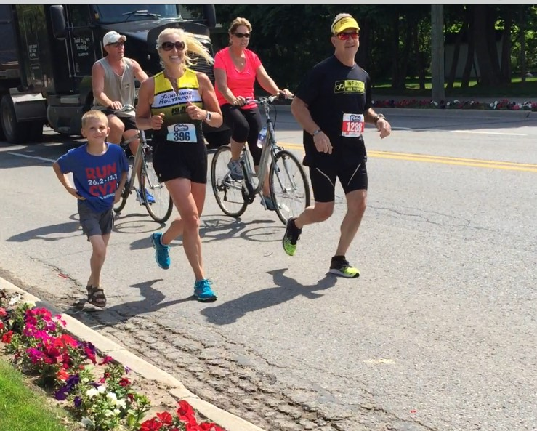
Last weekend Michelle Trachsel completed her first full marathon in Charlevoix. The whole family was there to cheer her on as she crossed the finish line. She said she enjoyed the run and will definitely do another one. She is recovering nicely and walking almost normally again.

Calendar of Events

July August
6th, 13th, 20th, 27th Men’s Golf (430 pm) 3rd, 10th, 17th Men’s Golf (430 pm)
26th Tri-V Picnic 3rd – 5th Ladies Getaway
21st -23rd Final Golf

July Birthdays August Birthdays
4th Dion Angelosanto 2nd Kathie Dushary
21st Michael Trachsel 6th John Lardin
9th Matt VanHollebeke
21st Katie Stress
28th John Mackson
29th Peg Hoffman

July Anniversaries August Anniversaries
7-14-45 Bill & Onallee Trachsel 8-4-72 Jay & Liz Trachsel
7-17-65 Terry & Ellie Connolly 8-4-05 Steve & Amber Trachsel
8-27-71 Terry & Sue Dunham

MEMORIES FROM THE JULY 2005 ISSUE OF TRI-V UMPH
Our prayers went out to the Brenton family on their loss of Wilma Brenton on June 25^{th.} She had suffered a stroke in mid-June. Wilma had just celebrated her 90th birthday. She was the wife of original member Brady. Art Trachsel found out in late June that he had the beginning of Macular Degeneration. Doctors were hoping vitamins would keep his eyes from getting any worse and he continued to battle shingles. Dave Ruetenik woke one morning in late June and couldn’t see out of one eye. Geri took him to the hospital where he stayed for a couple of days while they ran test and they think he had a small stroke and part of his sight has returned. We ask all to continue to remember all in our prayers. We welcomed to the TRI-V Family Jerry Gies and wife Barb as our newest prospective. The month of July found TRI-V members traveling as well as having visitors coming into town. Maryann Little was in Interlochen MI visiting Ray and Dorothy Suchner, Doris and Jim DeLanoy flew to MI to help celebrate his great grandson’s first birthday. Babs Wagner was up at her cottage in Northern Michigan and having daughter Nancy from Hawaii with her for three weeks. Art Trachsel was coming up to MI to spend the month of August with his daughter Diane. Betty Galloway was going to San Francisco CA to help spread the ashes of her brother near the Golden Gate Bridge. Sherry Kuhr had company from KY while Judy Lardin spent the first week of July with her Mom in Buhl Idaho celebrating her Uncle’s 80th birthday. Karlyn and Tim Gies spend the 4th of July with Kathie and Art Dushary in Lansing MI and Ellie and Terry Connolly spent that weekend with Jan and Cal Cashman at their cottage.Geoff Steinhauer started a new job doing desk top support for AAA life in Livonia and it was July 16th of 2005 that John Lardin retired from Northwest Airlines. Upcoming events included the Annual TRI-V Wives swim on July 16th at the pool and club house of Onallee Trachsel and the Steak Roast on August 13th at Gilbert Willis Park, Wixom. The Girls Book Club was to meet on August 22nd at the home of Onallee Trachsel and the RI-V Couples Golf weekend was set for September 17th and 18th in Clair MI.

MEMORIES FROM THE JULY 2010 ISSUE OF TRI-V UMPH
Our prayers were asked for our TRI-V Family as well as our extended TRI-V Family. Nick Angelosanto was suffering from a bladder infection as well as continued back pain. After test and treatment by an Urologist and a back treatment at the pain center things have improved. Prayers for the extended family included Grandma Rosa, Nick Angelosanto’s Mom. She was admitted to the hospital for a week with congestive heart failure and pneumonia. As of July 1st Vickie’s Mom, Victoria, will be living permanently with Vickie and Nick and be attending Senior Day Care for five hours a day. Also to Grandma Millie, mother of Judy Lardin, who suffered a mini stroke. She was diagnosed with congestive heart failure when she was in FL in January with Judy and John and has had breathing problems ever since. Congratulations to Robyn and John Mackson and grandparents Vickie and Angelosanto on the birth of Anthony on June 11th and to Bev and Mike Lardin and grandparents Judy and John Lardin on the birth of Alyssa on June 1st. Diane Plocharczyk decided to take and early retirement on September 30th, about 1 ½ years early, from Bristol-Myers Squibb. Art Trachsel has been forced to give up some of his activities due to his declining health. In the process he was honored for serving as the coordinator for helping put on five blood drives a year for 14 years, a plaque and special service from his Church for his work in many areas for 14 years and honored by Meals on Wheels for the same period for his service on their Board of Directors and Recording Secretary. Upcoming events start with the TRI-V Family Picnic on July 18th Mettala Park, Wixom, the Eives July Swim on July 21st at Blondie Forsyth home, Northville, and the TRI-V Steak Roast on August 14th at Mettala Park, Wixom. The events conclude the weekend of August 20th – 22nd, with the TRI-V Wives Weekend Getaway at Mannsiding Lodge Bed and Breakfast, Harrison MI, and TRI-V Final Golf at Ray’s Retreat, Gaylord.
This wraps up another trip down memory lane. Hard to believe that John Lardin has been retired from the Detroit Free Press for 15 years and Northwest Airlines for 10 years. He continues to use the flight benefits as part of his retirement. While we still wait for summer to arrive in full force you can think back five years ago when we had a string of 90 degree temps. As miserable we felt with the heat as adults we never complained as “kids” as one thinks back to our childhood. Can you imagine our children or grandchildren growing up without the conveniences they have today? We made popsicles from Kool-Aid using the Rubber Maid holders. No matter how it was almost every Mom still fixed a warm meal in the hot kitchen for dinner. Would we take the time to hang out the clothes to dry then having to iron them and most of the time she would just let us play and do the daily chores all by herself and complain very little about how hot it was or how tired she was? How about Dad cutting the grass with a bladed pus mower and cutting the hedges and bushes with hand clippers? None of those gas or electric powered equipment or ozone action days and no water restrictions. Maybe one family in the neighborhood had an above ground swimming pool that we went to. Maybe you could not go because the owner of the pool did not want to be a babysitter and required your mom or dad to be there to watch you. Back then if you had to run to the store you could ask a neighbor to watch the kids so you could go and you would do the same for them. Now days so many do not know their neighbors if they live more than two doors away. Perhaps with a little bit of effort on all our part we can once again enjoy some of the things that our parents had that made if a good time to be raised, helped make us a better kid and adult. With that we close out this month memories. Until we see you in print next month, the Good Lord willing, take care of one another; share a hug, a kiss or a hand shake.

