
Loyalty Tri-V Umph
Cooperation July 2014
Friendship

President- Bill Trachsel-734-658-7115 Sec.- M. Van Hollenbeke-734-765-2555
V. President-Steve Trachsel-586-850-0161 Treas.-M. Trachsel-586-484-0836

President’s Message

Summer is in full swing. Hopefully everyone is enjoying a little sunshine and maybe a family vacation. Last month we had our Anniversary party at Joy Manor. Thanks to the committee for putting together a fun evening. We will soon be gathering for our annual July picnic. I know my family is looking forward to
that. On a special note I would like to wish Terry And Ellie Connolly the best as they have decided to leave behind the cold weather and potholes Michigan is famous for and move to the unbearable humidity and alligators of Florida. Thank you Terry, for all your years of dedication to the club. You will be missed.

Tri-V Wives Meeting

Please note that the Tri-V Wives Club meetings are now scheduled for the first Wednesday of the month at 1pm. (no longer in the evenings) All of the women who attended the July swim voted for this day change. All women of Tri-V members are invited to join us. There will not be a meeting in August because of the Ladies Getaway weekend on August 4-6th. The next real meeting will be at the home of Peggy Hoffman on Sept. 3rd. Please watch the Ump for details of meeting on Oct. 1st.

Book Club
No Report received

Tri V Golf

The first half of the tri V golf league ended on June 9th with Jay Trachsel winning the A flight and John Mackson taking the B flight. We are happy to have some new golfers for the 2nd half as Tim Gies has returned from Florida and Bill Trachsel’s schedule for the kid’s baseball league cleared up. The 2nd half has been under way for 3 weeks and now golfers who struggled the 1st half have begun to golf better and take advantage of higher than normal handicaps. The 2nd half looks like it will be very competitive.
Your golf committee: Jay Trachsel, Dave Burke

Anniversary Party

On June 27 we had the anniversary party at Joy Manor of Westland. We had 39 in attendance. The weather was beautiful, the hall was lovely and the staff was excellent. Our evening started out with lots of socializing. The buffet style dinner consisted of salad, roast beef, California chicken, stuffed pork chops, fresh cut green beans and oven roasted potatoes and for dessert we had the choice between cake and a hot fudge cream puff or indulging with both. John Lardin and Lee Anderson did a wonderful skit. Then we played Family Feud. This was a hit. There were many that stayed and closed the hall down. There were great prized to be won. It was a great evening with lots of smiles to be seen and laughs to be heard. The night was full of fun. I’d like to thank my committee for excellent support. Brian Trachsel, Lee Anderson, George Hoffman and Matt Hoffman

Ladies Getaway

Final payment of $100 must be made to Judy or Victoria no later than July 25, 2014. Please make check out to either Judy Lardin or Victoria Angelosanto. There is a golf course next door if you want to make tee times (on your own)—Hankerd Hills is the name of the course 517-769-2507. Victoria (734) 522-5366 or victoriadominic@yahoo.com or Judy Lardin (734) 261-1391 or jalardin@aol.com.

Thanks, your committee
Victoria Angelosanto
Judy Lardin

Tri –V Picnic

The 2014 Tri V picnic will be held on Sunday July 13th from 12:00 to 5:00pm at Rotary Park in Livonia. Rotary Park is located on the north side of 6 mile road between Merriman and Farmington Rd. Please try to be there by at least 12:30 and we will start to eat as close to 1:00 as possible. As usual please bring a dish to pass plus your own plates and utensils. We will provide pop and ice. We will have an alcohol permit but I would suggest a glass to pour into so no open containers are in plain sight.
If possible please send an email to myself or Tim Gies with how many people and kids (with ages) will be attending so we can plan our games. Also include what dish you plan on bringing and we will try to establish a list of the food people can reference so we will have good variety. Games will follow lunch and depending on weather and interest we may try to organize a parent child whiffle ball or kick ball game after the regular games. Bring your own equipment if you have any. Hope to see everyone there.
Your committee: Tim Gies, Jay Trachsel, Dale Horst, Dave Burke
Final Golf
It’s that time again. You have less than a month to get the final 125.00 to me by August 1st. We will be playing the Lakes on Friday, please be there by 11:00am. We will be playing a 2 man scramble the first day. You can check in at Ray’s before Golf. Committee: Jeff, Geoff, John, Romas
Children’s Xmas Party

Children’s Christmas Party will be Dec. 14, 2014 at Eddie Edgar Ice Arena. Mark your calendars. More information as we get closer.
Steak Roast

The Steak Roast is set for August 23 at Rotary Park from 3 to 8 pm.

Trifles

From the Connollys
Terry & Ellie will have a new address after July 11th:
8702 E SW 94th Street
Ocala, Florida 34481

From the Dusharys
After 6 rounds of chemo we have gone back to Moffitt Cancer and Art's cancer is in remission He has one new lesion and they do not know if is cancerous. The want him to keep going to chemo, to keep any new cells from forming. But because he is so run down they are giving him a break for 7 weeks
to hopefully get him built up. August 21st we will go back to Moffitt for another pet scan and go from there. God is good and we are thankful

From the N. Angelosantos

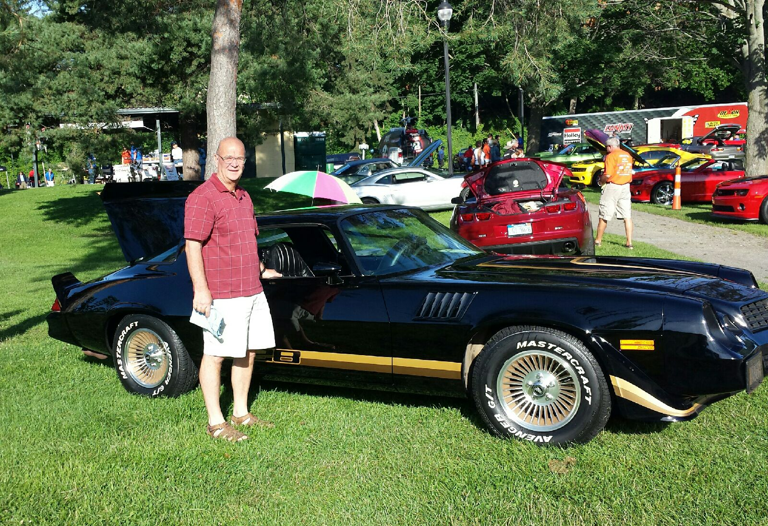
Nick Angelosanto took his 1979, Z28 Camaro to his first car show. His was one of over 500 Camaros being shown. Even though he didn't win in his catagory, he had very positive results. In fact, Channel 4 News used his car as a showcase in their news story on the car show. The car show was in Ypsilanti and runs every 4th of July weekend. He's looking forward to the next show. Not only were there a lot of Camaros showing the owners distinct personalities he met a lot of great people

From the Andersons

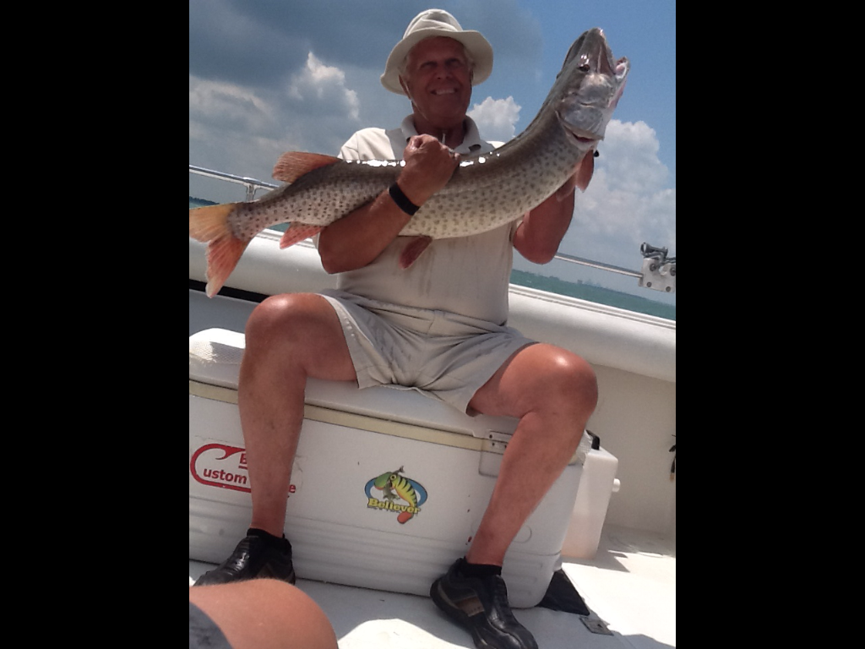
A Father’s Day present of a fishing trip on Lake St. Clair, Lee caught a 30 pound Musky that was 49 ¼ inches long.

From the J. Lardins
Judy Lardin continues to keep busy. Daughter-in-law, Bev, is teaching summer school at Canton High for five weeks in the morning. Judy volunteered to watch Alyssa Tue through Thur morning. This requires Judy being over there at 6:30 AM each day and leaves when Bev gets home at 11: AM. This also includes one, maybe a second sleep over. Unfortunately, or maybe fortunately, she along with Karlyn Gies and Jan Cashman are golfing in a girl’s league, nine holes scramble, on Mon. morning with a tee time at 8:00 AM. It is not unusual for Judy to need that short afternoon nap. Of course John encourages her.

Calendar of Events

July August
Men’s Golf League Every Monday 4th & 11th Men’s Golf League
Hickory Hills Hickory Hills
13th Picnic 4th-6th Ladies Getaway
Rotary Park (12 pm ⁾ Hankerd Inn Resort
16th-18th Final Golf

23rd Steak Roast
Rotary Park (3pm)

July Birthdays August Birthdays
4th Dion Angelosanto 2nd Kathie Dushary
21st Michael Trachsel 6th John Lardin
9th Matthew VanHollebeke
21st Katie Stress
28th John Mackson
29th Peggy Hoffman

July Anniversaries August Anniversaries
7-14-45 Bill & Onallee Trachsel 8-4-72 Jay & Liz Trachsel
7-17-65 Terry & Ellie Connolly 8-4-09 Steve & Amber Trachsel
8-12-78 Jerry & Barb Gies
8-27-71 Terry & Sue Dunham

MEMORIES FROM THE JULY 2004 ISSUE OF TRI-V UMPH

The July 2004 Issue of the Umph shared both good news and sad news to share with the Club. Our prayers were in need for Club members as well as the extended families. Grace Devault, wife of late member Doug, suffered a massive stroke early in May and was in a nursing home in Plymouth with little hope of recovery. On Memorial Day weekend Vickie Angelosanto’s oldest sister, Helena, suffered the loss of her husband, Jim, of only eight short years. Jim was only 57 years old, so young. Ray Suchner, our founding father, and Dorothy were back in Traverse City but unfortunately land locked. Ray’s sight has gotten worse and is neither he or Dorothy is able to drive. Visitors are always welcome if up north. Ken Plocharczyk continues to have some back problems and is scheduled for another cortisone injection. Victor Battel, mother of Vickie Angelosanto, tripped while running to the phone and cracked her knee and Vickie, not to be outdone, suffered bad bruises when s wooden stepping stool shattered under her and she landed on her backside. John Lardin suffered the loss of his 98 year old Aunt Anna the end of June. She was the grand patriot of the Lardin Family. Last but not least Robyn Mackson took a tumble at her students “all night senior party” and tore the tendons in her ankle. This just two days before the Angelosanto Family was preparing to leave for a weeks’ vacation at Orlando. To all we ask you to remember them in your prayers. There was a lot of traveling going on that was reported. Diane Plocharczyk flew to Sarasota FL to visit her Dad, Art Trachsel, for Father’s Day. The trip was in conjunction with a business trip for her. Art was to fly into Detroit on Aug. 2nd to visit Diane and Ken and then go to Final Golf returning to FL on Aug. 25th. Cy and Dorothy Richeson were making their annual trip to MI on Aug. 3rd and returning to FL on Aug. 26th. John and Judy Lardin made a quick overnight trip with John’s sisters to visit their cousin in Akron OH while Mike Lardin spend the last week of June and first part of July at Grandma’s home (Judy’s Mom) in IL and Judy flew down on July 3rd and rode back with Mike on July 6th. Kim and Larry Lardin will be making a trip to MI on July 13th staying for a week. Kim is expecting a little girl in Oct. and all travel has to be approved by her Doctor because of the problems she has had with two previous pregnancies. Vickie Angelosanto’s Mom, Vickie Battel, is scheduled to arrive in MI on July 6th for the remainder of the summer. Karlyn and Tim Gies were in Montreal Canada over the July 4th weekend. Special congratulations go out to Rob Kuhr, son of Sherry and Bob, who will wed Deanna on July 10th and plans are in the making for the family to go to Albania in Sep. to be married in a proper Albanian marriage ceremony. Finally Sue and Terry Dunham are leaving for Oregon on July 5th to see their hippy kids. 29 Men of TRI-V attended the Initiation of Dion Angelosanto, Eric Hoffman and Mike Trachsel into the Club on June 4th. The TRI-V Wives Club Swim was scheduled at the home of Blondie Forsyth on July 21st and the TRI-V Wives Weekend was set for Aug. 13th to 15th at the Northwoods Lodge, Indian River MI. The TRI-V Steak Roast was set for Aug. 7th at Willis Park, Wixom and Final Golf the weekend of Aug. 20th to 22nd. Couples Golf was set for Sep. 18th-19th at Oakwood in Grand Bend Ontario Canada.

MEMORIES FROM THE JULY 2009 ISSUE OF TRI-V UMPH

We start off the July 2009 Issue of the TRI-V Umph with the Members and extended family being healthier than the July 2004 Issue. We are asked to remember in our prayers the family of Nick Angelosanto who suffered the loss of his Sally Layton, his sister, on July 25th. Terry Connolly had a portion of his lower lip removed on June 16th. The sore turned out to be squamous cell cancer and the doctor got it all. On June 9th Karen Thrift had surgery on her right hand to relieve an arthritic thumb. They took out a bone and inserted a pin. Karly Gies’ daughter, Lisa, was in severe pain suffering from Bells Palsy and Lyme’s disease which required Karlyn to spend two weeks in PA helping Lisa and the family with her recovery. We ask you to remember them in your prayers. Congratulations go out to Sherry and Geoff Steinhauer on the birth of daughter, Alyssa, on June 16th. Those traveling included Judy Lardin, Jacquie Schaefer, and two friends on a last minute five day trip to New York City. The TRI-V Golf League had a three way tie between Romas Bliudzius, Dave Burke and Billy Trachsel at the half way point of the season. Final Golf was set for the weekend of Aug. 28th thru the 30th in Gaylord MI with accommodations at Ray’s Retreat Country Inn. There are 28 members and gust committed. The Tri-V Steak Roast was set for Aug. 8th at Mettala Park, Wixom. This wraps up another trip down memory lane. The cancer suffered by Terry Connolly in 2009 returned again this year and was hopefully once again removed for good. My personal prayers go out to little brother Nick on the loss of his sister Sally. Nick also lost his brother, Michael, 18 years ago, both so young. Perhaps now is a good time for all of us to take a moment and reflect on family and friends that we have lost over the years. Also maybe take the time to call or visit those family and friends that are suffering various ailments. Do not wait until it is too late. Like I continually tell friend, “Do not be ashamed to give that family member or friend a hug. The day will come when you will say “”I wish I could give him one more hug.”” Until we see you in print next month, the Good Lord willing, take care of one another.

