
Loyalty Tri-V Umph
Cooperation April 2014
Friendship

President- Bill Trachsel-734-658-7115 Sec.- M. Van Hollenbeke-734-765-2555
V. President-Steve Trachsel-586-850-0161 Treas.-M. Trachsel-586-484-0836

President’s Message

Last month we voted on three new council members. Welcome Dave Burke, Johm Mackson, and Jeff Trachsel. This month we will be interviewing and voting on two perspective members, Dale Horst and Ryan Trachsel. Speaking of adding members, I'd like to welcome two new members to the Trachsel family. Adalena Rose (Steve and Amber) and Madeline Michelle (Mike and Kristen) were born within a few days of each other in March. Congratulations to the proud parents. Our April meeting will be held at the Woodlore condominium clubhouse again. We will again discuss new meeting locations as the clubhouse has decided not to waive the 25 dollar room usage fee. Hope to see everyone there.

New Council Members

The newly elected council members for 2 year terms are
Jeff Trachsel, Dave Burke and John Mackson, they join Dion Angelosanto, Bob Kuhr and Ken Stress with 1 year remaining on their term.

Your committee
Jack, Romas & Ken

Initiation

Initiation is planned for Friday June 6th. Time and place to be determined.

Your committee,

Jack & Geoff

Tri-V Wives Meeting

After missing many meetings because of the bad weather and poor attendance we are once again
scheduling a meeting on April 16th. We are hoping to have many of the Florida women attend.
The meeting is Wednesday, April 16th, at 1:00 at Jacqui Schaefer's house. 248-349-7359.

Book Club

There will be no book club information until the spring.

Final Pinochle

For final Pinochle on Saturday, April 5, we will be Feather Bowling at the Cadieux Café at 4300 Cadieux Road, Detroit, Mich., 313-882-8560 from 4 pm to 6 pm. Dinner will be after bowling. Everyone can join us, you didn’t have to play Pinochle to join us. Please let the committee know as soon as possible so we can turn in a final count. Committee: Romas Biudzius and Jeff Trachsel.

2014 Tri V Golf

The 2014 golf season will start on April 14th and run until August 11th at Hickory Hills. There will be two 8 week halves with a play off on week 17 (August 11th). The cost will be $60 ($30 per half) to get into the prize money. We will also run 3 nightly $2 jackpots for those that want to get in. You will not need to be in the prize money to get into jackpots. We would like to know if you will be golfing and also if you will be getting into prize money as soon as possible for planning so please contact myself or Dave as soon as possible. Committee: Jay Trachsel, Dave Burke

May Open House

Open House will be at Brentwood Country Club, May 10. Starting time will hopefully be by 8:30 am. Cost to be about the same as last year - $70. If you plan on playing or bringing a guest please notify Nick at (734) 522-5366 or victoriadominic@yahoo.com. I need a head count by May 1.

Anniversary Party

Anniversary Party is scheduled for Friday, June 27. We will have info in the next newsletter.

Tri –V Picnic

The Tri V picnic is going to be held on Sunday July13th from 12:00 to 5:00pm at Rotary Park Pavilion #1 in Livonia. Hold the date and more information will forth coming in future papers.
Committee: Tim Gies, Jay Trachsel, Dave Burke, Dale Horst

Final Golf
August 15th-17th
Gaylord
Ray’s Retreat
Just something to get people thinking of warm weather I thought I would get started early for final golf this year. The courses have been picked, just not sure what course on what day. We will need 150.00 deposit by May 15th. Remember to get your money in, Ray’s only holds 28 people and I would like to book the whole Hotel again like last year.
Golf Committee: Jeff T., Geoff S., Matt V., Romas B.
Again May 15th for 150.00 deposit.

Children’s Xmas Party

Children’s Christmas Party will be Dec. 14, 2014 at Eddie Edgar Ice Arena. Mark you calendars. More information as we get closer.

Trifles

From the J. Lardins
Judy and I will have arrived back home in MI as you read this. We left “sunny warm” FL on Sun. April 6th, arriving home on Mon., April 7th. Judy had mixed feelings about returning as the weather was still predicted to be on the cool side while John had wishes to stay one more week. The winter in FL was good for us with visits from son John the end of March and Mike, Bev and grandkids the middle of February and sandwiched in between their visits “little brother” Nick Angelosanto for a week. Judy played a little golf while John played more golf. We spent time with the Andersons, Cashmans, Connollys, Gies, Hoffmans, Trachsels and Geri Ruetenik so although away from MI was almost as if not away. Plans have been confirmed for next year at the same condo and same dates though it is always good to get home and back to your own bed. Dates have been confirmed for next year in the same condo and same time frame, first weekend of Jan. to first weekend of April.

From the S. Suchner
Dorothy Suchner passed away on Tuesday 25th of natural causes. There will be no memorial at this time. She was in Hospices the last 3 wks and died a peaceful death
If Tri-V wants to send a memorial card they can send it to:
Bob Suchner
426 Gayle
DeKalb, Illinois 60115

From the Kuhrs
As Bob did his calling list for the death of Dorothy Suchner, he learned that Julie Parker had passed away a few months ago. No details were given.

From the Dusharys
Just wanted to let everyone know Art will spend another birthday in the hospital. While I was out today he was lightheaded and while heading back to his chair he passed out and landed face first on the floor. We do not know how long he was passed out but when he came around he headed for the bathroom and again fell in our bedroom. He broke his glasses frame which gave him several deep lacerations He has a broken nose, a black eye and 8 stitches on his face They are keeping him in the hospital until they find out what the cause was.

From the Steve Trachsels
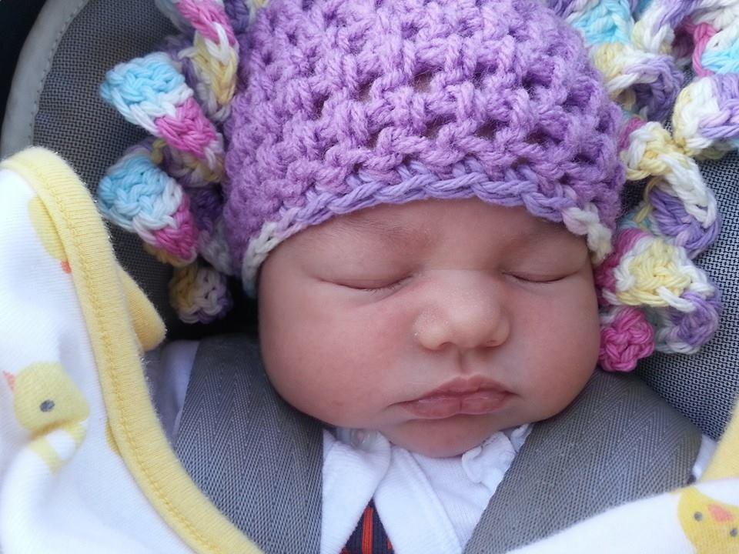
Steve and Amber Trachsel would like to announce the birth of their second daughter, Adalena Rose weighing 9lbs. 4oz., 21 inches long. She was born on March 20 at 10:52 am. She is the granddaughter of Brian & Jane and the great granddaughter of Bill & Onallee Trachsel.

From the Michael Trachsels

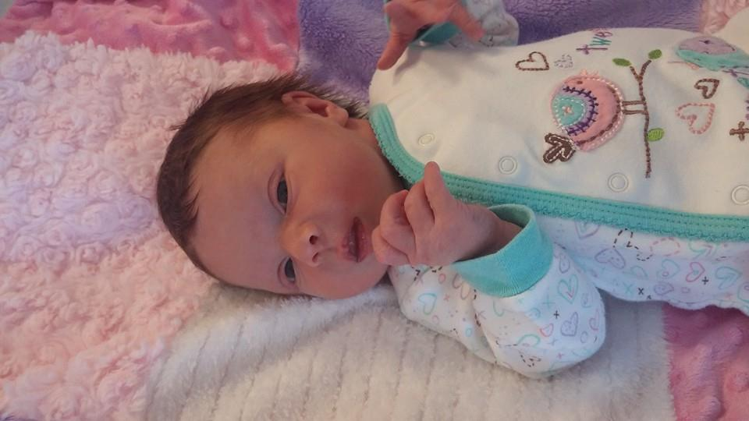
Michael and Kristin Trachsel would like to announce the birth o their daughter, Madeline Michelle, weighing 8lbs, 2oz and 20.5 inches long. She was born on March 29 at 7:56 am. She is the granddaughter of Brian & Jane and the great granddaughter of Bill & Onallee Trachsel.

Calendar of Events

April May
5th Final Pinochle 10th Open House
Cadieux Café (4pm) Brentwood Country Club (8:30am)
12th Men’s Mtg. 15th Final Golf Money Due
Woodlore Clubhouse off Farmington Rd (6:30 pm)
14th Men’s Golf League Starts Every Monday thru August
Hickory Hills

April Birthdays May Birthdays
3rd Judy Lardin 1st Nick Angelosanto
13th Dorothy Suchner & Jerry Gies
16th AnnMarie Angelosanto 6th Onallee Trachsel
23rd Brian Trachsel 8th Karlyn Gies & Jan Cashman
25th Marion Anderson 14th Sherry Steinhauer
28th Steve Trachsel 22nd Donna Clingerman
23rd Liz Trachsel
24th Susie Dunham
26th Dave Burke

April Anniversaries May Anniversaries
4-22-72 Brian & Jane Trachsel 5-9-69 Ken & Kate Stress
5-11-02 Geoff & Sherry Steinhauer
5-12-06 Matt & Christine Hoffman
5-14-71 Nick & Vickie Angelosanto
5-24-09 Dave & Kim Burke

MEMORIES FROM THE APRIL 2004 ISSUE OF TRI-V UMPH
Once again we start the memories asking for your prayers. Lorraine Trachsel, wife of Art, went to be with her Savior on April 3rd. Services were held in FL on April 6th then her body was taken to MS to be buried after services there with her family. We also ask your prayers for Bishop Ken Untener brother of TRIO-V Member Ken on his passing. We reported last month on Tom’s brother Andy and ask you to remember him in your prayers who is still trying to fight through the pancreatitis and how pneumonia. We ask you to add Bonnie Untener’s Mother who was in assisted living and fell, breaking her shoulder, arm and hip. On March 23rd Peg Wendt fell again and hurt her back. X-rays were taken and nothing was broken but the bad news was her protein count was 9.0 and normal is 2.5 so she was admitted to the hospital and while there was able to get the blood count down but she developed another bladder infection. She has returned home and as of April 7th she is on antibiotics. In the middle of March Pat Reid had her second leg amputated, again a result of her diabetes. She is now home getting ready to be fitted with her second artificial leg. To compound the problem she is also on dialysis. We are happy to report that Jim Buckley is mending rapidly from his recent illness. To the Art Trachsel, Wendt, Untener, Reid and Buckley families we ask you to keep them in your prayers. Congratulations to Robyn Mackson who just received her Masters Degree in Education and to Terry Connolly who recently retired and has passed the exam to be a real estate broker along with Ellie who passed the exam earlier last year. Susie Dunham will be in town the middle of April and a group of the girls will be meeting with her for lunch and a gab session on April 17th and John Lardin tried to surprise Judy on her “BIG” birthday on April 3rd by having her Mom come up for the Easter Weekend. Judy knew something was up but was still able to surprise here and they were able to spend some quality mom/daughter time together. There were articles on the following upcoming events stating with the TRI-V Golf League on April 9th at Hickory Hills Golf Club, Wixom, May Open House on May 8th at Hartland Glenn Golf Club, Hartland Glenn, TGRI-V Couples Golf on May 9th at San Marino Golf Course, Farmington Hills, TRI-V Mens Initiation on June 4th at the Crystal Lounge, Dearborn Heights, THR-V Picnic on July 11th at Rotary Park, Livonia and TRI-V Steak Roast on Aug. 7th at Willis Park, Wixom. TRI-V Final Pinochle was held on April 3rd at Hawthorne Valley Country Club, Westland, with 40 people in attendance.

MEMORIES FROM THE APRIL 2009 ISSUE OF TRI-V UMPH
We are happy to report that there were no known members of the TRI-V Family including the extended family that had special need for our prayers though I am sure there are and to those we ask you to remember them in our prayers. We introduced two new prospective members to the Club. Dave Oflara sponsor is Bill Trachsel Jr. Dave and his wife Josephina are the parents of two boys, Dominic who is three years old and Vito who is ten months old, reside in Sterling Heights MI. Our other prospective is Jason Osborne sponsor is Dion Angelosanto. Dave and his wife April are the parent of Jalynn and reside in Garden City MI. Judy and John Lardin on their return from FL the first part of April spend a week with in Corpus Christi TX with son Larry, Kim and the grandchildren. They helped them move into their new home that is on a canal that leads into the Gulf of Mexico. Larry found it necessary to close his restaurant and was fortunate to be hired as a manager at Red Lobster. Upcoming scheduled events included TRI-V Anniversary Party on April 18th at the Maples of Novi, Novi, the first night of the TRI-V Golf League on April 20th at Hickory Hills Golf Course, Wixom, TRI-V Final Pinochle on April 25th at Docs, Livonia, May Open House on May 1st at Gateway Golf Club, Romulus, Ladies May Dinner on May 20th at Bonefish Grill, Novi, TRI-V Steak Roast on Aug. 8th at Mettala Park, Wixom, TRI-V Wives Weekend Getaway on Aug. 28th and 29th at Saravilla Bed and Breakfast, Alma and TRI-V Final Golf the weekend of Aug. 28th thru Aug. 30th at Ray’s Retreat, Gaylord. This wraps another trip down Memory Lane. Easter has come and gone and the warmer weather is here. Judy and I were in FL on a vacation and we were the first non-family members that Lorraine Trachsel met. She always had a special place in our hearts. Pat and Stan Reid was a fun couple to be around. Unfortunately Stan became a member of TRI-V at a late age and then retired to FL and Jim Buckley was responsible for the bidding to be changed in TRI-V Pinochle. He felt it was better for him to over bid his hand and go set and let the opponent get half of his bid than for the opponent to get the bid points. On the golf course Jim would say so often “The ball just does not go where I hit it.” These are memories I have to these people. There are so many other memories we all have in our minds and hearts. Some of them are about people, some of things we did as children as well as with our children or grandchildren. Don’t keep these memories locked up. Take the time once in a while to share them with others. See how many of them that you remember they remember also. Until we see you in print next month, the Good Lord willing, take care of one another.

