
Loyalty Tri-V Umph
Cooperation February 2013
Friendship

President- M. Van Hollenbeke-734-765-2555 Sec.-D. Angelosanto-734-422-3501
V. President-Bill Trachsel-734-658-7115 Treas.-M. Trachsel-586-484-0836

President’s Message

It’s February and only 2 more months until golf starts, at least for those of us not lucky enough to be in Florida. The Council party was this past month regretfully I was unable to attend. I’m sure it was great. The meeting is on Wednesday the 13th hope to see you there.

TRI-V ELECTION

As we reported last month we will be holding the nominations for the office of President, Vice-President, Secretary and Treasured at this month’s meeting. We also included last month and again this month the history of the last five years of officers and a list of active members. Hopefully you have taken the time to review them and are ready to make your nominations. The final election for the above mentioned offices will take place at the March meeting and that to be followed by the nomination and election of three new council members. Those unable to attend the March may request an absentee ballot from the election, Ken Stress at kenandkatestres@yahoo.com or Romas Bliudzius at 734-261-1896. Please keep in mind that you must request the ballot to be sent to you electronically or by mail and may be returned electronically or by mail. YOU MUST BE AN ACTIVE OR LOCAL INACTIVE MEMBER TO VOTE.
Election Committee
Cal Cashman, Chairman
Romas Bliudzius, Ken Stress

Tri-V Wives Meeting

The Tri-V Ladies meeting will be held on February 20th at the home of Ellie Connolly at 1:00 pm. All women of Tri-V are invited.
Book Club

No information was received.

Pinochle
March Schedule
HOST: Stress
M. Trachsel
Romas/Mackson
N. Angelosanto
Jeff Trachsel
Kuhr
Schaefer
B. Trachsel

Pinochle in Florida

Florida Tri-V Pinochle was held at Del Tura Country Club and hosted by Onallee and Bill Trachsel. We had three tables with subs Betty and Jim Buscher along with Hoffmans, Lardins, Cashmans, Gies's and Trachsels. Next month on March 2nd we plan to have a pot luck at the Gies's new home with swimming, food and cards. Hope all up north had a good night. We sure enjoyed getting together with our Tri-V friends.

Final Pinochle - 2013

Final Pinochle will be held on Saturday April 20th at Leon’s of Wixom, located at:

29710 South Wixom Road (North of I-96 on the east side of the road)
Wixom, MI 48393

Cocktails and socializing will commence at 5:30 p.m. (Cash Bar)

Dinner will be served at approximately 6:30 p.m. You must choose in advance from anyone of the following entrees:

Lemon Chicken – Chicken breast sautéed in a lemon butter tossed with mushrooms, spinach, and tomatoes. Served with mashed potatoes and vegetables.
Pork Chops – Two 6 oz. char grilled pork chops served with vegetables, mashed potatoes, and gravy.
Grilled Salmon – Topped with a pineapple salsa, served with rice and vegetable.

St. Louis BBQ Ribs – Half slab served with French fries and coleslaw.

All dinners include soup (chicken noodle, tomato basil, or cabbage) or salad, and rolls.
We will follow dinner with games that have yet to be established by the committee.

We need to have a firm count of all those who plan to attend by Monday April 15. Please notify Ken Stress if you are planning to attend, and give him your meal selections. The cost is estimated to be $17 per person. Your Committee (Bob Kuhr, Geof Steinhauer, Ken Stress, and Romas Bliudzius)

Council Party

The Tri-V Council Party was held on January 19th at the Detroit Institute of Arts. 24 people attended the event include 10 club members and spouses and 4 guests. The group toured the Faberge exhibit at the museum. The exhibit featured hundreds of amazing pieces from the House of Faberge including several of the famous Faberge eggs. After the exhibit, we had dinner at The Traffic Jam and Snug restaurant in Midtown Detroit. The food was very good, and everyone seemed to enjoy themselves. $3.00 was collected from each club member and their spouse. $12.00 was collected from each of the 4 four guests to cover the cost of the museum exhibit.

Thank you to everyone who attended the event.

The Council
Bill, Brian, Steve, Dave, Jay, Nick, and Cal

The Tri-V Family Event
Coming this March, (March 10th at 1:00) at Drakeshire Lanes in Farmington, the Tri-V Club is about to embark on one of the foundational sports of this Sportsman’s Club. It is an event (sport) that has created websites that contain a language all to its self. (Over 350 words) and can be enjoyed by young, old, male and female.
ABC: | Come up: | Grandma¹s teeth: | One in the dark: | Slot grip:
Action | Conversion: | Grasshopper: | On the nose: | Small ball:
Address: | Count: | Graveyards: | Open: | Snake eyes:
Alley: | Counting marks: | Greek Church: | Open bowling: | Snow plow:
All the way: | Cracked thumb: | Groove: | Out and in: | Soft alley; soft lane:
Anchor: | Cranker: | Gutter: | Out of bounds: | Sour apple:
Angle: | Crawler: | Gutter ball: | Outside: | Span:
Apple: | Creeper: | Gutter shot: | Over: | Spare:
Approach: | Crooked arm: | Half hit: | Over-turn: | Spare leave:
Arm swing: | Cross: | Handicap: | Pack: | Spiller
Arrows: | Crow hopper: | Hard way: | Par: | Splasher:
Automatic foul detector: | Curtain: | Head pin: | Part of the building: | Splice:
Automatic Pinsetter: | Curve: | High board: | Perfect game: | Split:
Baby ball, | Cushion: | High hit: | Pick: | Spot bowling:
Baby split: | Cutter: | Higher | Piano keys: | Squeeze:
Baby split with company: | Darts: | Hold, holding alley: | Pie, Pie alley: | Steal:
Back ends: | Dead apple, dead ball: | Hole: | Pin bowling: | Stiff, stiff alley:
Backup: | Dead wood: | Home alley: | Pinching the ball: | Strap the ball:
Backup alley: | Deflection: | Honey: | Pin deck: | Strike:
Balk: | Delivery: | Hook: | Pindicator: | Strike out:
Ball rack | Deuce: | Hook alley: | Pine: | Strike split:
Ball return: | Dime store: | Hot: | Pit: | String:
Ball track: | Dinner bucket: | House: | Pitch: | Stroke:
Balsa: | Dive: | House ball: | Platform: | Sweeper:
Barmaid: | Division boards: | Inside: | Plugged ball: | Sweepstakes:
Bed: | D.O.A.: | In there: | Pocket: | Swing shot:
Bedposts: | Dodo: | Jam: | Point the ball: | Swiss cheese ball:
Beer frame: | Dots: | Jersey, Jersey side: | Point Shot: | Take off a mark:
Belly the ball: | Dry, dry lanes: | Kegler: | Poison ivy: | Tandem:
Bench work: | Double: | Kickbacks: | Position rounds: | Tap:
Bender: | Double pinochle: | Kick off: | Pot game: | Team captain:
Berlin Wall: | Double wood: | Kill the ball: | Powder puff, puff ball: | Telephone poles:
Bevel: | Dovetails: | Kindling wood: | Powerhouse: | Thin hit:
Bicycle: | Drive: | Kingpin: | Preparation: | 300 game:
Big ball: | Dummy: | Kitty: | Puddle: | 300 game jinx:
Big ears: | Dump the ball: | Kresge: | Pumpkin: | Three quarter bucket:
Big fill:. | Dutch 200: | Lane: | Punch out: | Three quarters:
Big five: | Early foundation: | Late 10: | Pushaway: | Throwing rocks:
Big four: | Emblem: | Leadoff man: | Quick eight: | Tickler:
Blended condition: | Ends: | Leave: | Rail: | Topping the ball:
Blind: | Error: | Leverage: | Railroad: | Touch
Blocked lanes: | Faith, Hope, Charity: | Lift: | Range finders: | Track:
Blow: | Fast: | Light: | Rap: | Triple:
Blow a rack: | Fence posts: | Light seven: | Rat club | Tripped 4:
Blowout: | Field goal: | Light wood: | Reading the lanes: | Tumbler:
Board: | Fill: | Lilly: | Release: | Tunnel block:
Body English: | Fill ball; fill frame: | Line: | Reset: | Turkey:
Bonus: | Finger grips: | Line ball: | Return: | Turn:
Box: | Fingertip: | Loafing: | Reverse | Umbrella ball:
Bowling shoes: | Fit split: | Loft: | Reverse block: | Under:
Break: | Five-bagger: | Lofting: | Reverse pitch: | Up the hill:
Break of the boards: | Flat alley: | Logs: | Revolutions: | Venting:
Bridge: | Flat arc: | Looper: | Ringing ten-burner:. | Washout:
Brooklyn: | Flat ball: | Loose hit: | Rotation: | Water in the ball:
Broom ball: | Floater: | Lose count: | Rug jerker: | WIBC:
Bucket: | Flying elbow: | Love tap: | Run, running late: | Winding them in:
Burner: | Follow-through: | Low: | Runway: | Web:
Buzzard: | Forward pitch: | Makeable split: | Sanctioned: | Weight block:
Call the numbers: | Foul: | Maples: | Sandbagger: | Wood:
Carry: | Foul line: | Match play: | Sandwich game: | Wooden bottles:
Channel: | Foundation: | Medal play: | Scenic route: | Working ball:
Charge: | Four-bagger: | Messenger: | Scratch: | Wrap around:
Charts: | Four-step line: | Miss: | Semi-fingertip: | Wrist master:
Cheesy cakes: | Frame: | Mister Average: | Semi-roller: | X:
Cherry: | Frozen rope: | Mixer: | Separation: | Yank the shot:
Chicken wing: | Fudge: | Moat: | Set: | Zero in:
Choke: | Full hit: | Mother-in-law: | Short pin:
Chop: | Full roller: | Move in: | Shotgun shot:
Christmas tree: | Funnel block: | Move out: | Sidearming;
Cincinnati: | Garbage hit: | Mule ears: | Sixpack:
Classified:. | Getting the wood: | Murphy: | Sleeper:
Clean game: | Goal posts: | Nose hit: | Slick:
Clothesline: | Golden gate: | Nothing ball: | Slide:
Clutch: | Grab: | NBC: | Slot, slot alley:

Knowing that the club is turning over a bit and that there are a lot of newer parents and many children, I found it interesting that we will actually teach these words to our children in addition to everything else. Wow, what a joy. The charge on this event will be dependent on participation, therefore, please let the committee know as soon as possible. However, prior to the budget, the bowling alley is quoting us anywhere from $7.00 to $11.00 per person depending on the package. If you are not at the February meeting and plan to attend, please call Jeff Trachsel 248 2492921 or Matt Hoffman 248 5157037.

Tri-V Final Golf
August 16th-18th
We will be going up to the Gaylord area again and staying at Ray’s Retreat. The price this year is going to be 300.00 dollars. The price increase is due to the golf courses that we are going to play. Elk Ridge in Atlanta, Mi. will be 1 of the courses. The committee will need a deposit of 100.00 dollars by May 15th. We would like to get at least 32 golfers so we can lock up all the rooms at Ray’s. For the older golfers we will work something out so the distances will be fair for everyone. Please get your money in on time to the committee, as the first 32 people will be at Ray’s if we get more than that Ray’s will work something out with the place next door. Let’s get a big group out this year as the last couple years have been low in numbers. Committee:Jeff Trachsel, Steve Trachsel, Geoff Steinhauer, John Lardin, John Mackson
Trifles

From the J. Lardins
Judy and John Lardin made it safely to FL leaving MI on Sun., Jan. 6th, and arriving in Ft. Myers on Mon., Jan. 7th at three in the afternoon. Very little traffic and no bad weather. It took a couple of weeks to get set up completely in the new condo this year. We are in the same complex but a different unit. It has not been upgraded but seems larger than the previous one we rented. John walked in, saw the king size bed, and said “I like it!” Friends from NY had us over for dinner that evening and after Bill said “Welcome John” asked “Do you want to play golf tomorrow?” John looked at Judy and she smiled and said “Go ahead.” Life is good. Between getting set up, golfing, hand-in-foot, euchre and renewing acquaintances from friends we have made over the last five years, we have been busy. As you read this Nick Angelosanto and Jack Schaefer will be our guest for 10 days, arriving on Mon., Feb. 4th, and returning on Wed., Feb. 13th. When asked how much golf they wanted to play Nick responded “As much as possible” while Jack response was “At least four times.” Cal and Jan Cashman arrived on Thur., Jan. 31st and will be here for a month, renting next door to Lee and Marian Anderson. We made the trip to N. Ft. Myers on Sat. night for Florida version of TRI-V Pinochle, joining Bill and Onallee, Tim and Karlyn and George and Peg. Judy will be heading back to MI probably on Sun., Feb. 10th and returning on Wed., Feb. 13th with Alyssa. Grandma needs her quality time with granddaughter. On Fri., Feb. 15th Mike and Bev will be arriving for a week. That will follow with Judy’s niece and her friend coming on the 13th for a week then oldest son, John, arrives the end of Feb. for a week. John keeps track of the weather on serius radio and does honestly feel sorry for all you are having to put up with but does not miss the winters. That is all for this month. Please take care of one another.

From the Plocharczyks
Dad (Art Trachsel) wanted me to send an update to our Tri-V friends and family. In particular, he wanted to let you all know that he misses you, loves you and thinks of you often. Many of you are aware that he has had physical and mental deterioration over the last 6 months. This fall he was diagnosed with Alzheimer’s moderate stage and he was placed on a drug that slows the progression. This January, he contracted what we think is the norovirus that made many people in our area very sick. It’s not the flu, so the flu vaccine he received was not effective against it. He was sick for over a week and it really took its toll. He’s very weak, very tired, often confused and is now confined to a wheelchair as well as sleeping much of the day. He (and I) appreciate the many cards sent as well as prayers.

From Jeff Trachsel
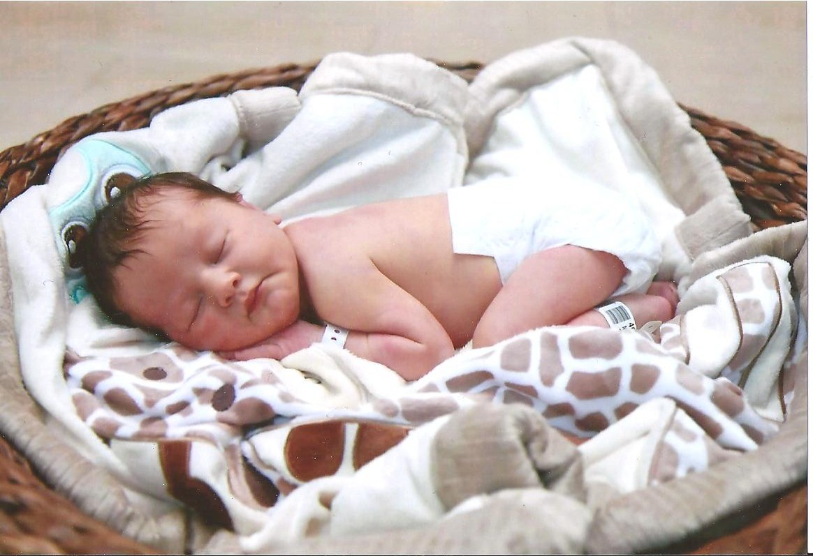
Jeff Trachsel would like to announce the birth of his Granddaughter,Kailyn Anne, born to Daughter Andrea and husband Steve Novack. Kailyn was born January 14 weighing in at 6lbs 11oz and 20 inches long.

Calendar of Events

February March
2nd Pinochle 2nd Pinochle
13th Men’s Mtg. 10th Family Event
Walker’s Speakeasy (6:30pm) 13th Men’s mtg
20th Wive’s Mtg (1pm) Walker’s Speakeasy (6:30pm)

February Birthdays March Birthdays
1st Eric Hoffman 3rd Victoria Angelosanto

2nd Ken Stress 4th Terry Dunham & Barb Gies
7th Romas Bliudzius 20th Ellie Connolly
9th Tim Gies 28th John Clingerman
11th Amber Trachsel 29th Bill Trachsel(young)
13th Lynne Barnes 30th Cal Cashman
22nd Tom Untener 31st Art Dushary & Geri Ruetenik
23rd Bonnie Untener
24th Sherry Kuhr
26th Esther Chamberlin
28th Helene Ryan

February Anniversaries March Anniversaries
None 3-22-03 Bill & Michelle Trachsel

MEMORIES FROM THE FEBRUARY 2003 ISSUE OF TRI-V UMPH
As reported last month our prayers were asked for Marian Anderson and her family. Her Mom passed away on Christmas Morning. Marian and Lee made the trip to Colonie NY for a mass on Jan. 4th and internment at the cemetery. Also reported last month the grandson of Lee and Marian born to son Andy was diagnosed with a collapsed lung and our prayers were answered and he fully recovered. Bill Suchner continues his chemo and radiation treatments to combat the cancer and continues to do well. He has lost his taste for food and swallowing is difficult. They hope the Drs. will allow his travel to FL in Feb. and lastly Lorraine Trachsel was admitted to the hospital on Jan. 30th with pneumonia in both lungs and returned home on Feb. 3rd. she was to have further test done to see if the aggressive cancer may have gone to other parts of her body. Once again we ask you to please remember them in your prayers. The TRI-V Anniversary Party is to be held on March 15 at Montana’s Steak and Seafood House Westland, Final Pinochle was set for April 12th at the Maples Club, Novi, May Open House for May 10th at Hartland Glenn Golf Club, Hartland, the TRI-V Wives Weekend set for the weekend of Aug 9th-11th at Sauder Village, Archbold OH and Final Golf the weekend of Aug. 22nd-24th in Gaylord MI with lodging at the “Big House.” We read about the 40 members, prospective members and guest attending curling on Jan. 11th at Roseland Golf and Curling Club, Windsor Canada. The Florida Anniversary Party was held on Jan. 13th-15th at Del Tura in N. Ft. Myers FL. Pinochle standings through Jan. play had Jane Trachsel in first place with 102.5 points, Brian Trachsel in second place with 99 points and Lou Koewler in third place with 98 points.

MEMORIES FROM THE FEBRUARY 2008 ISSUE OF TRI-V UMPH
February 2008 was a good month for TRI-V Members and their families. No serious medical problems reported though Bob Wendt did try to be the TV handyman helping out the Bright House Tech. over the phone. Bob was asked to read some numbers located on the lower part on the back of the TV. Bob had to squat so low in a tight squeeze that he was unable to get up and had to call 911 to help him. While he was doing this Peg fell down in the kitchen and hit her head on the table and put an inch gash in it. She pressed her alert button and they send a second EMS unit out. Both were hauled out on stretchers and after some test and x-rays were allowed to return home that evening.Those reporting travels included Diane and Ken Plocharczyk in FL. to visit Art Trachsel the middle of Jan. Dorothy Suchner to FL the end of Feb. for two weeks and Diane Plocharczyk returning to FL the end of Feb. for business and adding some time to visit her Dad, Art Trachsel. Karlyn Gies is also officially retired and she and Tim will be traveling in March to visit retirement communities in N. Carolina, S. Carolina and Florida. Judy and John Lardin made a trip to FL the end of Jan. to visit Marian and Lee Anderson. Upon their return along with Vickie and Nick Angelosanto were preparing to spend a week in Cancun Mexico. Upon their return from Cancun Judy and John will take a week to visit son Larry and family in Corpus Christy TX. Sure is a good thing that Judy has kept John healthy to keep him on the go. Finally Mike Lardin and his fiancée Bev were making a trip to Naples FL during spring break from school to make final plans for their upcoming wedding on June 21st in Naples FL. The February Social was a tour at the Detroit Institute of Arts on Feb. 23rd with dinner to follow at McNally’s on Woodward Ave, downtown Detroit. Final Pinochle was set for April 5th at the Wayne AM Vets Hall on Merriman Road in Westland. Pinochle standings through Feb. play had Jeff Trachsel in first with 119 points, Brian Trachsel in second place with 114 points and Jacqui Schaefer and Romas Bliudzius tied for third place with 108 points. This wraps up another trip down memory lane. I guess as we age each month our memories seem to diminish as there was less to report in Feb. then there was in Jan. of 2008. Jane Trachsel must have had John Lardin for a partner again in Feb. for pinochle as she slipped three more notches to 11 place. Seriously, I have kidded in print Jane’s misfortune in pinochle for Jan. and Feb. mainly because over all the years of me being the editor as well as doing the memories I have not known Jane to have such bad cards. Perhaps she is having the same luck I usually have “bad partners.” The trip to Fl. by Judy and John Lardin was the beginning of them becoming “snow birds” This makes it five years now. What a wonderful memory each year and they thank the Good Lord for being able to do so each year. Most of all remember to take care of one another until we see you in print next month, the Good Lord willing.

