
Loyalty Tri-V Umph
Cooperation April 2012
Friendship

President- M. Van Hollenbeke-734-765-2555 Sec.-D. Angelosanto-734-422-3501
V. President-Bill Trachsel-734-658-7115 Treas.-M. Trachsel-586-484-0836

President’s Message

So we are into spring. Golf has started for some of us, it just continues for others. The first ever family event was on April 1st and was a blast for kids and adults. That was a great job by the committee. We have a meeting on the 11th at 6:30pm at Walkers. Also, final pinochle on the 22nd. Hope to see you there.

Earl Tishler

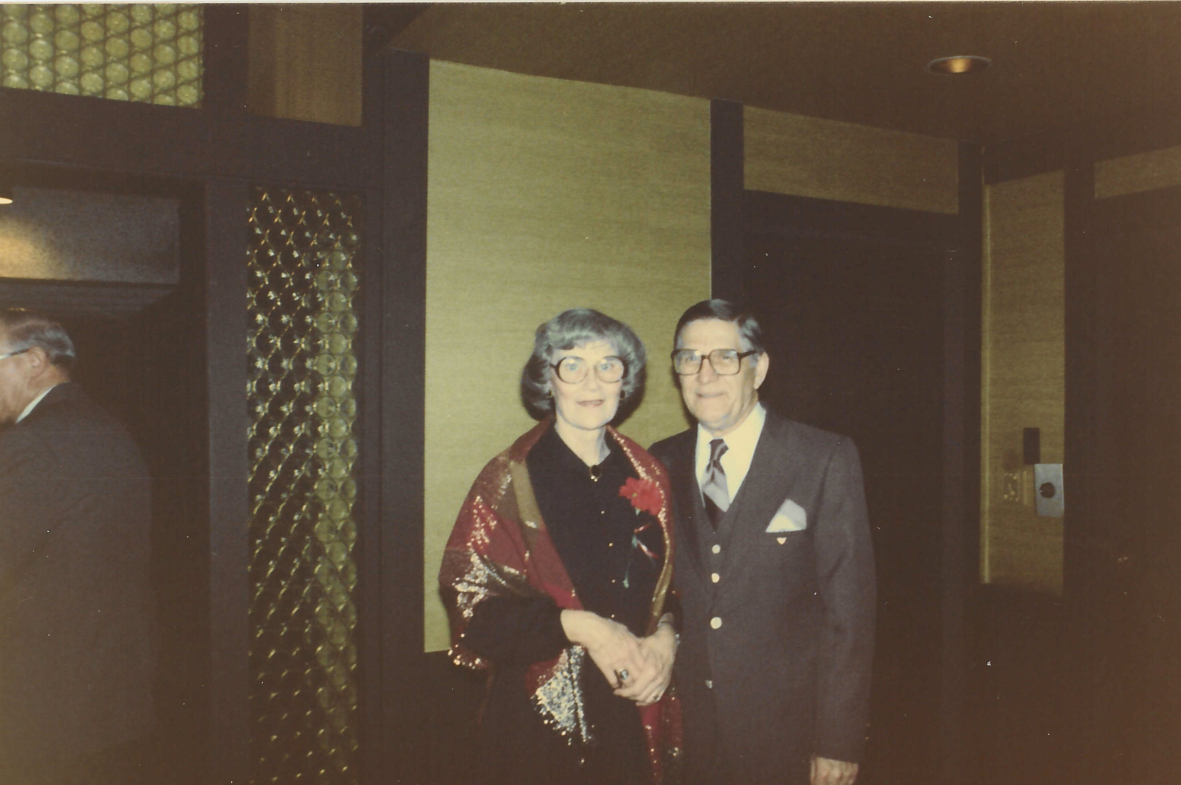
Last month we lost long time member, Earl Tishler. Earl joined
Tri-V in 1949 and remained very active in the club until the last few years. Earl will be dearly missed.

Tri-V Wives Club

All women of Tri-V are invited to the following meetings. The meetings are held at member's homes once a month with the exception of the May dinner, July swim, and Christmas dinner. We have a short meeting and then play three rounds of Tri-V pinochle. The meetings start at 7:00 pm and we are usually done between 9:30 and 10:00 pm.

TRI-V Women's May Dinner

The annual Women's dinner will be held on Wednesday May 16th. We will meet at 5:30 at Bahama Breeze located on 19600 Haggerty Rd., Livonia. Phone 734-542-0891. All women associated in any way with Tri-V are welcome to attend this annual event. Please call Barb Gies 248-437-2219 by Saturday May 12th. Regular memebers of the Tri-V Wives Club please call even if you do not plan to attend so we won't have to make calls. Hope to see you all there.

Final Pinochle
When: April 22nd Where: Cadieux Café Time: 6:00 p.m.
I know this is a Sunday night but we had trouble getting a booking earlier or on a different day.
We will be eating at 6:00 till 8:00. We have the feather bowling courts from 8:00 till 10:00.I hope everyone can make it. Please let the committee know as soon as possible so we can give a count to Cadiux café.
Committee: Romas Bluidzuis, Jeff Trachsel, Dave Burke
Family Event

The TRI-V Family Event was held on Sunday April 1 at the Imagination Station located in Toledo, Ohio. Our group met at 12:00pm to start our day of fun. The Imagination Station has hands on activities for all ages. They have a KidSpace area where the younger children can pretend to go grocery shopping, play in an ambulance that lights up, treehouse to climb on, playhouse that the sides can be removed and put back on time and time again and so many other activities to keep them busy. The older children and adults have the Waterworks area, an Energy Factory, Simulator Theater, TV Station, Mind Bender Zone, Extreme Science Theater, Science Studio, Flex Space, Science Park and last but not least a high wire bicycle ride. Several in our group were daring enough to ride the bike. They certainly do have something for every age. The event was well attended with 30 members and families. We had 20 adults and 10 children. Everyone seemed to have a fun time. The event cost
was covered by the TRI-V budget. After we left the Imagination Theater at 4:30pm we had 10 people attend dinner at Tony Packos Family Restaurant at 7 South Superior Street which is across from the Toledo MudHens Baseball Park. The food was great ------ especially the apple dumpling with ice cream and topped with whip cream.

Your Committee:Ken Stress, Cal Cashman

75th Anniversary Party

A day is coming in the near future when we have the opportunity to go back in time right here close to the city and enjoy the place where many of us have grown up. Nestled right in our backyard is a town that is a throwback to times that seem so long ago. As we celebrate 75 years together as a club, come join us in Chelsea, MI for factory tours, food and fine entertainment.
(Yes, I know it sounds like a Pure Michigan plug, but maybe it is, this is where we live.)
June 23/24, 2012 will be our time to look back, connect and look forward to the things of Tri-V.
Temporary agenda (subject to some modifications)
June 23rd a factory tour of the Chelsea Teddy Bear Factory will be held at either 11:00, 1:00 or 3:00 with the store being open till 6:00 for anyone that has to have one.
June 23rd the Chelsea Comfort Inn & Village Conference Center will have room available for us at a reduced rate of $99 for those that want to stay and will also be where a formal meal will be dished out. More than likely a buffet style with 2 meat selections and a cash bar.
June 24th there will be a warm breakfast for all that stay and then at 2:00 in the afternoon, we will be entertained by the Award Winning Theater in Chelsea "The Purple Rose". They will be entertaining us with an American Classic by Ernest Thompson "On Golden Pond" and this is a talk back show where we can be part of the festivities with the cast afterward.
We are excited to have this event and look forward to seeing everyone soon. Sign-ups will be coming out via e-mail and/or at the meetings to come. Proposed cost for the event (minus the room) are $30-$50 per person. As details formalize, we will be able to give a more accurate and lower number I am sure.
Matt Hoffman on behalf of the Anniversary Committee

Tri V Golf 2012

The Tri V golf season will start on April 23rd at Hickory Hills. We will have two 7 week halves and the 15th week will be the playoff. The cost will again be $30 per half payable by June 4th. This year we are going to go to a 100% handicap system and we will use a 6 or 7 point system per night depending on how many golfers pay into the prize money. Please email Dave or myself as soon as possible if you are intending to golf regularly so we can finalize the season’s details. Committee: Jay Trachsel (trachseljay@att.net), Dave Burke (d1burke@hotmail.com)

May Open House
Saturday, May 19, 2010
Gateway Golf Club
$65 per person includes: golf, cart, steak dinner, hot dog, chips, pop at the turn. (prize money - not included)
Exact time to be announced (8:00 to 8:30 am)
Sign up at meeting or contact Nick (734) 522-5366

Final Golf

Final Golf this year will be August 17th - 19th. We will once again be staying at Ray's Retreat. At this point the plan is to play Marsh Ridge, The Pines, and Wilderness Valley. The total cost per person should be somewhere between $250 and $275. I will need a deposity of $100 by July 1st so that I can reserve our spot. I have been promised great weather!! John Mackson

U of M Dearborn Golf Outing hosted by John Mackson

I am hosting a golf outing for U of M Dearborn Men's Basketball on Saturday June 2, 2012. The outing will take place at The Woodland Golf Course on Ecorse Rd. in Wayne, MI. Registration begins at 8:00am. There will be a continental breakfast followed by a shotgun start at 9:00 AM. We will have hot dogs, chips, and beer or soda at the turn. There will be a banquet style chicken dinner following the round of golf. There will be an open bar for 2 hours following the event along with a silent raffle. There will be prize give-aways as well and plenty of great contests on the course. The cost is $100 per golfer and it should be a beautiful day!! Just call (313) 593-5670 to register. Or let me know and I can pass it on to the event manager.
I have attached a flyer as well.

Trifles

From the J. Lardins
This is the final trifles to be sent from Fl. by Judy and John Lardin. It is hard to believe that we will be leaving to head north in two days. The trip will have us leaving on Thur., April 5th, going to Illinois arriving on Fri., April 6th. We will celebrate Mom’s 89th birthday on Sat., April 7th, followed by Easter and leave on Tue., April 10, to Mich. On our last trip to Mich. the weekend of March 24th we were greeted with a pin hole in the ice maker which resulted in the insurance company tearing out the kitchen flooring, drying the floor and having us meet with them when we return to have things replaced. This gives Judy a chance to do some small remodeling that was not planned. As for Florida the three months has been wonderful. This week the temps have come close to hitting 90 for three days. John was able to play golf every Fri. and both of us played almost every Sun. The time seemed to fly by but Judy feels that her three trips of Mich., Bev and Mike and family here for a week, oldest son, John, making a trip in Feb. and March for a week each time, three months of playing TRI-V Pinochle, the Cashmans and Angelosantos being here for two weeks, the Connellys for two months and Andersons for three months, the golfing every week, euchre and hand-in-foot every week plus all the activities held at the condo also had a big effect. Things are set for next year, the Good Lord willing. See everyone soon.

From the Dusharys
Art had an appendectomy on Thursday, 29. Karlyn & Tim were visiting at the time. They woke up to an empty home as Kathie drove him to Monroe Regional MC at 1:30 AM. Surgery went well, but platelet count was very low. So he's not being released. Connolloy's were going to spend much of next week here, but they're on their way home. I just got home yesterday after spending four lousy days at Monroe Reg Med Ctr. I had an attack of appendicitis last Wed/Thur. We were visiting friends who knew the friends that were visiting us. Around 8:00 I felt some discomfort, but I thought it was gas from some really great bean soup I ate at lunch. Went to bed at 11:00. At 12:30 I was up and called AARP nurse hot line. They thought it was appendicitis and said I should go to the the ER. We arrived at the ER at 1:30am. It was a long wait and they gave me nothing. Vomited a couple of times and was in severe pain. A lot of the intervening time is blurry to me. I think I spent a lot of time in the ER holding room. Surgery was after 7:00pm. Over 17 hours after we arrived. And there was trouble taking blood and getting the port in (and keeping it working) My arms became pin cushions. I ate very little of my food (dry and poor taste) Day staff was not very good. Night staff was at the opposite side of the spectrum. I'm on antibiotics and pain meds for a few days and have an appt this Friday with the surgeon. Karlyn & Tim left early and Terry & Ellie who were coming on Saturday just keep driving north to FH. So I decided I know how to throw a birthday party (400 of my closest medical staff and patients friends) and get people to leave early or not come at all. As my sister, Rhea, said: "this is one birthday you won't forget!" On the bright side I did lose 4 pounds.
Thanks for all your prayers, cards, notes and calls.
Art

From the N. Angelsantos
We would like to thank all our Tri-V friends for the tremendous show of love, sympathy and support over the death of our mom, Rosa. We are grateful for all the good years we had with her. Rosa was a loving and caring person. She had a lot of illness in her life, but we thought we would have her for much longer. She did have a way of getting what she wanted, always saying that she wanted to die just like her mom who got sick and died one week later. Vickie used to tease her and say that wouldn’t happen, because when she got sick we always went to the hospital and she got well again. Either God was listening or got tired of her badgering him, either way she died exactly one week after having a stroke from a blood clot. We have happy memories and still have dad, Papa Joe to keep those good thoughts alive. Thanks again, Nick and Victoria

Calendar of Events

April May
1st Family Event 7th Mens Golf
Imagination Station, Toledo Hickory Hills
11th Men’s Mtg 14th Mens Golf
Walkers Speakeasy(6:30 pm) Hickory Hills
22nd Final Pinochle 16th Wives Dinner
Cadieux Café (6:00 pm) Bahama Breeze (5:30 pm)
23rd Golf Start 19th May Open House
Hickory Hills Gateway Golf Club (8 am)
30th Mens Golf 21st Mens Golf
Hickory Hills Hickory Hills

April Birthdays May Birthdays
3rd Judy Lardin 1st Nick Angelosanto & Jerry Gies
13th Dorothy Suchner 6th Onallee Trachsel
16th AnneMarie Angelosanto 7th Bev Lardin
23rd Brian Trachsel 8th Karlyn Gies &Jan Cashman
25th Marian Anderson 14th Sherry Steinhauer
28th Steve Trachsel 18th Susanne Martin
22nd Donna Clingerman
23rd Liz Trachsel
24th Susan Dunham & Dave Burke

*** Last month Cal Cashmans birthday was missed. So Sorry!! His birthday was March 30.

April Anniversaries May Anniversaries
4-22-72 Brian & Jane Trachsel 5-9-69 Ken & Kate Stress
5-11-02 Geoff & Sherry Steinhauer
5-12-06 Matt & Christine Hoffman
5-14-71 Nick & Victoria Angelosanto
5-24-09 Dave & Kim Burke

MEMORIES FROM THE APRIL 2002 ISSUE OF TRIV UMPH

Another month and once again TRI-V Members and the extended family are in need of our prayers. Vickie Angelosanto mother, Vickie Battel, tripped and broke her collarbone. The recovery time was six to eight weeks but will not stop her from being here to celebrate Dion, her grandson, wedding in June. Dorothy Suchner continues to recovery from her broken hip but still moving a little slow with the help of a cane. Ray Suchner, our founder, has constant pain in his hips and both legs and spends most nights sleeping in his lounge chair. He had a cauterization in February to take pictures of the veins n his legs and the doctor was trying medication to resolve the problem. So far it has not worked. We ask you to remember them in your prayers. On the brighter side Kate Stress is expected to make a full recovery from her recent illness and Jacqui Schaefer reported that her son-in-law’s result from the Mayo Clinic was he had Neuropathy, a deadening of the nerves in the legs. Fortunately he was able to walk away from the Clinic and is expected to recover in time and she ask that we continue to pray for him. Jacquie was also enthused; happy to let us know her other son-in-law will be graduating with his Masters in International Business from Central Michigan University in May. Bill Trachsel was suffering from a rash the end of March and was diagnosed as a reaction to some mediation he was taking. Bill and Onallee will be back in Michigan in time for Bill to participate in Open House as will Dave and Gerry Ruetenik. John Mackson coached both the boys and girls basketball in Taylor and has added the boys track to the list. Joan Fischer and Marilyn Myers just returned from a cruise on Princess Line spending two days in Puerto Rico and then cruised seven days to Aruba, Caracas, Grenada, Dominica and St. Thomas. One of the mainstays of TRI-V has been the golf league. It is sad to report that it has been harder and harder to get enough golfers even though we had the wives of club members included the league has to no longer exist after this season. The Wives Club May dinner was set for May 15th and Kim’s Garden, Novi, and they were looking for volunteers to drive to the Girls Weekend in Canada. Final Golf was set for the weekend of August 23rd thru August 25th in Gaylord Michigan. The 65th Anniversary Party was held on March 23 at the Maples Country Club, Novi with 29 members and 24 spouses/guest attending. After dinner the there was the installation of the new officers for the coming year and Earl Tishler read the names of deceased members and their spouses. The new officers for the coming year were President Tom Untener, Vice-President Tim Gies, Secretary Roy Lockhart and Treasurer George Hoffman. Plans are being finalized for the marriage of Brian Lardin and Gina Yaquinto in April and Judy seem more excited that the kids are of the upcoming event.

MEMORIES FROM THE APRIL 2007 ISSUE OF TRIV UMPH

Another new month and once again we have to report that Peg Wendt is still having health problems. Though she was back home and had been doing good on her therapy she had a slight setback Easter Weekend when she got the U.T.I. again which seems to come on every couple of months. We ask you to continue to pray for Peg. New arrivals to the TRI-V Family start with the birth of Kayla Irene on March 20th to Geoff and Sherry Steinhauer and the arrival of Madison on April 10th to John and Robyn Mackson. Another TRI-V Member has purchased a home in Florida. This time it is Art and Katy Dushary purchasing their home in Top of the World Complex near Ocala Florida. They plan on renting it out next winter then retire there the following year. The Hoffmans, Schaefers and Andersons were finalizing their plans for their 15 day cruise thru the Panama Canal the end of April. Judy and John Lardin made a long weekend trip to Illinois the end of March to visit her Mom to celebrate Judy’s birthday on April 3rd and her Mom’s birthday on April 7th. They returned to Michigan on March 27th. Upon their return home Judy’s Mom called to let her know her Uncle, her Mom’s brother, had passed away and there was going to be a memorial service for him in Tucson Arizona on April 3rd and she wanted to go. Judy returned to Moms on March 31st and left for Tucson on April 2nd returning on April 4th. There was an article from John and Donna Clingerman about their two week visit to Africa to visit their Daughter and son-in-law Jason. This years Florida golf weekend for the “guys” included Jack Schaefer, George Hoffman, Terry Dunham, Lee Anderson, Nick Angelosanto, Matt VanHollebeke and Mike and John Lardin. After golf on Monday, Matt flew back to Detroit to go to work and Mike flew to Texas to spend the rest of the week with his brother Larry. The remaining six remained and were met by Jacqui, Peg, Sue, Marian, Vickie and Judy for the rest of the week. We stayed in three different time shares but did meet each day and did things as a group as well as socializing in the evening. The month of March was hard on many of us with some nasty colds. The Kuhrs and Lardins had to change March pinochle switched as Sherry both were sick with John having pneumonia in one lung. Granddaughter Bella and grandson Dante who were staying with Grandpa and Grandma while there new house was being completed were also sick with pneumonia (Bella) and two ear infections (Dante) and Judy was suffering with a nagging hard cough. Kim in Texas was also close to pneumonia and strep throat and granddaughter Christine also the verge of pneumonia. The TRI-V Wives May Dinner was set for May 16th at G. Subu’s Leather Bottle on Farmington Road, Livonia. The article for the 70th Anniversary Party set for the weekend of June 22nd at McGuire’s Resort in Cadillac listed a final schedule of events with times and locations and a form for those attending to make their preference known to the Committee. Newly elected officers were President John Clingerman, Vice-President Mike Trachsel, Secretary Dion Angelosanto and Treasurer Geoff Steinhauer. This wraps another trip down memory lane. I would like to give all one of the best examples of the meaning of TRI-V and its Family. At the 65th Anniversary Party Mike Lardin asked to address the Club. There was a special sharing by Mike thanking the Club Members, and most of all his parents, for supporting through his personal struggles. Mike’s words seemed proper and touched all that truly reflects what TRI-V is all about. Until we see you next month in print, the Good Lord willing, take care of one another.

