
Loyalty Tri-V Umph
Cooperation April 2008
Friendship

President-J. Clingerman-248-788-1378 Sec.-D. Angelosanto-734-422-3501
V. President-M.Trachsel-586-484-0836 Treas.-J. Steinhauer-734-459-4471

President’s Message

After spending two weeks on a vacation in the southeast, it is really hard to look at piles of snow. But I did have to return to Michigan and go back to work. April is supposed to be the rainy month and it is starting out as planned. We celebrated our anniversary this past month with parties in Michigan and Florida. Both events had a good turn out. As more of our members go south for the winter, we might want to think about changing the anniversary party to another month. Or just create a competition on who can have the best party, Michigan or Florida? April is a great month. We start off with final pinochle and end with the start of the golf league. This must mean that spring is near. Can I get relief from a golf ball that lands in a snow bank? I hope I do not have to worry about that. Congratulations to our new counsel members: Nick Angelosanto, Brian Trachsel, and Jack Schaefer. Between these three guys there must be 100 years of Try-V experience.

Last Friday there was a memorial service locally for Lu Wagner. I never had the pleasure of meeting Lu, but after the service I felt I knew him. All the stories from his children and Tri-V members explained why Lu was fondly remembered. Lu represented what we all want to strive for as Tri-V members: In addition to our motto of co-operation, friendship, and loyalty, Lu was fiercely competitive, hard working, and unselfish. We will miss Lu.

John Clingerman

Tri-V Wives Club

All women of TRI-V (significant others, prospective members wives/significant others, etc.) are invited to join us on Wednesday, May 21, 2008 for the TRI-V Wives spring dinner. We will meet at 6:00 p.m. at Brass Pointe Food & Spirits, 24234 Orchard Lake Road, Famington HIlls--10 Mile and Orchard Lake Road. We can order off the menu and separate checks will be available with an 18% gratuity included. Menu consists of soups, salads, sandwiches, dinner entrees, and Mexican specialities. Please call Jan Cashman 248-669-9209 if you plan to attend no later than May 14, 2008. Reservations are under TRI-V Wives and/or Jan Cashman.

LU WAGNER REMEMBERED

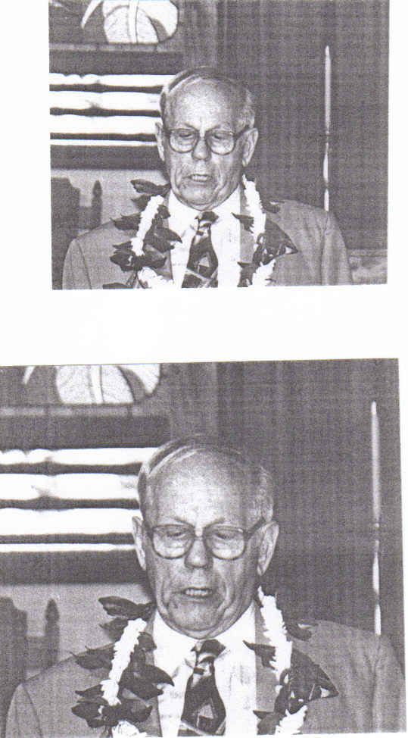
Lu Wagner. a TRI-V member since 1939, passed away on Friday March 21, 2008. Lu was 92 years young. He was cremated on March 26 and his ashes were sent to his daughter Wendy in Oakland, California to be scattered at Boc Tower in Florida and Burt Lake in Michigan at a later date. On March 7th Lu, who lived at the Oakbridge Nursing Center, fell in the elevator and hit his head knocking him unconscious. When found he was rushed to the hospital emergency room and required an operation to relieve the blood that was forming on his brain. After the surgery he suffered a stroke or seizure which left him paralyzed on his left side. His daughters Nancy & Wendy and son Carey flew from Hawaii & California to be with him. He remained in a coma so the family decision was made to transfer him to the Good Shepard Hospice Center as his wish was not be kept alive on machines. Lu remained at the hospice center until his death on March 21 where he passed quietly in his sleep.

Lu was a member of TRI-V for 69 years joining in September, 1939. He loved TRI-V and it was a very important part of his life. He was President for 3 terms (very few served more than 2 terms), Vice President for 3 terms, Treasurer and Secretary for 1 term each and Council for 16 terms. What an accomplishment. In 1948 Lu was responsible for introducing the pantomime show to TRI-V after he saw it performed at a comedy Club and thought it would be a good thing for the guys in TRI-V. It went over very well with the members and it also helped raise funds for the Club in the early years.
Lu joined many of the TRI-V activities such as baseball, golf, bowling (carrying an average of 170)
and card playing. He was also an avid hockey fan and played the game many times. I met Lu in the early 1980’s when I became a member of TRI-V. Lu was a great friend, mentor, and father-like
figure to me. He was always there for me when I needed him. He introduced me to the MultiLakes
Conservation Club which I am still an active member. We went deer hunting together at my cottage in Farwell, Michigan along with Bill Suchner and a few other TRI-V guys who hunted with us over the years. Lu loved being at deer camp with everyone. He also enjoyed fishing at Burt Lake where his cottage was located.

After Lu retired from UniRoyal Tire, he joined SCORE which stands for Service Corps of Retired Executives. Thru this organization he volunteered many hours helping business people in their daily endeavors of running a small business. He also volunteered at the Prison Correctional Services in Michigan and Florida. He devoted many hours of his time to inmates who were to be released back into the mainstream of life. He gave many seminars and many one on one sessions with inmates to help them get their life back on the right track. He worked with the prison chaplains to help bring the inmates to the Lord. This truly gave him pleasure. In one of his letters to me he said “ I find the prison volunteer program very rewarding and enjoy seeing the inmates make a positive life change for the better.” He was also involved with Angel Tree, an organization which collects gifts at Christmas time for children of inmates. Lu truly cared about people and he would give you the shirt off his back if you needed it.

Jan and I visited with Lu at Oakbridge in February. We all enjoyed seeing each other again and he seemed to be in good health at that time. We were so glad we took the time to be with him again and relive the days gone by. Lu was truly a great friend and he will be missed. If you would like to send cards to his children to show you’re Love and support for them at this time their addresses are listed below:

Nancy Wagner Carey Wagner
50 Halili Lane 2105 Hacienda
Unit 5 L Redding, California 96003
Kihei, Hawaii 96753

Wendy Wagner
4473 Reinhardt Drive
Oakland, California 94619

Cal Cashman

Book Club

Book Club will meet on April 7 at Victoria Angelosanto's at 7:00 pm to discuss "The Thirteenth Tale" by Diane Sutterfield. On May 5 book club will meet at Judy Lardin's to discuss "Like Dandelion Dust" by Karen Kingsbury. All members of TRI-V and friends are welcome to join us to discuss these books. If you've read a book that you think would be a good book for discussion, please let one of the regular members know. The regular members of book club are Victoria Angelosanto, Karlyn Gies, Sherry Kuhr, Ellie Connolly, Jacqui Schaefer, Peg Hoffman, Judy Lardin, Irene Bliudzius, and Renee DeOrtenzio. Others who have attended are Dolores McMillan, Donna Clingerman, and Glenda (Ellie's neighbor).

Michigan Anniversary Party Plans

71ST ANNIVERSARY CELEBRATION
Forty people attended the Anniversary dinner. There was good food, great conversation and outstanding entertainment. We listened to a four person jazz band while visiting with our fellow members. This party is always a great opportunity to visit and exchange news among the club.
It is a great way to welcome spring with this warm loving group. The highlight of the entire evening was.......the chocolate fountain. If you have never experienced enjoying such a treat do not miss next year as it may just return. Your Committee
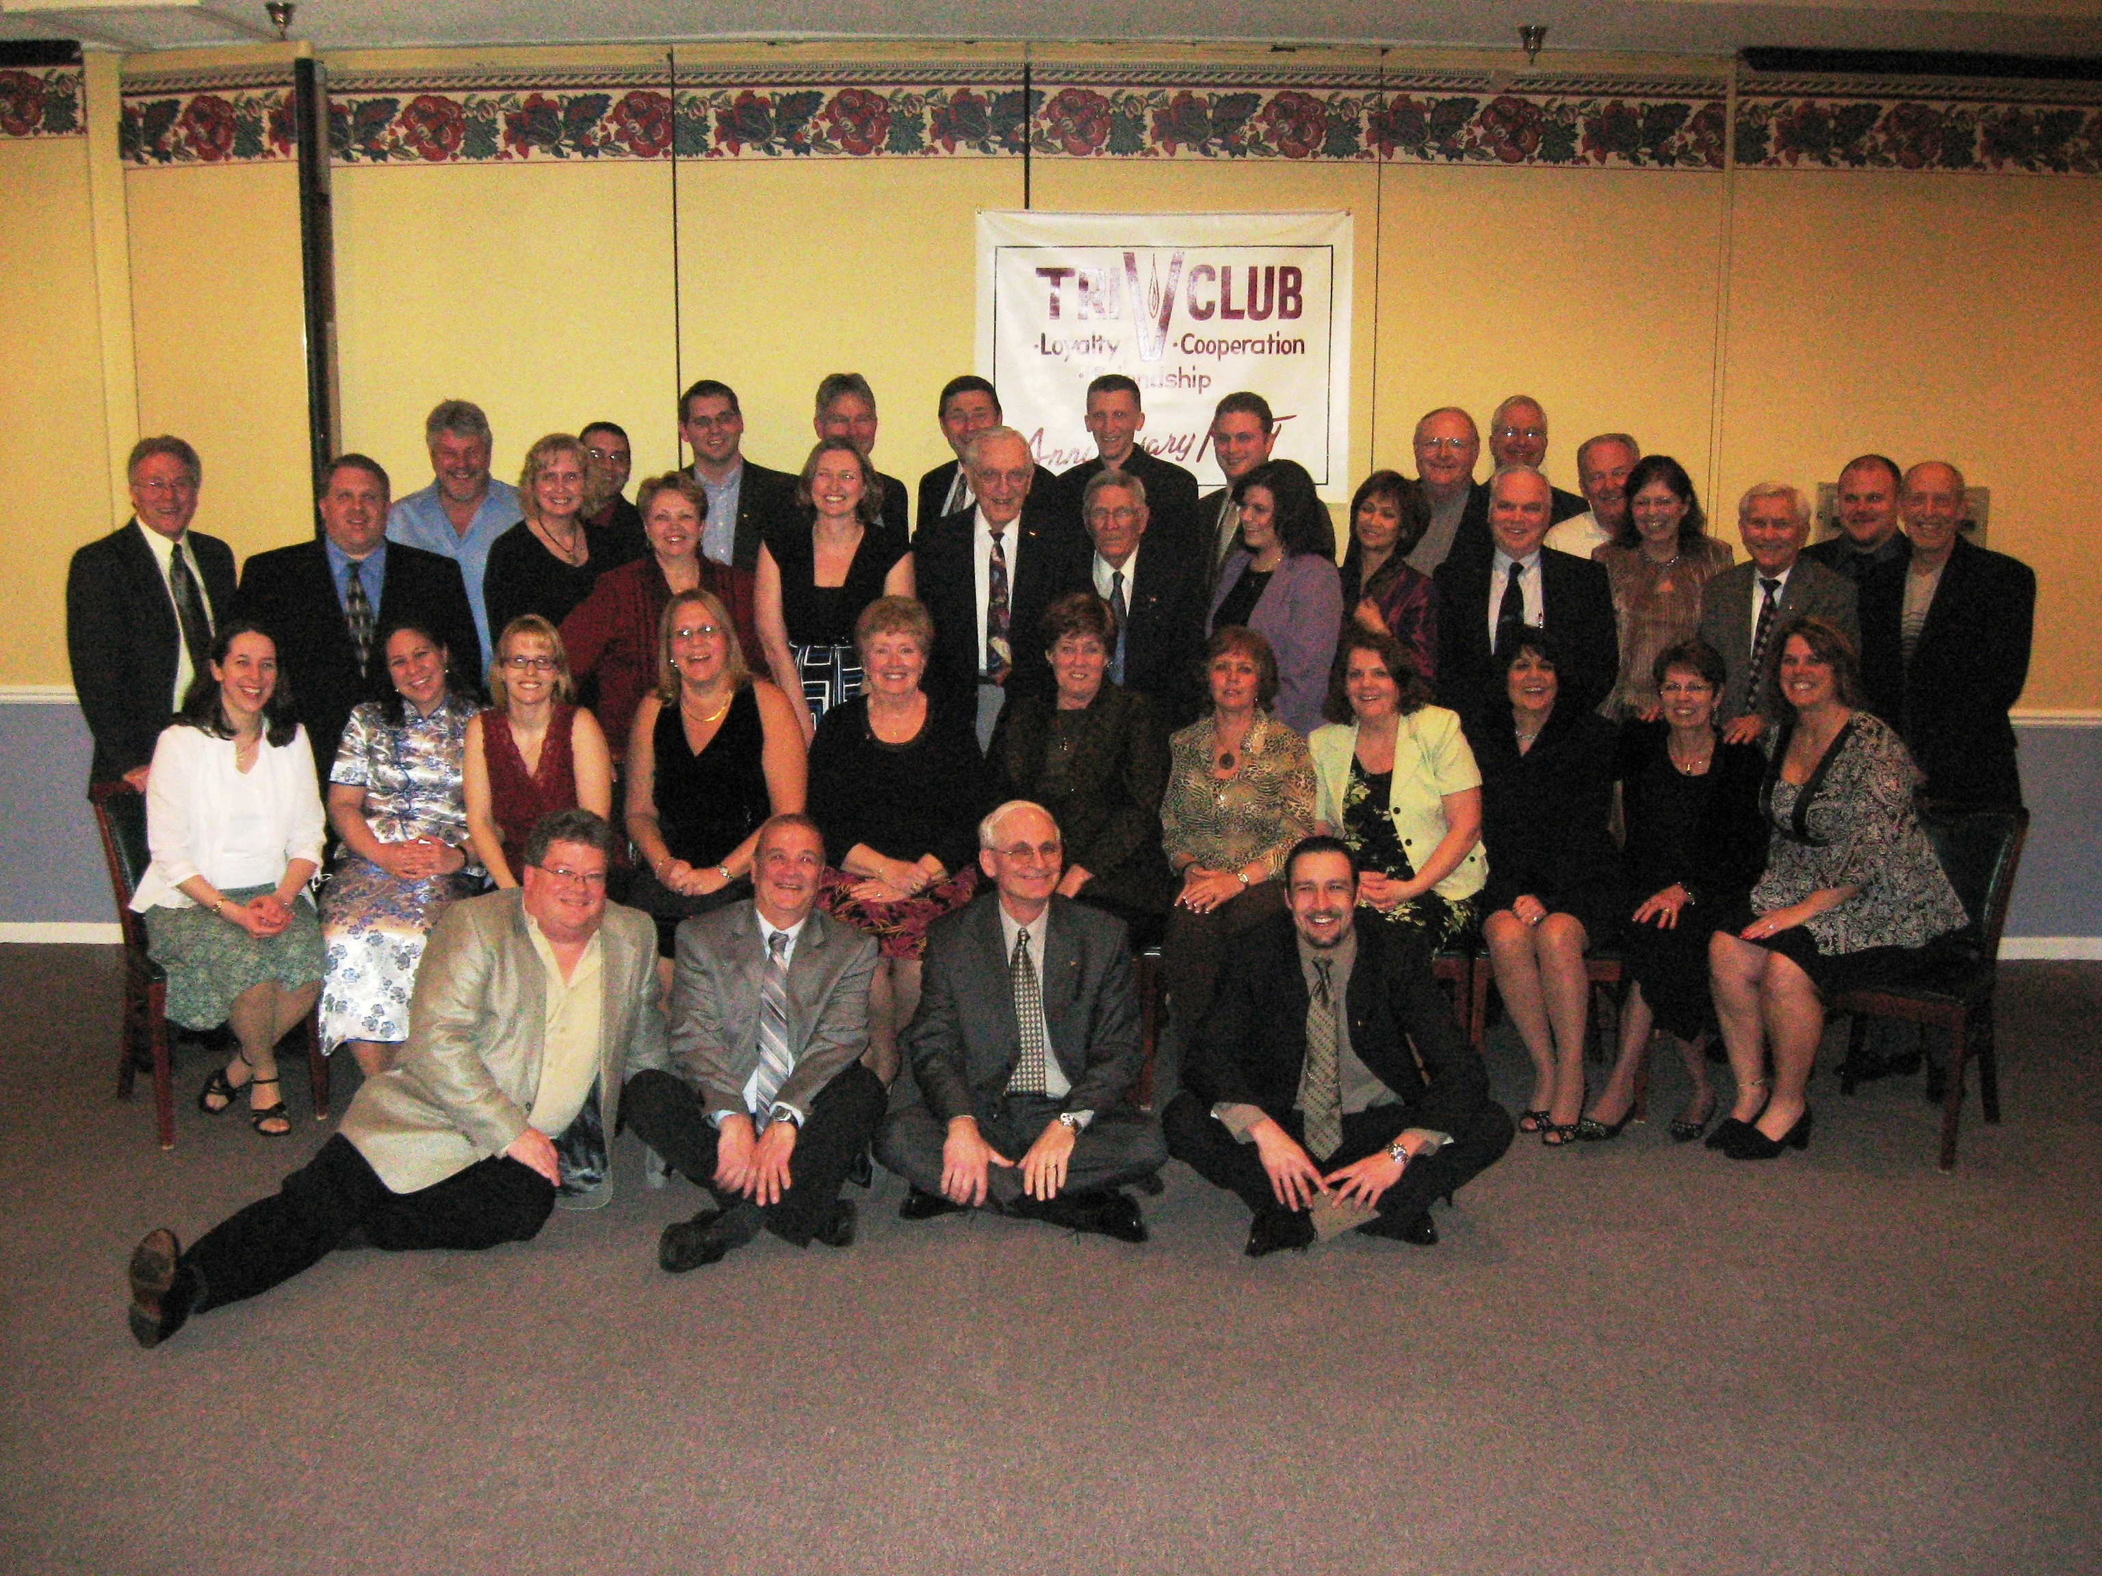
ANNIVERSARY GREETING

We would like to wish the TRI-V family a very happy Anniversary. We have enjoyed all the activities that the committees planned for 2007 and look forward to the upcoming events in 2008. It is a real joy to be part of such a wonderful organization. Cal & Jan Cashman

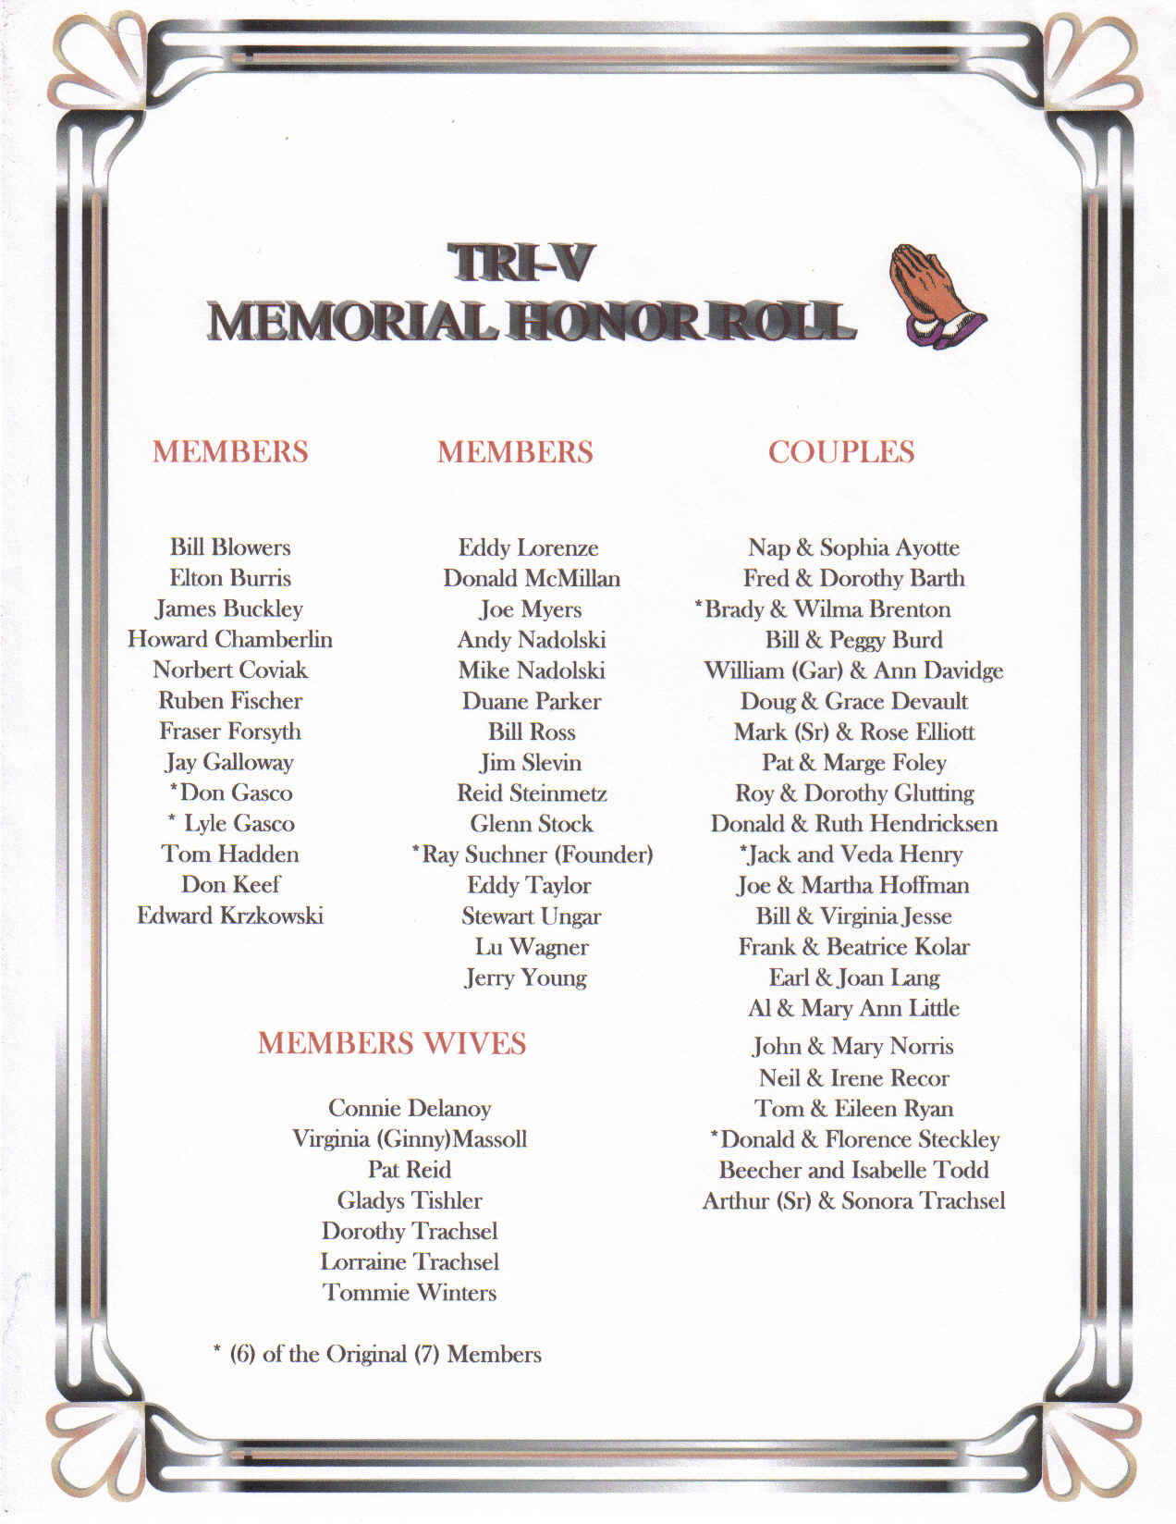

TRI-V GOLF LEAGUE

We plan to start the TRI-V golf season on Monday, APRIL 21. The basic rules will remain the same, although the prize money is increased to $60.00 ($30 per half). It would be helpful if you could let one of us know if you plan to play and if you will be in the prize money. Hope to see you all at Hickory Hills at 4:30 the 21st! Your Committee, Romas & Tom

May Open House
The Men's Open House will be held Saturday, May 10 at Gateway Golf Course, Romulus. The course is located 1/2 mile west of Merriman off VanBorn Road. If you are interested in playing and/or bringing a guest please contact Nick at (734) 522-5366 or victoriadominic@yahoo.com. I have not heard from any members that weren't at the March meeting. Please let me know your intentions.

JUNE INITIATION/SOCIAL

June 6th, Friday, the TRI-V Club will have our annual initiation of new members if so needed; otherwise we will have a social evening. The event will be held at the Speakeasy, the same location of our local meeting. More information will follow at the April meeting and the May issue of TRI-V Umph. We want all to know that arrangements have been made to play golf that Friday, June 6th, at Gateway Golf Club, Romulus, on Van Borne Road west of Merriman. John Lardin has arranged to have 4 tee times, starting at noon, for 16 players. The rate will be the “Senior Rate”, $26 for 18 holes of golf and cart. Please let the Committee know if you will be attending golf and/or the evening event. The Golf Course has to be notified by June 1st if we have to cancel any of the tee times. The Committee, Romas Bliudzius, Lee Anderson

Meet Dave Burke

Tri V has a new Prospective member Dave Burke. Dave grew up in the Flint area and went to Western Michigan University where he graduated in engineering in Dec 2004. After graduating Dave bought a house in Livonia and went to work for Johnson Controls in Plymouth Mi. Dave currently is working for Global Technology & Assoc (an automotive supplier for Toyota) located in Ann Arbor. Dave plays softball and he is on 1 of the 3 Tuesday night Tri V bowling teams (the team made up of the young Tri V members). Dave also enjoys golfing and he was a regular last year on the Tri V league. He went on the golf weekend and he has also attended many of the recent Tri V events. Dave will be a great asset to the club. Jay Trachsel

New Tri-V Shirts

We will be ordering new shirts in April. They will be a pique, poly blend shirt; not the heavy all cotton ones. The members decided on an ash colored shirt with a black, embroidered logo. The cost is $15.00 plus tax, anything over an x-large size will be $2.00 more per shirt. Checks are to be made out to Terry Connolly. This is a unisex shirt. So the women can order also. They come in sizes s, m, l, xl, 2x and 3x.

Eastern Market Trip

Marian Anderson (248) 318-3379 is inviting Tri-V women to join her on a bus trip to the Eastern Market, May 10 for Flowers, lunch and if interested a casino visit. The bus will leave Walled Lake at approximately 9:00 a.m. and return at approximately 4:00 p.m. There is a cost of $5.00 per person
.
Please call Marian for more information and to reserve your spot. Seating may be limited.

Shower of Love

Sophia Ayotte's daughter, Carolyn Haselwood, is again sponsoring the "Shower of Love" baby shower charity event. This will be held Thursday, May 8 at Monaghan K of C, 19801 Farmington Road, Livonia. I will not be able to attend this year, but will be happy to help a group reserve a table.
Victoria Angelosanto

Steak Roast

Save the date of August 9 for the Tri-V Steak Roast which will be held at Gunnar Mettala Park in Wixom. See you there—Cal Cashman & Committee

Tri-V Picnic

The Tri-V Picnic is to be held on Saturday July 26th at Gunnar Metallic Park in Wixom. Details will follow.

Trifles

From the Schaefers
Thank you for all your interest and concerns about our daughter who has recently moved to Japan. I am happy to say she is doing very well but our 4 1/2 year old granddaughter is having some big adjustments. We plan on visiting the middle of May and the time cannot get here to quickly.

From the Dominic Angelosantos
Vickie Angelosanto will be in AZ May 6 to 14. She is going to be visiting her mom who is rapidly showing the signs of Alzheimer's. Even though her mom needs some supervision, because she is very forgetful it should be a good trip as Vickie's sister wrote in an email: "Mom is a super neat, nice and a fun person and I really think you will enjoy her when you are here!”

From the Connollys
We left Sunday Feb 24 and arrived at Dusharys’ Monday night. Art and Kathy are great hosts. We enjoyed four great days with them in their new condo in Ocala. We all golfed and Ellie managed to beat me on two holes. We arrived at our rental unit in Ft Myers on Mar 1st. Lee and Marion picked us up for church (they ask parishioners to bring their own palms on Palm Sunday) and dinner at their house. Our places were only about 1 1/2 apart. We went on a bus trip together to Hard Rock Casino in Hollywood Fl. We were winners. Marion fixed a terrific Easter brunch. We were amused by their Park musical production in which both Lee and Marian participated. We were also treated to Marian's famous pulled pork sandwiches. Most of our time was spent at the park swimming pool and the area beaches. We also went to the Edison & Ford winter homes. Ellie's birthday was celebrated with cocktails at Anderson's and a nice restaurant dinner. We were also joined by Gies, Hoffmans. We had a game of hand and foot and Key lime pie for desert. Wutkas spent a rainy Saturday with us and taught us how to play bid euchre. Then the tri v clan of Reutniks, Bill Trachsels, Gies, Hoffmans, Andersons, Wutkas, Connollys went out for another great dinner, preceded by cocktails and hoers devours at the Anderson's party house. Gieses went deep sea fishing with us on a perfectly calm, sunny day. We caught some some groupers (pretty but not keepers), and lots of grunts.
While Tim was waiting for the fish to be cleaned, a pelican stole his biggest fish right out of the bucket. We also visited our son Terry from Miami. He met us in Hollywood for a nice dinner and stroll on the beach. Terry's niece Pam is touring with the musical the Jersey Boys. It's the story of the "Four Seasons" (Sherry Baby). Pam is in charge of wardrobe. She arranged for excellent front center seats at the Tampa Performing Arts Center. Andersons and their out of town guests also came. Terry and Ellie met Terry's sister and her husband for dinner before the play. Pam gave us a back stage tour. Ellie's brother and sister-in-law live year round in Englewood. We took a day trip to visit them where we were served a delightful pasta lunch and antipasto salad. Then we went to the art gallery where Jan has her original jewelry and art work on display. We would love to do this again next year.

From the Clingermans
John and I had a fun two week trip down the Atlantic coast, visiting friends and family. Not beach weather, but lots of sun and definitely warmer than Detroit. We combined fun with “business”. The business being: what city do we want to retire to some day? Charleston, SC is my favorite city. We stayed at a gorgeous Victorian Bed & Breakfast, Two Meeting Street Inn, which is right on Battery Park and the river. If you know about my love of antiques, you know I was in heaven. We took the Garden Tour walk and got to see behind the fences of the big beautiful old homes. Unfortunately, we didn’t like the retirement communities there. We then moved on to Savannah, St. Simons Island, and Jacksonville FL. Jacksonville feels like home since we have friends and family there. So, we shall see. In the meantime, it’s sure fun looking. Spring is almost here and we made it through another winter.

From the Gies
Tim and Karlyn Gies left on March 1st for a month of exploring 55+ communities. They spent one night with daughter Lisa and family in PA and after finding a place on Sunday morning to buy a new tire were on their way to look at Del Webb communities in North Carolina near Raleigh, Charlotte NC, stopping on the way down to Sun City Hilton Head at a couple of places then spending four days with brother Dave in Sun City. On to The Villages for a week stay. They gave us all kinds of freebies like golf, movies, lunches, dinners. Needless to say we had a ball and hated to leave. But off to Top of the World to visit with the Dushary's for four days checking all the places along the way. Then on down to N. Ft. Myers for a two week stay at Bill and Onallee's. Got together with several Tri-Vers while there, The Hoffman's, Connolly's, Anderson's, Ruetenik and even Wutka's. In fact one night we all went out to dinner and there was 14 of us. Thanks to Anderson's for hosting the cocktail party before dinner. We all had time to catch up. It was a great month and Karlyn got a lot of decorating ideas for all of the wonderful models they looked at. It looks like we have a place for next March booked that is in a complex five minutes from Bill and Onallee. Counting the days already. Tim and Karlyn will be grandparents for the seventh time this coming October as daughter Tracey and her husband Nick are expecting their second at that time. Also both Tracey and Nick graduate from U of M with their MBA's on April 25th. Nick Katcherian (son-in-law of Tim & Karlyn Gies) traveled to Uganda Africa in March for one of his Masters Classes. He says it was an eye opening experience. He kept saying these people have nothing and yet they are happy. John Sponsky (son-in-law of Tim and Karlyn Gies) traveled to Sweden in March for his company Volvo. This was his first trip but will likely be going at least one a year. It was tiring but certainly something he enjoyed. Bill and Onallee had a flood in their home while Tim and Karlyn were there. The toilet in the guest bathroom overflowed into several rooms and was deep enough to be over the tops of Tim shoes. Insurance was called and they provided about six huge dryers to dry out the plywood flooring after ripping up the carpet and tile. All got dried out and the check has been insured by the insurance company. Looks like Onallee will get to remodel with new tile in the kitchen and bathroom and new carpet throughout the house just in time for the visit of Jeff and Karen in June. Bill and Onallee will be home in the middle of May.

From the J. Lardins
Once again Judy and John Lardin were on the road again, or should say in the air again. They returned from their visit in Texas to make a trip to Illinois to spend Easter weekend with Judy’s Mom. While they were gone it snowed in the Detroit area. That made 4 trips out of town since January and 4 snowfalls here while they were gone. The trip made if possible for Judy to start making arrangements for what was supposed to be a surprise 85th birthday party for her Mom that is now just a party to be held Memorial Day weekend in Illinois. Everything seems to be falling into place and hopefully there will not be any snow for this trip. Judy’s Mom and next door neighbor will be coming in the weekend of April 12th to attend a wedding of a friend in Southgate. The trip will be quick as they will arrive on Thursday evening and return home on Sunday. The next trip for a Judy and John will be to Corpus Christi Texas the weekend of April 20th. Granddaughter Christine will be performing during the Corpus Christi Hooks baseball game. The Hooks are a minor league baseball team affiliated with the Texas Rangers and there is a good chance that she will be able to perform with the team mascot. With Judy’s Mom birthday party in March and Mike and Bev’s wedding in Florida in June, it looks like July will be the first month since last September that they will be home for the entire month. Judy thought that her retirement would be a time of rest and relaxation. Someday it might be.

From the W. Trachsels
Bill and Michelle Trachsel are very excited to announce that they are expecting. The couple's second child is due to arrive at the beginning of October. Julia is also starting to understand that there is a baby on the way. She keeps asking her mommy if she can see the baby and give it kisses. Realizing their need for more space, Bill and Michelle have put their house up for sale. If you or anyone you know is looking for a great three bedroom ranch in Warren give them a call.

Editor’s Note:
Dory Gasco’s newsletter keeps coming back that she has moved with no forwarding address. Does anyone have any information on her? If so, please contact me. If I don’t get any information I will discontinue her newsletter.

From Babs Wagner
Car for Sale 1990 Honda Civic, Black, 80,000 miles, $3750.00 or best offer 248-476-0979

Calendar of Events

April May
5th Final Pinochle 5th Men’s Golf
Westland Amvets Hall 5th Wives Book Club
9th Men’s Club Mtg. 10th Men’s Open House Gateway Golf Club
16th Wives Club Mtg 12th Men’s Golf Babs Wagner Home 19th Men’s Golf
21st Men’s Golf Starts 21st Wive’s Spring Dinner
28th Men’s Golf Brass Pointe Food & Spirits
26th Men’s Golf

April Birthdays May Birthdays
3rd Judy Lardin 1st Dominic Angelosanto
7th Curt Martin Jerry Gies
13th Dorothy Suchner 6th Onallee Trachsel
16th Annmarie Angelosanto 7th Bob Wendt
23rd Brian Trachsel 8th Karlyn Gies
25th Marion Anderson Jan Cashman
28th Steve Trachsel 14th Sherry Steinhauer
18th Susanne Martin
April Anniversaries 19th Bud Massoll
4-22-72 Brian & Jane Trachsel 22nd Donna Clingerman
May Anniversaries 23rd Liz Trachsel
5-9-69 Ken & Katie Stress 24th Susan Dunham 5-11-02 Geoff & Sherry Steinhauer
5-14-71 Dominic & Victoria Angelosanto

MEMORIES FROM THE APRIL1998 ISSUE OF TRI-V UMPH

A review of the April 1998 issue of TRI-V Umph found most Members and their families in good health. The one exception was Pat Reid who despite valiant efforts by her Doctors was unable to stop the infection from spreading in her leg and it became necessary for them to amputate her leg above the knee. Art Trachsel had a basal cell carcinoma removed from his nose. An MRI showed there was only fluid on the hip joint and could be reduced through special exercise and letting time take its course. Dottie Wagner’s neck therapy was giving her some relief but still coping with much discomfort and restricted arm movement. Ray and Bill Suchner and Lu Wagner had a tornado hit within two blocks of their homes in Nalcrest and Fedhaven and suffered being without power for two days. Fortunately there was no damage done in their buildings but some homes were destroyed within a couple of blocks. Bob and Peg Wendt wanted a little more room so they purchased a doublewide place at Forest Lakes Estates in Florida with a the location right on the lake. Ellie and Terry Connolly were returning to the local area after Ameritech’s decision to close the Lansing branch Cal and Jan Cashman spent the first part of February in Cozumel, Mexico attending the wedding of Jan’s son, Matt Newton, overlooking the ocean. The TRI-V Wives Spring Dinner was to be held at Montana’s Steak and Seafood House in Westland May 20th. There was no initiation to be held this year so the Club voted to have a June Social at Bogie Lake Golf Club on June 5th. There was golf in the afternoon followed by a fish dinner and socializing late into the night. There were thirteen TRI-V Couples attending the Florida Anniversary Party the end of January in Venice Florida. There were 34 TRI-V members and their family in attendance at the 61st Anniversary Party held at Genitti’s Hole in the Wall. Sadly none of the incoming officers were able to attend the function to be formally installed for the coming year. 36 Members and friends attend the Whaler Hockey Outing in Plymouth in February. After 6 months of Pinochle the final standings had Ken Plocharczyk in first with 152.5 points, Judy Lardin in second with 151.5 points and Nick Angelosanto and Joan Fischer tied for third with 151 points.

MEMORIES FROM THE APRIL 2003 ISSUE OF TRI-V UMPH
One of the unpleasant things of doing the Memories is when I have to tell of one of the passing of one of Family. This was the case with the passing of Ruth Hendricksen, wife of former member Don Hendricksen. Lu Wagner’s knee replacement was healing nicely. He is ble to drive again and had three more weeks of therapy to go. Lorraine Trachsel suffered another cellulites infection on her right leg. The other two had been on the left leg but this one was the worst of the three. She received intravenous antibiotics and was instructed to stay off of them for two weeks and seemed to be responding to the treatment well. The Club welcomed our three newest Prospective Members, Dion Angelosanto, Michael Trachsel and Matt VanHollebeke. Dion Angelosanto had his gall bladder removed the first part of April. All went well and because of his age and being in good shape the recovery should not be a problem. Terry and Sue Dunham were able to go to Las Vegas for 4 days and this was the first trip to “Sin City” for Sue. Her reaction? “Oh, the pastries! Oh, the buffet! Oh my feet as I tried to walk it all off.” John and Mike made a quick trip to San Antonio to visit Kim and Larry and of course play some golf. Judy stayed home and found out what it was like to be a “Grandma” as she babysat Bella. Judy did survive this first time experience even though she did panic some when Bella had a case of the hic-cups that Judy could not stop. Now that the number of grandchildren for Judy is at eight and soon to be ten John thinks it is safe to say that she has mastered how to be a Grandma.” The Wives Club Dinner was set for May 21st at the Olive Garden in Livonia. May Open House was set for May 10th at Hartland Glenn Golf Course. June Initiation/Social was set for June 13th at the Crystal Lounge. The Girls Weekend was to be the weekend of August 8th at Sauder Village near Archbold Ohio The Anniversary Party was held at Montana’s Restaurant with 54 Members and guest in attendance. The entertainment for the evening was a traveling theatre group performing the Neil Simon’s The Odd Couple Female Version. The Men’s Final golf was set for the weekend of August 22nd in Gaylord and Couples Final Golf Weekend set for September 13th, the site not determined yet. Pinochle Standings after 6 months of play had Jane Trachsel winning with 144.5 points, Lou Koewler in second with 141 points and Vickie Angelosanto third with 140 points. This wraps up another trip down Memory Lane. Once again as we read this issue of TRI-V Umph there are articles about Judy and John traveling. It was reported in the 2003 issue that John was still working at Northwest but had made a trip to Texas in January, February and March. You have to wonder if he was ever working there. As I typed these memories, I read about Lu Wagner’s youngest daughter, Wendy, flying up to Alaska with her women’s hockey team, daughter, Nancy, also had knee replacement about the time Lu did. I only mention this because this morning I attended a Memorial Service for Lu who recently passed away. It was my first chance to meet Wendy and Nancy and Wendy is still playing hockey with her women’s hockey team. At the Memorial Service we heard of Lu’s likes, pleasures and what life meant to him and what he meant to his family as well as to TRI-V. There were memories shared by his daughters, son, Cal Cashman, Bud Massoll and Earl Tishler.
To those who did not know Lu it gave a chance to find out something about this “special” person. Let all of us learn something from this. Take the time to share your memories, your thoughts, with you children, our parents, family members as well as friends. Give the grandchildren a chance to ask “Grandma did Mommie or Daddy really do that when they were small?” Life is short, break the rules, forgive quickly, kiss slowly, love truly, laugh uncontrollably and NEVER regret anything that made you smile. Until we see you in print next month, the Good Lord willing, take care of one another.

