
Loyalty Tri-V Umph
Cooperation February 2008
Friendship

President-J. Clingerman-248-788-1378 Sec.-D. Angelosanto-734-422-3501
V. President-M.Trachsel-586-484-0836 Treas.-J. Steinhauer-734-459-4471

President’s Message

Last week I got a phone call from George Hoffman. He was so kind to call me from the Florida anniversary party. I think his main purpose was to let me know how great the weather was, but it was still great to hear from George.

This past month the February event was at the DIA. For the people who did not make it, they missed a great afternoon and evening. I must admit I was apprehensive about going to an art museum. But the DIA has done an amazing job at making art viewing very entertaining. My hats off to the committee (Brian and Eric) for scheduling something different for our club.

March is anniversary party month. As George told me, the Florida group had a great turn out and there should be a good turn out for the Michigan group. Only three new counsel members will be introduced at the Michigan party since the current officers are just finishing up the first year of their two year term. This party is always a good time to thank all the members for their help. And all of our members are needed to support making our club successful. That includes the little thing like paying your dues on time, making a full report after an activity is completed, and having all members on a committee supporting their committee chairman. These little things make our club work and keep the work load evenly divided, as it is intended to be.

March is also the transition month. We say goodbye to Pinochle and hello the golf. Even though with snow still on the ground it is hard to imagine we will be playing golf in about one month (I hope).

Happy Anniversary Tri-V!

John Clingerman

Tri-V Wives Club

March’s meeting will be hosted by Dolores McMillan at her home on Wed., March 19. April’s meeting is scheduled for April 16 and will be hosted by Babs Wagner. The meetings start at 7:00 pm. All women of Tri-V are invited and we welcome new members.
Book Club

Book Club will meet on April 7 at Victoria Angelosanto's at 7:00 pm to discuss "The Thirteenth Tale" by Diane Sutterfield. On May 5 book club will meet at Judy Lardin's to discuss "Like Dandelion Dust" by Karen Kingsbury. All members of TRI-V and friends are welcome to join us to discuss these books. If you've read a book that you think would be a good book for discussion, please let one of the regular members know. The regular members of book club are Victoria Angelosanto, Karlyn Gies, Sherry Kuhr, Ellie Connolly, Jacqui Schaefer, Peg Hoffman, Judy Lardin, Irene Bliudzius, and Renee DeOrtenzio. Others who have attended are Dolores McMillan, Donna Clingerman, and Glenda (Ellie's neighbor).

Tri-V Anniversary Party-Florida
On Sunday March 2nd, 24 folks gathered at the Hampton Inn in Ellenton, Florida just north of Bradenton. Actually there were 25 there but Diane Plocharczyk, after dropping her Dad, Art Trachsel, off left at 3:30 for Tampa and a return to frozen Michigan. As the group got larger we had a party room and everyone got comfortable with a “toddy" and there were at least 15 conversations going at one time. At about 4:30, everyone headed over to the "Roaring Twenties" where everyone bought their own meals & drinks. We set on padded benches and enjoyed music from the huge Wurlitzer organ as it came rising up out of the floor. Shades of the Fox & Michigan theaters of the 30's & 40's. The organist was excellent and acknowledged our group & our anniversary. Most people stayed for 2 or 3 segments before returning to the hotel, where some card games got gong. Some left to go back home that night. The rest enjoyed a complimentary breakfast the next morning before heading home.
A "Russian" election was held and Lee Anderson & George Hoffman will plan next year's event.
Those in attendance were: Terry & Ellie Connolly, Lee & Marian Anderson, George & Peg Hoffman, Dennis & Marlene Wutka, Bob & Peg Wendt, Art & Cathy Dushary. Jim Delanoy & Doris Mclean, Dave & Geri Ruetnik, Dorothy Suchner & her oldest daughter, Barbara, & Barb's husband, Don, Bill & Shirley Suchner, Bill & Onallee Trachsel, and Art Trachsel.
Committee: Bill Trachsel, chairman, Bill Suchner, Art Trachsel

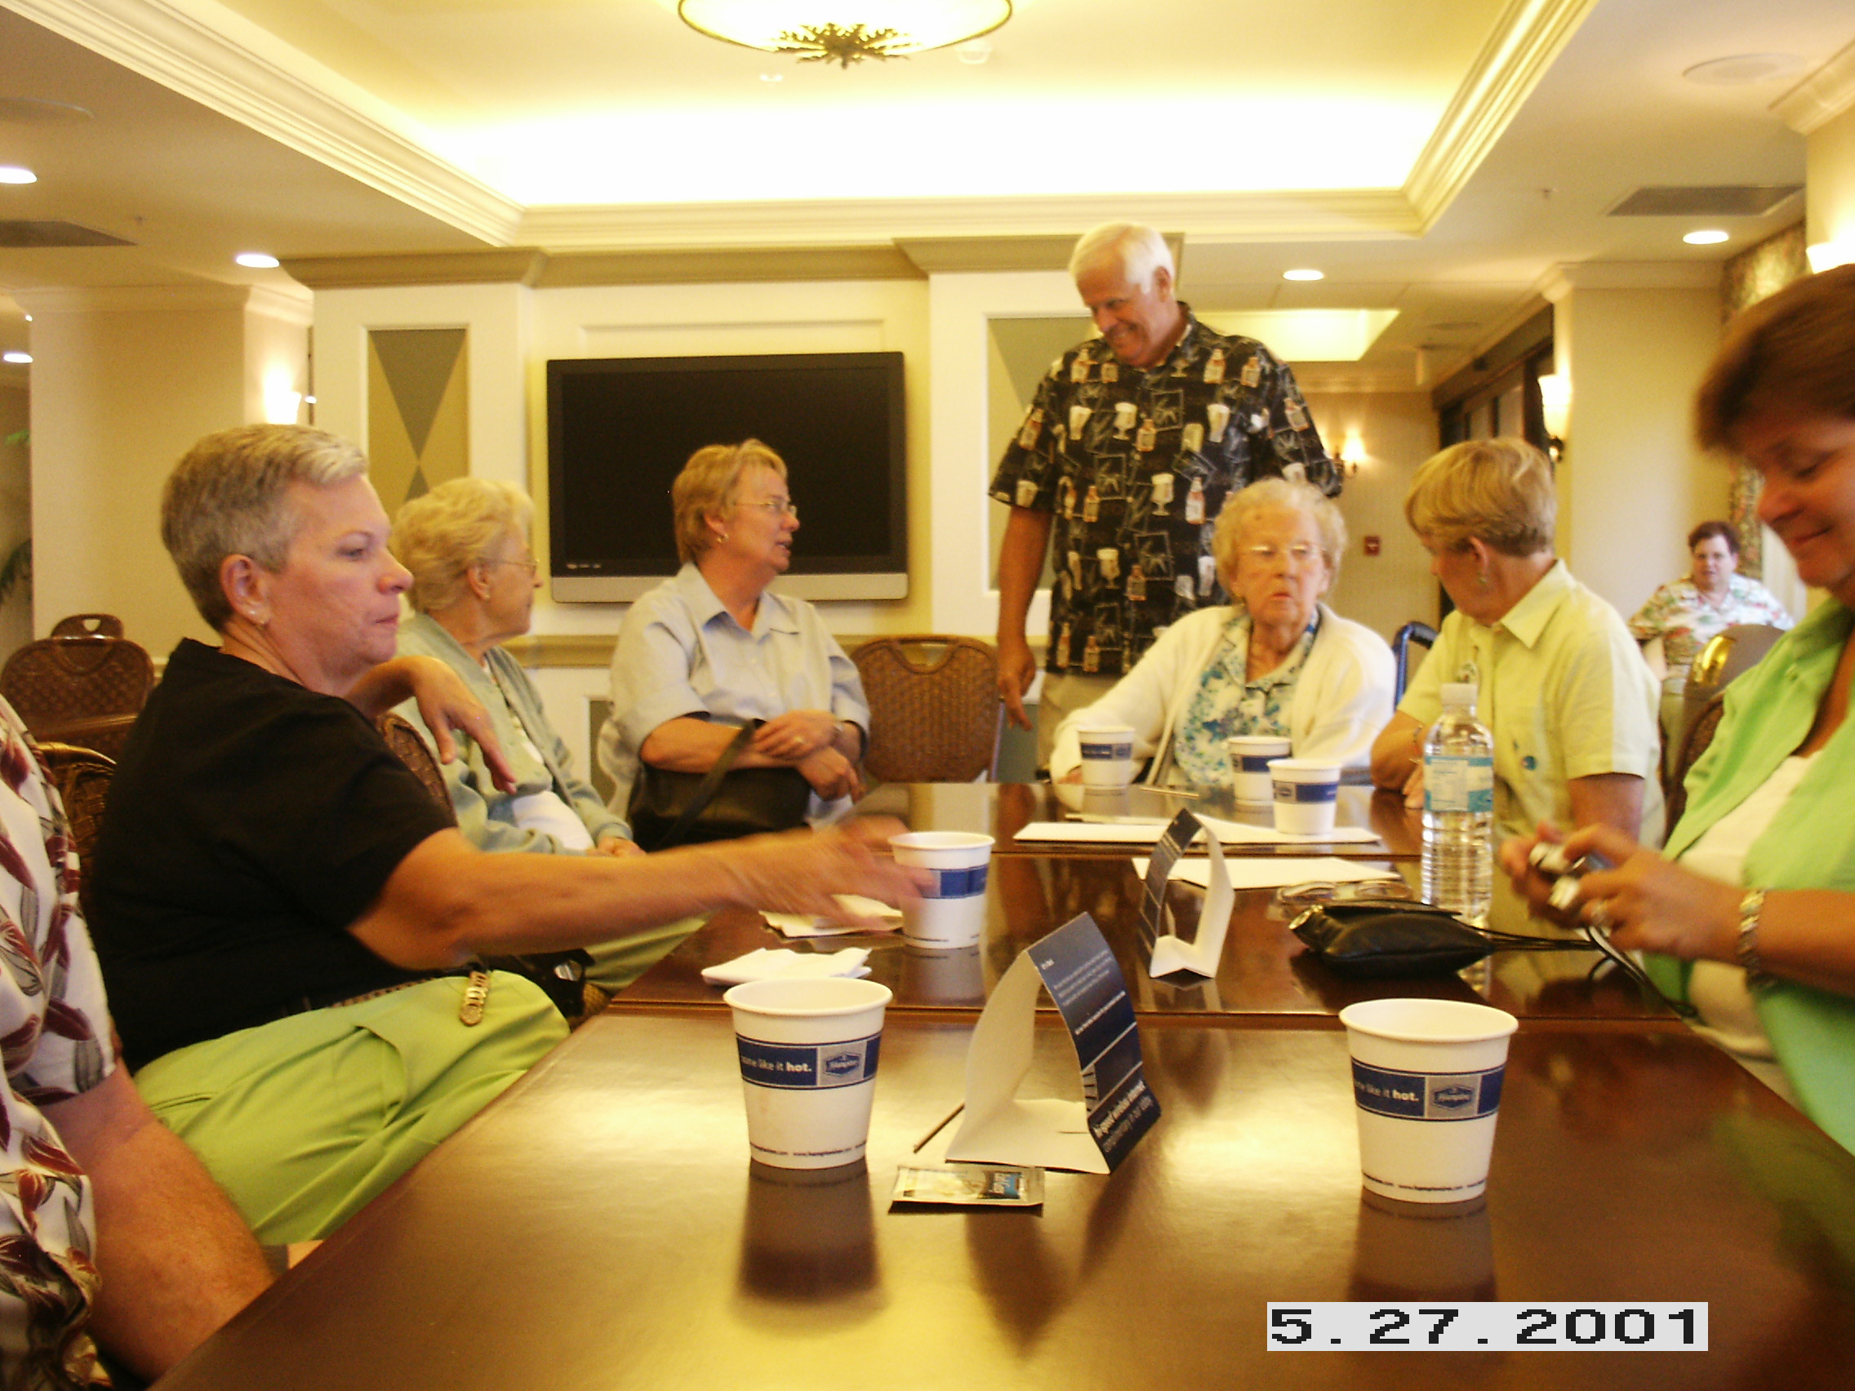
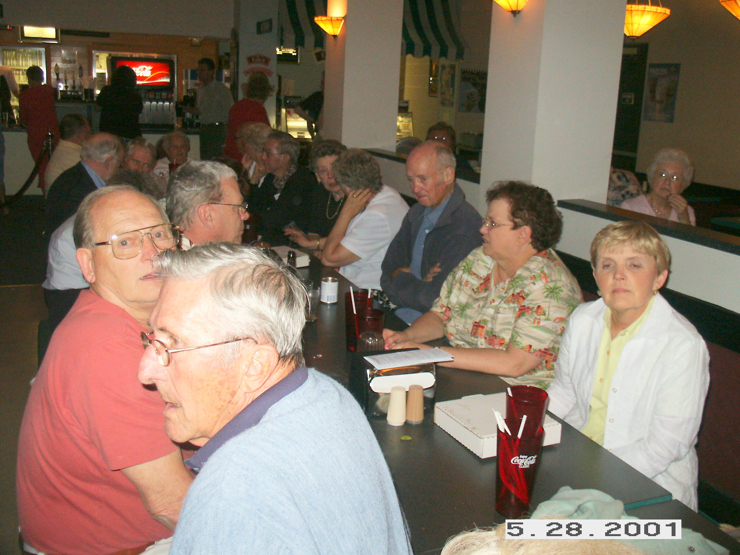

Michigan Anniversary Party Plans

71ST ANNIVERSARY CELEBRATION
Come join us on Saturday, March l5th at 6:00 at the Maples of Novi, located on 14 mile road between Novi Rd. and M-5. Dinner, of Beef, Fish, and Chicken, will be served at 7:00. It will be a night to celebrate with yummy food and entertainment. The cost is $15.00 per person. Please call Jack at 248-349-7359 if you are attending. This is a celebration you will not want to miss. Come one come all for a good time, good food, good friends and cash bar for your libation. See you there for a fun evening! Your committee.

ANNIVERSARY GREETING

Happy Anniversary TRI-V!! Seventy-one years young and still going strong. The memories and friendship that have been formed from this wonderful organization can never be duplicated anywhere else. Think about it! We are not just a social organization but a true family of different backgrounds and jobs coming together to be there for one another. We feel so honored to be a part of this special family. Again Happy Anniversary! Judy and John Lardin

May Open House
The Men's Open House will be held Saturday, May 10 at Gateway Golf Course, Romulus. The course is located 1/2 mile west of Merriman off VanBorn Road. If you are interested in playing and/or bringing a guest please contact Nick at (734) 522-5366 or victoriadominic@yahoo.com.

Pinochle

March Pinochle at the Cashmans
We were happy to host Pinochle at our house on March 1 with our guests, John & Donna Clingerman, Brett & Lynn Barnes, Jack & Jacqui Schaefer, Ken & Katie Stress, Blondie Forsyth and Bud Massoll. We enjoyed snacks and conversation for about an hour and then proceeded to dinner which consisted of a spiral cut ham, green bean casserole, mashed potatoes and gravy, rolls and wine. The dessert was brownies with ice cream. Let the cards begin! We would like to say the cards were great for all but as usual that was not the case. The highest score for the evening was Cal with 24 points followed by Blondie and Jack in a tie with 23 ½ points. We all had a good time with lively conversation but the cards stayed pretty quiet for the most part. We really enjoyed the group we had and look forward to next season.

Final Pinochle
Final Pinochle will be held Saturday, April 5, at the Wayne AmVets Hall. The AmVets is located at 1217 S. Merriman Rd, Westland, MI. The cost is $18.00 per person, somewhat less for members. The doors open at 6:00 pm. Dinner is at 7:00. As always, NO PINOCHLE will be played. We will expect each Pinochle player, whether regular or sub, to attend unless you notify the committee. All others are welcome and encouraged to attend. Please let the committee know so that we can get an accurate count for dinner. We have plenty of room for all. The evening will include a buffet dinner and an OPEN BAR. Yes open bar. There will be some sort of activity, yet to be determined. Plan to attend. Brian Trachsel, Bob Kuhr and Tim Gies
February Social

On February 23, 2008, 31 of Tri’s best and brightest (you know who you are) attended the Detroit Institute of Arts for a docent (expert guided) tour. We arrived at 4:00 pm for an expected one hour tour. We were broken up into three different groups, and each group went to a different floor to begin the tour. The guides were very knowledgeable and made the hour fly by. Each groups tour went longer than an hour, and the people I spoke to thought it was still far too short. I think all that attended really enjoyed the DIA. After the DIA most of the group was able to find McNally’s restaurant where we meet for a LARGE tasty sandwich. Thanks for the recommendation, Tim. Since McNally’s closed at 5:00 pm and stayed open just for us, we had the place all to ourselves. Only one of us took advantage of the option to bring our own beverage. My wine was very good. The evening was a big success and many people expressed interest in going again sometime.—Brian Trachsel

New Tri-V Shirts

We will be ordering new shirts in April. They will be a pique, poly blend shirt; not the heavy all cotton ones. The members decided on an ash colored shirt with a black, embroidered logo. The cost is $15.00 plus tax, anything over an x-large size will be $2.00 more per shirt. Checks are to be made out to Terry Connolly. This is a unisex shirt. So the women can order also. They come in sizes s, m, l, xl, 2x and 3x.

Eastern Market Trip

Marian Anderson (248) 318-3379 is inviting Tri-V women to join her on a bus trip to the Eastern Market, May 10 for Flowers, lunch and if interested a casino visit. The bus will leave Walled Lake at approximately 9:00 a.m. and return at approximately 4:00 p.m. There is a cost of $5.00 per person.
Please call Marian for more information and to reserve your spot. Seating may be limited.

Steak Roast

Save the date of August 8 for the Tri-V Steak Roast which will be held at Gunnar Mettala Park in Wixom. See you there—Cal Cashman & Committee

Trifles

From the Cashmans
Cal & I decided to get away from the cold weather in February and went to Florida for a week. Definitely not enough time away but we enjoyed every minute of it anyway. When we left on February 6 (Wednesday) it was snowing and very cold. When we arrived in Orlando it was 78 degrees and the sun was shining. What a difference 2 ½ hours make! We went to the Epcot Center at Disney World on February 7 (Thursday) and spent the whole day. So much to see and the evening fireworks were spectacular. Friday morning we went to the “Money Show” in Orlando which Cal really wanted to see as he subscribes to various financial brochures from them. It was very interesting and there were tons of people there just enjoying all the booths and information available. After about 3 hours there we drove to Lakeland to visit with Lu & Dottie Wagner and Dennis & Marlene Wutka. Both couples were glad we took the time to stop and see them. We stayed the night with the Wutkas’ and left the next morning for Tampa after having breakfast at the local restaurant. We spent the next 2 days with Cal’s brother Doug and his wife Lori who live in Palmetto just south of Tampa. We had not been to their home in about 5 years so we really enjoyed the visit. On Monday morning we left their place and drove to Ft. Myers to visit with Lee & Marian Anderson. They took us to Sanibel and Captiva Island as we had never been there before and we had lunch at a lovely little restaurant called the Bubble Room. We also stopped at one of the beaches on our way back and walked part of the beach looking for shells. We left the Andersons’ on Tuesday morning and headed back to Orlando. Tuesday afternoon we went to the MGM studios at Disney World as we had never been to that part. It was a rainy day but still warm. Wednesday we spent part of the morning going to the Disney Marketplace strolling around and eating Ghiradelli ice cream cones and anything else that looked good before we had to leave for the airport. It sure was hard to get back on that airplane when the temperature was 80 and Detroit was 20!! Terry Connolly picked us up at the airport and brought us home. Thanks Terry, we appreciated it. We had a wonderful but short time and enjoyed seeing our TRI-V families and where they hang their hats in the winter time.

From Art Trachsel
Great news ....Kirk came home from the hospital Saturday night about 8:30 pm. He is now able to get out of bed without help. Also uses the walker unassisted and walks for longer periods. He has good feeling in his legs and not much pain. Thanks for your prayers, support and love.

From the Plocharczyks
Diane Plocharczyk was in the Tampa area for a Bristol-Myers Squibb meeting, Feb 24-27. While at the meeting, it was announced that she had attained top 5% in sales and had won the performance trip to the Mayan Riviera (Cancun?) to take place in June. At the end of the meeting, Diane drove to Sarasota to spend a few days with Dad Art Trachsel. She was also able to visit with the Florida Tri-Vers that were attending the anniversary party in Ellenton as this was on the way to Tampa airport for her return to Michigan.

From Blondie Forsyth
Blondie is having a hammer toe operation on March 12 at Botsford Hospital.

From the Kuhrs
As many of you know Bob (Kuhr) retired the end of December. Well, he isn't letting the grass grow under his feet. He now plays tennis once a week on Mondays or Tuesdays during the day(besides his Thursday evenings), doing volunteer work helping tutor people who are going for their GEDs, helping with St Vincent De Paul, and also going to do some driving for the Gabriel Project at our church that helps pregnant women. Besides these things, he will be helping me watch our two grandchildren on most Tuesdays and plays bridge on Wed afternoons with some men and on Fridays he plays dup bridge with me. So retirement doesn't mean lazy for him. I am proud of him and his willingness to get involved. And so far it has been a pleasure having him around during the day as well as night. We decided not to go south this winter but plan to go next year during the month of March.

From the Stresses
I would like to inform members that my work email address (kenneth.stress@eds.com) is no longer valid. Our personal email address (kenandkatestress@yahoo.com) is active.

From Jeff Trachsel
Jeff’s son, Ryan, will be home on leave for the Easter Holidays and also to celebrate his 21st Birthday. Upon his return to Camp Lejuene, he will be leaving for 2 months desert training in California after which he will have a leave and then will be returning to Iraq in July. We are so very proud of him and his service to our country. Remember all our soldiers that are serving and also remember that “Freedom isn’t Free” Please keep him in your prayers.

From the Dusharys
Kathie and I have been retired for a month now. Actually she is working about 2 hours a day via the internet. OTOW (On Top of The World) has been all that we hoped it would be with so many activities. We recently bought a bright yellow golf cart to tool around in OTOW. With a new, bigger motor we can speed up to the mid 20s. Hopefully Kathie will learn that there is a speed other than full throttle. My favorite in-laws (Bob & Peg) spend two days with us. Mom wouldn't let Kathie take her for a ride in the new cart. We've had a few cool days in the upper 50's and one night of frost. Otherwise it's been in the mid 70's. Connolly's were able to spend a few days with us. Actually, that's when we had the bad weather. Now that Terry is gone, the weather pattern is back to normal. We had fun at the TRI-V Florida anniversary party. It's so good to see long time friends. Today (Saturday) we are going to Silver Springs for an Anne Murray concert. Then back to OTOW to see the musical Smokey Joe's Cafe at the OTOW performing arts theatre. Next week we will visit Karlyn and Tim at the Villages and they will come here (OTOW) for five days. After that we drive down to Lakeland to see a Tigers game with another group of friends from here and Rainbow Lake. Retirement is really time consuming!

From the Geo. Hoffmans
Peg and I recently purchased a park model trailer in Florida. It is 40 feet long and is fully furnished and is the full length Florida room. It also has a 10x12 shed in the back. Everything is going well and we will have pictures when we arrive home in late March.

From the J. Lardins
February 6th found Vickie, Judy, Nick and John leaving the cold weather for an eight day trip to Cancun Mexico. The flight left on time and arrived in Cancun to 80+ humid weather and it felt great. The trip was all inclusive and had 4 restaurants to pick from for our meals, each a different theme. Each night there was a show for us to see. After three shows Nick fell in love with the Mariachi Band music. He thought he was hearing the same song over and over again for the whole week. The highlight of the trip was an excursion to Excaret, a park and nature preserve. We opted for the 45 minute swim down an under ground river with tunnels followed in the evening with a 2 hour show that had over 200 people in the production. There are a few stories to tell about that. Vickie had her first and only lesson on scuba diving. You have to picture her in the water with an air tank on her back trying to see where she is going without her glasses on. The only bad weather day was on Monday when it rained most of the time. Fortunately this was one of the days that had been selected as a do nothing, a relaxing day. While we were gone those left behind unfortunately had to put up with snow. We felt sorry for you. A few tips we learned and used to share. When traveling out of the country notify your credit card company of the dates and countries you will be visiting. They will indicate this on their records to avoid any charges that might occur when you are not in the destination you told them and also arrange with your cell phone provider to allow for international calls, sending and receiving as the rate will be cheaper.

Judy and John Lardin spent the end of February in Corpus Christi Texas, going there 7 days after their return from Mexico. Son Larry is still in the process of opening a new restaurant and he will be the General Manager and part owner. He was able to have lots of free time while Mom and Dad were there and he and John did manage to get 18 holes of golf in on the Saturday and Sunday. Judy along with Kim and the rest of her family went to “Midnight Bingo” that started at midnight and lasted until 1:30am. Part of the games they played was called electronic bingo and there were 66 cards going at a time along with the paper games they were playing. She can tell you more about that. John came home on Wednesday while Judy stayed until late Thursday to help with the Grandkids as Kim’s 82 year grandmother was having knee replacement surgery. On the flight home as the plane was going over northern Indiana and John looked out the window, he thought to himself, “I was in Florida in January and while there it snowed in Michigan, was in Mexico the beginning of February and while there it snowed in Michigan and in Texas the end of February and while there it snowed in Michigan. I am retired, what am I doing going back to Michigan?” All have blamed Him for the snow but that theory was shot when we had the 7 inches of snow the first part of March and He was here.

From the M. Lardins
Mike and Bev made a trip to Naples Florida the middle of February to make final arrangements for their wedding to be June 21st on the beach. They have reserved a set of rooms for any planning on attending. While there Mike got in a round of golf and on his return had surgery on his left knee to repair a torn meniscus and a cyst removed. From the time Mike left pre-op to the time he was in recovery was no more than 30 minutes. The surgery was similar to the surgery he had done on his left knee in September and will be returning to work the end of March and be ready for golf in April.

From Aunt Clara

Dear Tri-V folks,
I know it’s been a long time since you’ve heard from me, good ol’ Aunt Clara, but not a lot has been happening down here in Sleepy Hollow. Until lately, that is. The two whippersnapper’s, Terry and Susie, at least they think they’re whippersnapper’s, just returned home from a trip up north to the fine Capital of our U.S. of A.; Washington D.C.. ‘Course, I’m campaigning for Las Vegas to be the made the capital, but that’s a whole ‘nuther story. Any-who, they were up there at the end of February when an Artic Clipper blew threw and near froze their bums off. They still went on to The Capital and sat in on a Senate debate where they saw John Kerry and all the other mucky-mucks vote to have a debate to debate the Iraq War. After the vote, the debates started and everyone left as the Senate Majority Leader talked himself blue in the face to nobody but some imposter sitting in for the Vice President, whoever he might be. Then they took a la-dee-da tour of The White House. Too bad the goofy President wasn’t home. Susie and he could have had their own debate about important issues like Weapons of Mass Destruction, which Susie thinks is makeup. They told me they walked for four hours one day looking at all the War Memorials on the Mall. After that trek they had to go back to their timeshare and have a couple of good stiff drinks. One to warm up and another to clear their minds of destruction and death. They thought it was an experience of a lifetime and wondered how good ol’ Abraham Lincoln feels as he looks over all those monuments from his enormous seat at the head of it all. I think he must need a giant box of tissues next to him. The most impressive thing I heard about the whole trip was that they parked their car on Monday and never used it again until they left Alexandria on Saturday. They used the Metro which is a train that goes under the ground and above the ground. Sounds like a ride at Mickey World, to me and I’m all for rides. ‘Specially on my Harley.Well, I won’t bore you with any more of their trip because the rest is kinda boring to me. No bar hopping or biking, just looking at a bunch of old places like Mount Vernon and Williamsburg. I hear Mount Vernon looks the same as it did when I visited Georgie and Martha back in the day. Y’all take care and keep your noses clean.

With moderate affection,
Aunt Clara

Calendar of Events

March April
1st Pinochle 5th Final Pinochle
12th Men’s Club Mtg. Westland Amvets Hall
15th Anniversary Party 9th Men’s Club Mtg.
at the Maples of Novi 16th Wives Club Mtg
19th Wives Club Mtg Babs Wagner Home
Dolores McMillan Home 21st Men’s Golf Starts

March Birthdays April Birthdays
^{3rd} Victoria Angelosanto 3rd Judy Lardin
4th Terry Dunham & Barb Gies 7th Curt Martin
7th Dave Ruetenik 13th Dorothy Suchner
8th Bill Suchner 16th Annmarie Angelosanto
Dick Barnes 23rd Brian Trachsel
17th Marlene Wutka 25th Marion Anderson
19th Mike Lardin 28th Steve Trachsel
20th Ellie Connolly
28th John Clingerman
29th Bill Trachsel (young)
30th Cal Cashman
31st Art Dushary & Geri Ruetenik

March Anniversaries April Anniversaries
3-22-03 Bill & Michelle Trachsel 4-22-72 Brian & Jane Trachsel

MEMORIES FROM THE MARCH 1998 ISSUE OF TRI-V UMPH

March 1998 found the majority of our TRI-V Family in good health though several were in need of our prayers. Most serious was Dorothy Barth who is recovering from her surgery and is now undergoing chemotherapy treatments for some period of time. The end of January Wilma Brenton was taken to the emergency room from her beauty parlor with a high fever. They administered glucose and sent her home in a few hours. She was diagnosed as having had an acute gastro-intestinal attack. Lorraine Trachsel had a successful removal of a basal cell carcinoma removed from her left nostril area of her nose the fist part of February and recovered well and lastly Lu Wagner has postponed his urinary operation and is using medication option to shrink the prostate. Wilma and Brady Brenton have decided to move from their Sun City West Community to a new community complex. Lu Wagner recently resigned from the Lake Wales Promise Keepers task force to cut back on his personal activities and received a plaque for “dedicated service and leadership.” The 1998 Anniversary Party was set for March 21st at Genitti’s Hole In the Wall Restaurant and Theater with dinner and live theater show following.
Ken and Diane Plocharczyk were preparing to move into their new home located three miles due north of Bogie Lake Golf Club. Mike and John Lardin spent 5 days in Corpus Christi Texas visiting Larry and Kim and were able to get 18 holes of golf in on Fri., Sat., Sun., and Mon.
The end of January found thirteen TRI-V Couples gathering at the Holiday Inn in Venice Florida to celebrate the Florida Anniversary Party. Pinochle scores through February Play had Nick Angelosanto in first with 121.5 points, Joan Fischer in second place with 120 points and Ken Plocharczyk in third place with 119.5 points and Judy Lardin in fourth place with 119 points, a very tight race with one month remaining.

MEMORIES FROM THE MARCH 2003 ISSUE OF TRI-V UMPH

We continue again to pray for Lorraine Trachsel as she continues to fight the aggressive cancer with an Experimental Drug Program. Bill Suchner was finally given the go for him and Shirley to get out of Michigan and get to the warmer weather in Florida only 4 months late. Judy and John Lardin were the proud first time grandparents as Isabella was born to Brian and Gina on March 6th. Final Pinochle was to be held at the Maples Club on April 12th, Open House set for Hartland Glenn Golf Course on May 10th, June Initiation, if necessary, to be held at The Crystal Lounge, Redford, the TRI-V Girls Weekend to be the weekend of August 10th in Archbold Ohio, Final Golf was returning to the Gaylord Area the weekend of August 22nd and finally Final Couples Golf Weekend was set for the weekend of September 13th. Pinochle scores through February play had Lou Koewler in first place with 122 points, Brian Trachsel in second with 121.5 points and Jane Trachsel in third with 120 points, another tight race with one more month to play. There was an article on the guys February Golf Trip to Florida and Vickie joining Nick for the remainder of the week and Judy and John Lardin flying to San Antonio on his return from Florida. This wraps up another trip down Memory Lane. A few observations: the 1998 Issue had no Anniversary Greetings and the 2003 issue had 9 greetings. How will this issue compare? February weather in 1998 had no snow with temps in the 50s while March 8th of 2003 we had 8 inches of snow. Mmmmmmmmmmm what goes around comes around. Judy and John 5 years ago celebrated the birth of their first grandchild, now 5 years later there will be a total of 10 with the upcoming marriage of Mike and Bev in June. How fast things happen. It seems each month we are reading about somewhere Judy and John Lardin have traveled. This month was no exception as both years had additional travels. Thank You Northwest. Easter will soon be upon us as we read this issue. This is the earliest it has been for most of us. Many of us have taken this period of time to reflect on what the Easter Season means and hopefully we have also thought of memories from this period of time. I can remember as a child (some think I still am) making a trip to Sears at Grandriver and Oakman or Monkey Wards, as we called it, at Grandriver and Greenfield to shop for Easter Clothes. What about the family get-togethers for dinner and Easter Egg Hunt or the chocolate bunnies that our parents let us have. I am sure most of Moms let us enjoy the candy this time of the year, quite a bit difference than a lot of parents are now. Take the time this season for Grandparents to tell the stories to their grandchildren about how their Mom and Dad were for Easter. At what age do we let our grandchildren or children know that we were not the “Angels” that they think we were? I am sure all of us have a few stories we can tell. Until we see you next month in print, the Good Lord willing, take care of one another.

