



Loyalty Tri-V Umph
Cooperation December 2007
Friendship

President-J. Clingerman-248-788-1378 Sec.-D. Angelosanto-734-422-3501
V. President-M.Trachsel-586-484-0836 Treas.-J. Steinhauer-734-459-4471

President’s Message

December started like, Dhh, winter is here. Going to Pinochle in the snow, but a day later it turned to rain for the Children's Christmas party. Welcome to a Michigan early winter. As the weather turns bad we turn our activities to the great indoors. Pinochle is in its third month, the blowing leagues are now up to three teams, Fantasy Football is heading into the playoffs, and this month we saw the Pistons play. I miss the out door activities, but we have found plenty to do indoors.

I would like to take a moment to slow down and thank all my fellow Tri-V members for another great year. The highlight being the anniversary party. We could not be where we are without our past members that keep this club strong and active. Each year that goes by makes me more thankful that Bob Kuhr and Tim Gies introduced me to Tri-V. It is a major part of my life now and perfect compliment to my job and family responsibilities.

All the planned events for December will be over by the time this message is in print. So start planning for the Council Party in January.

This Christmas will be a quiet one for Donna and me. Julie will be staying in Lake Tahoe and Becky in Tanzania. We are thankful that got to spend so much time with our family this year (two weddings and a trip to Africa), but we are paying for it now(and I really me we are paying $$). Have a Merry Christmas and a Happy New Year.

John Clingerman

Tri-V Wives Club

Date for the next Wives of Tri-V Club is Jan. 16 at Karlyn Gies. The meetings start at 7:00 pm. All women of Tri-V are invited and we welcome new members.

Book Club

No information was given as to when the next book club will meet.

Children’s Christmas Party
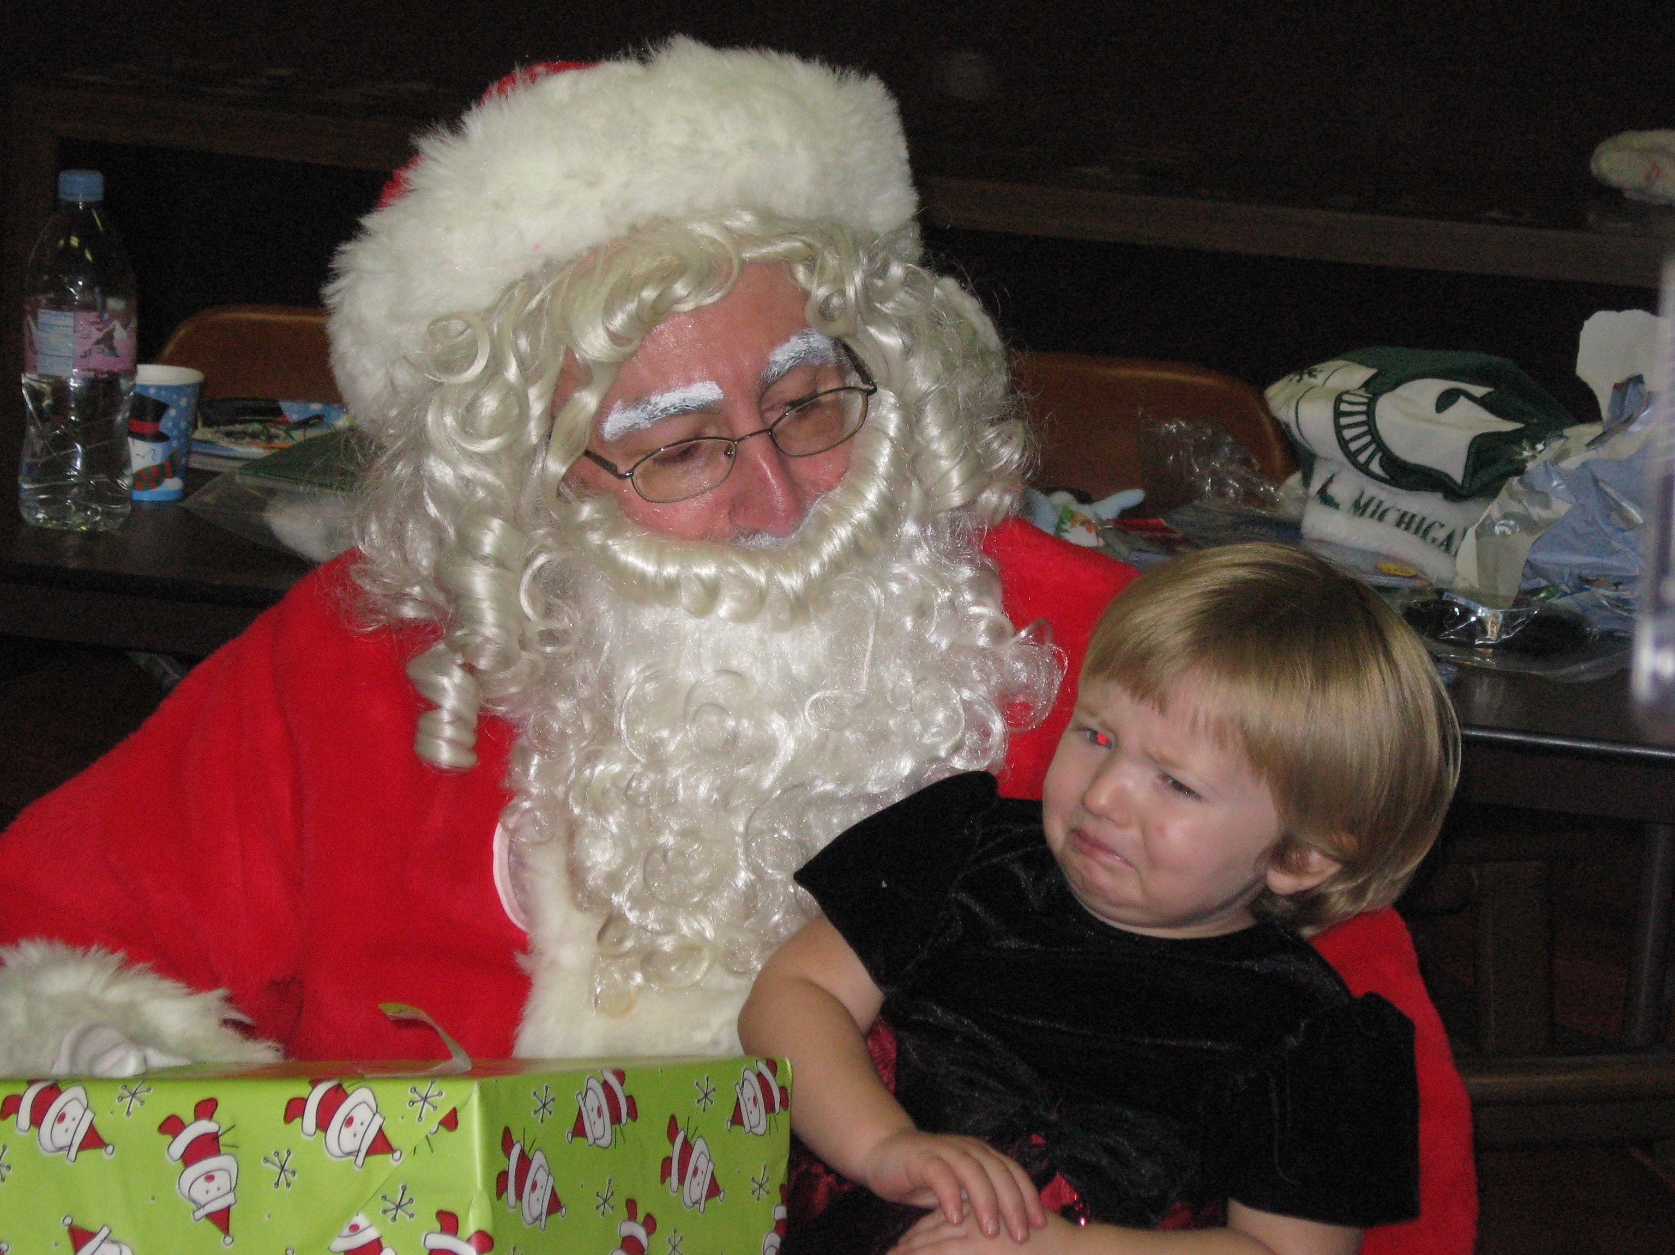
After watching the little children at the Children’s Christmas Party I couldn’t help but remember bringing my own two children to the parties when they were small. What happy memories they were. Tri-V has been such a big part of my family’s life as it grew and changed and now the traditions have continued to my grandchildren. I am thankful for Tri-V and want to extend a wish to ALL that they experience what Tri-V has to offer and that the goodness never stops.
Merry Christmas!
Nick Angelosanto

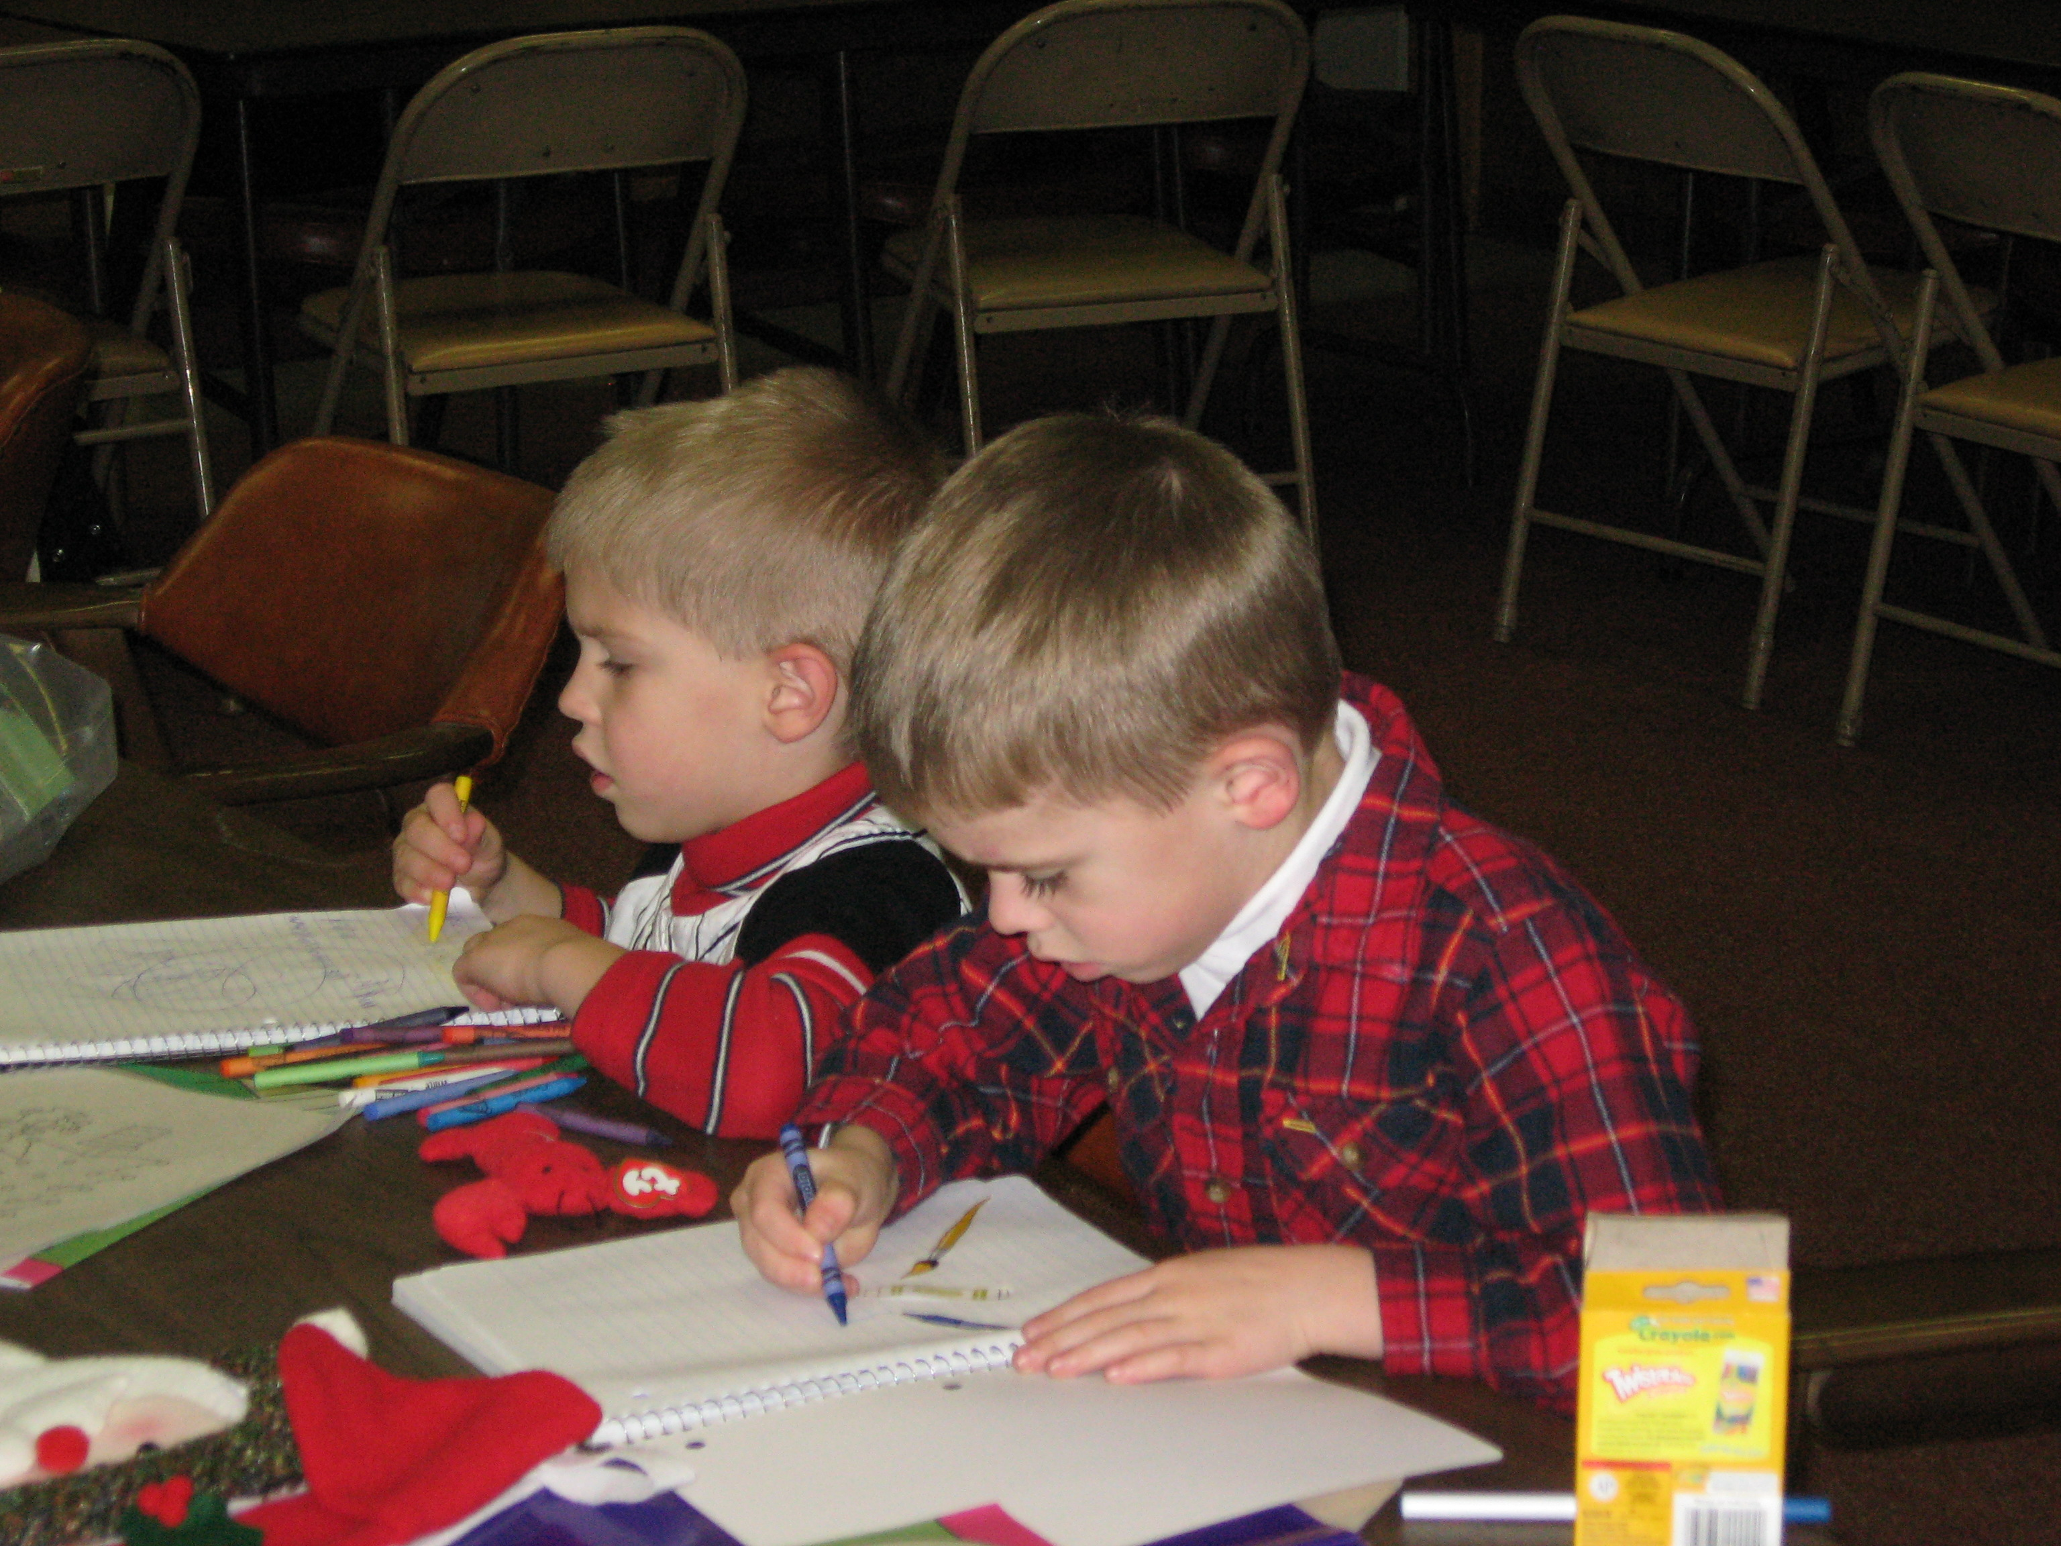
We would like to thank Mr. Nick, Mrs. Vicki, Mr. Dion, Mrs. Anne Marie, Mr. John and Mrs. Robin for all the fun we had today at our Christmas Party. Our parents and grandparents were good too, they dressed us up and took lots of pictures so we will remember this special time. And, oh boy, we got to see Santa Claus and some of us even sat on his lap. And best of all he gave us presents. We liked the pizza, but the ice cream was the best. Thanks again and we hope to see all our new friends gain next year at the picnic and the Christmas party.
The Kids of the Tri-V Family

Tri-V Anniversary Party-Florida 
We are looking to have the party in early March. By doing that we may be able to have more Tri-Vers present than having it earlier. Our current plans call for an overnight party that would find us at the Roaring 20s in Ellenton Florida. You would get off I-75 and go East a very short distance. As we get closer to the time we will give you more details. Florida Anniversary Party Committee; Bill Trachsel, Chairman... Bill Suchner & Art Trachsel

Michigan Anniversary Party Plans--Attention mark you calendars for March l5. It is the date of the Anniversary Party. More details will follow.....

Cards for Recovering Soldiers

In case any of you out there would like to please send a Christmas card to one of our recovering soldiers. A friend of ours gave us this address and we thought some of you might want to do this too.
Blessings to you all,
Sherry
A Recovering American Soldier
c/o Walter Reed Army Medical Center
6900 Georgia Ave NW
Washington DC 20307-5001

Pinochle

Cards at the Schaefer's was great fun. We had Blondie, Bud Massoll, Annemarie, Dion, Sherry, Geoff, Terry, Ellie, Barb, Jerry, and no burnt food. Last year Brett's grace included thanks for the burnt offerings. This year was much better. I just forgot the bread so we had it at the card tables instead of candy and nuts. I know you are all out there fighting to come to our house in February. It is always an adventure. Hoorah for the women, Ellie had 27 1/2, Blondie had 23 and Jacqui 22 1/2 (not enough to stay in first place). Gosh, I already had a place of honor in my house selected for the plaque. Thank God everyone got home safe as the weather was rotten, but the evening was warm and full of great friends.

November Social
On Friday December 7th, 15 members, 1 prospective member and 16 friends met at the Palace of Auburn Hills for the Detroit Pistons vs the Chicago Bulls basketball game. The place was loud, with lots to see and there was a basketball game also. Sadly the Pistons did not win, but the group all seemed to have a good time (except Belinda Bluidzius whose fear of heights prevented her from
sitting in her seat). I guess we were in the nose bleeds. The Committee: Brian and Mike Trachsel

Council Party
The Council Party will be held at Novi Bowl on January 26th. We will be eating at 7:00 with bowling following at approximately 8:30. Dinner will consist of Pizza, Italian subs and salad. After dinner we will be playing several "fun" bowling games. No bowling skills are required as we will not bowl for high scores each game. The approximate cost for the evening will be $15 dollars per person for dinner and bowling. Please let one of the council members know if you will be attending. Council Members: Mike Trachsel, Jeff Trachsel, Brett Barnes, Matt VanHollebeke, Call Cashman, Bill Trachsel, and Eric Hoffman

February Social

On February 23 we will be taking a guided tour of the newly remodeled Detroit Institute of Arts. The tour will begin at 4 p.m. and take about one hour. Following the tour there will some time for anyone interested to explore on your own. We will then meet for dinner. The dinner location has not been decided yet. The final details will be in the paper next month. Eric Hoffman, Chairman Brian Trachsel

Trifles

The Clingermans had an unusual and wonderful Thanksgiving. We flew to Zihuatenejo, Mexico for our nephew’s wedding. What a gorgeous place! It’s a fishing village with a lot of Mexican culture not yet ruined by tourists and American hotels. We were on a bay with beautiful green mountains surrounding us. The wedding took place on a terrace overlooking the ocean. One minor problem was the 95 degree temperature. We were glistening in a lot of pictures! We are, sadly, out of children and relatives to get married in great places. On to grandchildren! Hopefully.

Several Tri-V members and wives left for Greece in late September. The Kuhr’s, Tim and Karlyn Gies, Jerry and Barb Gies met up with Dave and Sandie Gies who live in South Carolina and several of their traveling friends from Atlanta. We all joined a larger group of about 70 people. We spent time in Athens, Heraklion, Knossos, Santorini, Mykonos, Delos, Kusadasi in Turkey where we saw the ruins of Ephisus, then Rhodes. Jerry and Barb Gies and Tim and Karlyn Gies added three day to the trip to go to Istanbul Turkey. We stayed in beautiful hotels, met wonderful people on the tour who came from all over the US. We visited more ruins and learned more about ancient history than we could possibly remember. Enjoyed the local foods, entertainment, and the people who were wonderful. Tim and I loved Turkey and wished we would have spent a whole week there instead of having the four day cruise at the end of the Greek Island tour. But all in all it was a trip we will always remember and are glad we went. The three brothers enjoyed each other’s company and everyone on the tour knew the Gies boys.
Bill and Onallee Trachsel will be flying north on December 19th and staying with Tim and Karlyn. You can reach them there and feel free to visit. The Trachsel children and spouses will be getting together for an evening with Mom and Dad on the Saturday before Christmas. On Christmas Day, the whole family will gather at Lynne and Brett Barnes for our traditional gathering. There is getting to be many new little ones, which makes it exciting and fun. Tim and Karlyns’ daughter Lisa and her family will be coming in the Thursday after Christmas for four days, so their family will be celebrating on the Friday after Christmas with an Open House on the Saturday after Christmas so family and friends can come visit with Lisa, John, Jacob and new little Andrew who was born in July. That is from 4-8 if anyone in Tri-V would like to stop by and see them, please do. Lisa and John will only be coming home every other year as he goes to visit his family in Maryland the alternate year. On New Year’s Eve Connollys, Kuhrs and the Tim Gies’s will travel to the Dushary’s for their traditional bridge, gourmet dinner event. They have been doing celebrating this way, rotating who hosts for about eighteen years.
Ken Plocharczyk flew out on Dec. 2nd, to Las Vegas to lend a helping hand to his brother-in- law, Kirk Trachsel. He is spending 2 weeks there. Kirk's healing is going so slowly. The incision on his leg will probably be fully healed by the end of this year. Then the by past surgery will not occur until the end of January. To say Kirk is discouraged would be putting it mildly. He can only stand for 10 minutes at a time, sit up for 15 minutes at a time, & walk painfully with a walker 4 times a day. He is still on pain medication every 4 hours around the clock. He appreciates all the prayers you are sending his way and he says " please don't stop" He sends his holiday wishes to all his Tri-V friends.

Letter from Kirk’s fiancée, D’Anna
Hi friends;
We are still here. We will make it through this but totally because of you and everyone else who have supported us through this worst year of our lives. THANK YOU! It's not even a phrase that comes close to expressing our gratitude.
Anyway, Kirk is still making slow progress but progress none the less. An inch a month seems to be an apt description. After the femoral bi-pass surgery the healing process will accelerate tremendously but right now we are just trying to get the wound on his leg healed and beyond the danger of infection.
Kirks brother in law, Kenny is here to stay with us for 12 days. He's helping me get some things done around here, giving me a desperately needed break and giving me time to look for work. It's nice to have male company for Kirk too, I'm sure! He's too nice to tell me but I can imagine he's getting pretty sick of me!
Jennifer has arranged for Kenny's flight to and from Michigan and we thank her for her caring kindness!!!!
World class martial artist Eric Lee is holding a 6 month raffle of his extraordinary China/Hawaii tour, scheduled for next fall. The tickets are a reasonable $5.00 minimum I believe for an amazing trip (I know I went on it two years ago!) and the proceeds are being donated to Kirk and I. This tour lasts about 12 days and goes for 3 or 4 thousand dollars a ticket. He has also circulated an e-mail plea to all his martial arts associates to make donations and he set a precedence with his own generous donation. He is truly a great humanitarian and a good friend/brother too!
Anyway, there's not much to tell at this point but the progress, though slow is in the right direction! I'll pass on the e-mails from Grand Master Eric soon!
Love,
D'anna

The Hoffmans are in Florida..... but you know that.... We had dinner around Thanksgiving with Bill and Onallee and Art who was visiting them. A good time was had by all. We were taught to play 5 card pinochle.......another old person’s game.... we can't remember how to play thirteen cards.... Everything is well here in Florida except for the heat... mid to high 80s everyday.... thank goodness for A/C. We will be home between the 18th and January 2 and hope to see everybody during that time frame.... along with all of the doctors...... I have lost 70 lbs so for and am feeling well.......

Peg and Bob have decided to stay where we are and not go into a retirement home at this time we have a beautiful home on the lake and plenty of room. As long as Peg stays as she is and don't have any major set backs we can manage just fine. On the happy side our Grandson sergeant Issac Wendt came home from his second deployment in Iraq and will be getting married on December 8th. Issac is the son of Patrick and Maryanne Wendt Peg and Bob’s son and daughter in law in Idaho. If any Tri- Vers come to Fla. and are in our area we have an extra bed room and you will be welcome to spend a night or two.

December is the time of the year that we celebrate the birth of Jesus Christ, our Lord and savior. Lately I have had time to reflect upon the many blessings he has bestowed upon me. He has abundantly given me all the necessities of life especially my dear wife, Virginia of over 70 years. Also thanks for the Tri-V Club, it has been has been a great source of comfort, fun and comradery. May the good Lord bless all of you as he has blessed me. Have a Merry Christmas and a Happy Healthy New Year.—Bud Massoll

Once again the joys of this beautiful season of Christmas are upon us. We can never say enough how special the TRI-V Family is to each one of us. The prayers and friendship we share throughout the year cannot be matched by any other organization. Again Ray we thank you for your insight in starting TRI-V and as you stand next to God looking down on us have Him send his blessings to all or us and our families. Merry Christmas and Happy New Year. Judy and John Lardin

Liz and I want to wish everyone in Tri V a very Merry Christmas and we pray for all to have a healthy Happy New Year. Jay and Liz Trachsel
Merry Christmas and a healthy, happy New Year to all our TriV friends and family! We are very blessed to be part of this wonderful group even though we keep moving farther away. Our family is particularly thankful for your prayers and support of brother Kirk. I know your prayers have helped him
endure this tough time. We wish each and every one of you God's blessings
and the Peace of Christmas. Love, Ken and Diane Plocharczyk

May the wonder of His love touch you this Christmas and bring you peace and happiness in the new year. Wishing all Tri- V members and their families a Blessed Christmas and a Wonderful New Year. Dennis And Marlene Wutka

To all of Tri-V: My family and I would like to take this opportunity to wish our Tri-V family, a very blessed and fun filled holiday. We look forward to spending another year with our extended family. Happy Holiday, Dion, Annemarie & Isabel Angelosanto

Marian and I wish you all a Blessed and Merry Christmas. You will be in our prayers and if you get down to Fort Myers, please look us up. We will be back in Michigan from December 15 to January 8, so hopefully we will see some of you then. We are enjoying our new experience in Florida and you can really get use to this 80's - 60's weather. God Bless and enjoy your special time with your families. We were fortunate to have all our children and grandchildren (6 under 4) at our son's in Atlanta for Thanksgiving. We had a wonderful time and the memories will last a lifetime. Corey still wants his baby sister to go back in mommy’s tummy, but they are working on resolving that issue.
Love and Hugs, Lee and Marian

To all my Tri-V family. You may be a long time Tri-Ver or a brand new member. To all of you, I pray you have wonderful holiday joy with your family and friends. And may your new year be filled with all that is good for you. And above all may you enjoy God's blessings always. Art Trachsel

Merry Christmas to our TRI-V family! As we look back at another year of all the blessings that HE has provided, we thank GOD and celebrate Christ’s birthday. We also thank you for allowing us to be a part of your lives and look forward to another blessed year. Wishing all our fellow TRI-V families a Merry Christmas and Happy New Year filled with good health, hope and the presence of His grace. Thanks for another year of memories and fun fellowship. Love, Brett, Lynne, Corey and Jenna

May the beauty of the season bring you joy, May the spirit of the season bring you peace.
Merry Christmas & a Happy New Year Blondie


We would like to take this time to wish all our friends in Tri-V a very Merry Christmas and a wonderful New Year. We are so blessed to belong to such a wonderful organization that has given us a second family that is so caring and fun to be around. We would like to thank all the committees for the great activities they planned in 2007 and look forward to what is being planned for 2008. We pray for those members with health issues that they will regain better health in the coming year. We also remember fondly those who have passed away this year and keep their family in our prayers. They will be truly missed by all. Cal & Jan Cashman

"Once upon a Miracle, a tiny Infant's birth brought love into the world and Heaven's Joy to earth Celebrate Life" Merry Christmas and Happy New Year to our Tri V family, Love, Terry & Ellie Connolly

Christmas greeting from Tim and Karlyn – Just enjoyed the children’s Christmas party last Sunday and it really brought back memories for me. It was so wonderful seeing all of the newer members’ children and all of our grandchildren. Life certainly does go round and round. Tri-V for me is like glue for my life. It’s values of faith, friendship, fun, laughter, support, encouragement and forgiveness are things all people hunger for and many do not have in their lives. So at this Season where we recognize the ONE WHO we believe gave us all of these values and the people who help us live them, it is appropriate to say to all of you Thanks, I love you all and may Christ bless you over this Season and the coming year.
To All Tri-Vers: Love, Joy and Peace: May Joy fill your days, Peace overflow in your heart and Love surround you always. Many Thanks for everyone that worked on the 70th--a wonderful job! Marilyn Myers
We pray every one of our Tri-V family members will have a holiday full of blessings and share in the spirit of the season. We have all been truly blessed by having one another. Hugs Jack & Jacqui
To all of our Tri-V friends, We have been extremely blessed this year. The birth
of our daughter has made us believe in miracles and we are truly thankful to have shared this special
occasion with our “Tri-V family.” We are very fortunate to be a part of such a great group. Our
family wants to wish everyone a safe and happy holiday season. We look forward to another wonderful year of events and fellowship with the Tri-V club members and their families next year.
Seasons Greetings! Geoff, Sherry and Kayla Steinhauer

To all our friends of the Tri-V Club, although we can't be with you to celebrate the holidays in person, we send you this special greeting with the hope that your Christmas is filled with warmth & joy.
BILL & SHIRLEY

To all our Tri-V friends, who are like family, we'd like to wish you and your families a safe and healthy holiday season filled with peaceful moments, raucous laughter, quiet reflection and lively chatter. Make memories that will be talked about by your kids and grandkids in the coming years. Wishing you all a Merry Christmas and a Peace-filled New Year. Susie and Terry

Holiday Greetings to each and every one of our family and friends in Tri-V. This is a special season for remembering. First the reason for celebrating--the birth of the Christ Child. We get in touch with family and friends. With each card sent, the memories of that person come flooding back to our minds. The 70th anniversary week-end certainly made us remember what a special, unique club we are members of. The reading of all the names of members, both past and present, reminds us of how many persons have touched our lives. We are thankful for each and every one. We do wish all a very special Holiday Season and a Healthy and Happy New Year. Onallee and Bill

Every year I look forward to the December issue of the Tri-V paper just for the Christmas messages. This is a thank you to all who take the time to put a message in the paper. It doesn’t matter if the note is short and to the point, clever, or long and involved. All your messages are special. May you have a blessed Christmas and a happy 2008. Smiles, Dominic and Victoria Angelosanto

Merry Christmas and Happy New Year to all our TRI-V friends young and old!! Bob and Peg Wendt

Happiness, may it yours throughout this holiday season and the up coming year. Karen and I wish everyone in our club family a safe Holiday and a year of Peace and Happiness.
Jeff & Karen
Merry Christmas everyone! Seems the correct thing to say these day is Happy Holidays, but that sort of neglects the reason for the holidays....The birth of Christ. We are so blessed by His love and the wonderful people He has placed in our lives. One group of friends we are most especially proud and blessed to know is our Tri-V family. We pray that God will be with you "ALL" during this season and in the year to come. And if you have worries or troubles that you will feel His presence there with you. We love you....Bob & Sherry

Calendar of Events

January February
5th Pinochle 2nd Pinochle
9th Men’s Club Mtg. 13th Men’s Club Mtg.
16th Wives Club (Karlyn Gies) 23rd Feb. Social
26th Council Party DIA—4 p.m.
Novi Bowl—7 p.m.

January Birthdays February Birthdays

2nd Geo. Hoffman 1st Eric Hoffman
3rd Cy Richeson 2nd Ken Stress
17th Diane Plocharczyk 7th Romas Bliudzius
19th Marge Stock 9th Tim Gies
23rd Geoff Steinhauer 13th Lynne Barnes
27th Bob Kuhr 18th Debbie Lockhart
28th Peg Wendt 22nd Tom Untener
30th Jack Schaefer 23rd Bonnie Untener
24th Sherry Kuhr
January Anniversaries 26th Esther Chamberlin &
1-3-75 Tim & Karlyn Gies Dorothy Richeson
28th Helene Ryan
February Anniversaries
None

MEMORIES FROM THE DECEMBER 1997 ISSUE OF TRI-V UMPH

The December issue of TRI-V Umph has always been our Christmas Issue that allows all of us to wish a Merry Christmas and Happy New Year to fellow TRI-Vers. This months issue was no exception with there being 34 greetings, a few more than in 1992, and more from the Active Members. We still were asked to remember in our prayers those less fortunate who might be suffering at this special time of the year. Those in need were Don and Dory Gasco on the loss of their daughter-in-law, Madalyn, who had been battling cancer for two years and Peg Wendt who was scheduled for surgery the end of November for tie doloreoux. On the brighter side, though still in need of our prayers, Jan Cashman had recovered from her surgery, Jack Henry who was convalescing from back surgery, Glenn Stock from knee surgery on the opposite knee he had done in 1992, Art Trachsel from the back surgery and Lu Wagner who was scheduled for knee surgery in January. The Wives Christmas Luncheon was to be December 13th at Somerset Mall in Troy. The Council Christmas Party was set for January 24th with a bus trip to Windsor for 5 pin bowling then returning to Detroit for dinner at the New Parthenon Restaurant in Greek then a week later the Family Weekend was set for the Wheels Inn, Ontario Canada.
The winter event was a Plymouth Whalers hockey game on February 21st while the Florida get-together was scheduled for January 26th in Venice Florida. Various articles on TRI-V Members travels included Lu and Dottie Wagner in October for a trip to Branson Missouri, Curt Martin with a trip to New York and Judy and John Lardin a trip to Corpus Christi TX. After two months of Pinochle Nick Angelosanto was in first place with 50.5 points, Fraser Forsyth in second place with 49 points and Helen Ryan in third placed with 48 points

MEMORIES FROM THE DECEMBER 2002 ISSUE OF TRI-V UMPH

Again the December issue of TRI-V Umph was our Christmas Issue and a chance to wish all of our TRI-V Family a Merry Christmas. Unfortunately there were only 18 greetings in the paper, 10 from Active Members. We were still asking for our prayers for Club Members and their family who were less fortunate than us. Lorraine Trachsel had been diagnosed with lung cancer after test and was to begin radiation, Bill Trachsel suffered a stroke the first part of December and fortunate there were no major complications, Bill Suchner’s departure to Florida was delayed as he had to have a cancerous tumor removed from his neck followed by 6 weeks of radiation, Bob Wendt was suffering from clots in his leg that had him hospitalized for 4 days and Lu Wagner took a spill in is apartment that forced him to use a walker and had to see an orthopedic surgeon. On the brighter side the scar on Judy Lardin’s nose that was thought to be caused by her glasses was diagnosed as skin cancer. Fortunately it did not go through the skin and affect the muscle and bone and was removed in his office. The January Social was set for January 11th in Windsor with the Club participating in curling. This was something new for the Club and most were excited about the event. The Wives Club had there weekend set for August 8th-10th in St. Joe Michigan being planned by Jacqui Schaefer and her daughter. Travels had Brett and Lynne Barnes and kids on a cruise to the Bahamas, the Schaefer’s to their cottage up north to hunt with the entire family, Terry and Sue Dunham to Myrtle Beach, Tim and Karlyn Gies to South Carolina and Bill & Shirley Suchner along with Bob and Peg Wendt on a train trip across Canada. After two months of pinochle Terry Connolly was in first place with 51 points and a three way tie for second between, Brian Trachsel, Marlene Wutka and Jan Cashman with 49 points followed by John Lardin with 48.5 points.

This wraps another trip down memory lane. Looking back at the Christmas Greetings it seems that it was the same people each year who took the time to send one. Kind of sad. Seeing I had 48.5 points after two months of pinochle is amazing. I don’t think I had that many points for all of last year and doubt if I will hit that number this year. As we all know this is a special time of the year. In many cases we renew a friendship by sending and receiving a Christmas from someone we have not seen, talked to or written since last Christmas. Maybe this year can be different as I know a few that I will make contact with again. Remember this is the birthday of Jesus so let’s not get too hung up in the material aspect of the Holiday. Thank him for all we have and how fortunate we are to be a Member of such a great group of people. And as I say every month take the time to share the memories of past Christmases with our children and grandchildren. Most of all take care of one another until we see you in print next month, the Good Lord willing

And I heard him exclaim as he drove out of sight



Merry Christmas
To
All and to all
A
Good night!!!!

