Life Legacy  EDITH LUCILLE (ROWE) FORSYTH  Passed away on August 25, 2016 at the age of 91 following her battle with Alzheimer’s disease. She was born on November 24, 1924 to Cecil and Verona (Garrett) Rowe in Detroit, MI. Edith married Fraser Forsyth on June 10, 1944; spending over 58 years devoted to each other until his death in 2002. She was an active member of the First United Methodist Church of Northville since 1952. Blondie or Deed, as family and friends called her, was a member of Tri-V, a fraternal organization. She often donated her time ringing the bell for the Salvation Army and enjoyed playing cards, especially pinochle.  Edith was preceded in death by her husband; siblings, Robert Rowe, Virginia Thomas, Patricia McKearney, and Lois Hlavaty; her son-in-law James Jiggens; and her granddaughter Jamie Jiggens.  She is survived by her children, Barbara Jiggens of Howell, William (Stephanie) Forsyth of Canton, and Beverly (James) Stewart of Holt; her granddaughters, Heather (James) Snider of Florida, Kayce Jiggens of Howell, Amber (Justin) Beckley of Dundee; her grandson Andrew (Sarah) Stewart of Connecticut; and her brother Kenneth (Mae) Rowe of Florida.  Visitation will be held Wednesday, August 31 from 10am until Noon with a funeral service beginning at Noon at Casterline Funeral Home, 122 West Dunlap Street, Northville. The service will be officiated by Rev. Dr. Douglas W. Vernon of the First United Methodist Church of Northville. A luncheon will follow at the church, 777 West Eight Mile Rd, Northville.  In lieu of flowers, memorial contributions may be made to the Alzheimer’s Association or a charity of your choice.  &nbsp;  PDF Printable Version |   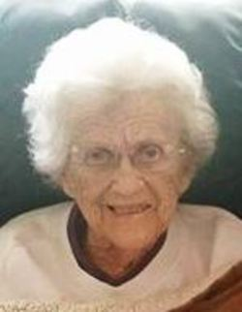      Born: November 24, 1924  Death: August 25, 2016    Memorial donations may be made to:  Alzheimer's Association  Charity of your choice  This memorial provided by:  CASTERLINE FUNERAL HOME  NORTHVILLE, MI

